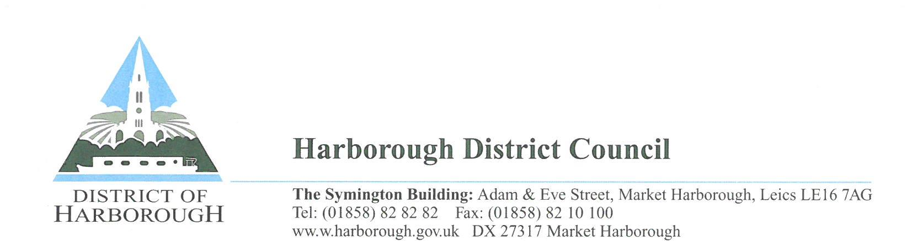

Gambling Act 2005 – Non Commercial Society Lotteries

Please return this form to the Licensing Section at the above address

Name of Society:……………………………………………………………………………..
Society Registration number (you will find this on your renewal reminder email):……………………
Society Contact Name……………………………………………………………………..
Telephone:………………………………………………………………………………….
Email Address……………………………………………………………………………..
I hereby apply for the renewal of the registration and
(please tick)
□ have enclosed a cheque for £20 payable to ‘Harborough District Council’.
□ have paid £20 by card by calling the contact centre on 01858 828282.

Signed: ................................................................. Date: ..................................................
Position held: ...........................................................

NB: If the name and address of the Society Official to whom this email was sent is no longer correct please give the correct details above.
If we do not hear from you within one calendar month of the renewal date we will assume that you do not wish to renew your registration. If the society does wish to be registered after the one month period it will need to make a new application (the fee is currently £40).

