Declaration of Local Count Totals
Referendum on the United Kingdom’s membership of the European Union
As Counting Officer for the Harborough voting area at the referendum held on 23rd June 2016 under the European Union Referendum Act 2015, and having been authorised to do so by the Regional Counting Officer, I hereby give notice that I have certified the following:
The total number of ballot papers counted was | 54,910
The number of votes cast in favour of REMAIN was | 27,028
The number of votes cast in favour of LEAVE was | 27,850
The number of ballot papers rejected was as follows:

- No official mark | 0
- Both answers voted for | 1
- Writing or mark by which the voter could be identified | 2
- Unmarked or void for uncertainty | 29
The total number of ballot papers rejected was | 32

Signed: 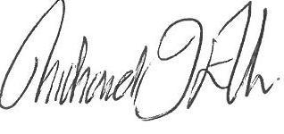 Counting Officer
Name: Richard Ellis
Dated: 24th June 2016

