Great Glen Neighbourhood Plan
Summary of representations submitted by Harborough District Council to the independent examiner pursuant to Regulation 17 of Part 5 of The Neighbourhood Planning (General) Regulations 2012

Name | Policy /Page | Full Representation
Bovis Homes Limited | GG1  GG2  GG$  GG5  GG6  GG7  GG12  GG14  GG16  GG17  GG19  GG20  GG23 | Introduction  1. These representations address the amended Submission Version of the Great Glen Neighbourhood Plan (November 2016) as published in March 2017. Bovis Homes Limited previously commented in upon the original Submission Version (July 2016).  Material Change Between the July and November 2016 Versions of the Neighbourhood Plan  2. The amended Submission Version of the plan is based upon the following resolution of Great Glen Parish Council at a meeting on 29 November 2016:  '1077/16 Neighbourhood Plan Revision Approval  Due to the correspondence received from Historic England and the change in housing numbers it was felt that amendments were needed to the Neigbourhood Plan (sic) before it went for inspection.  The following statement has been removed "Development at Sycamores Farm Extension site B for 100 units is identified as a reserve site in the event of an increase in housing need or a failure to deliver the existing commitments within the Neighbourhood Plan. " along with the map showing the area.  The reserve site has been removed in the light of significant updated information  It was proposed to accept this ammendemnt (sic} to remove a reserve site. Proposed Cllr Parrott; seconded Cllr Hawes; unanimpusly ( sic} received.  The Local Plan Options Paper, updated in May 201Ii does not apportion housing targets to specific Rural Centres or Selected Rural Villages. It does/ however, put forward four options/ depending on various a/location options elsewhere/ for each of the Rural Centres and Selected Rural Villages across the District . In the case of Great Glen, this could see the Parish having a minimum housing target of anywhere from O to 64 new home/s depending on the distribution strategy finally agreed through the Local Plan. A report agreed by the District Council Executive in September 2016 set a residual target for Great Glen of 5 additional dwellings up to 2031/ a figure which has been exceeded through Planning Applications approved since the cut-off for calculating the residual housing target (March 2016) with a total of nine additional dwellings having secured planning permission since this time.  It was proposed to accept the addition of the comments above reflecting the change to housing numbers Proposed Cllr Glasper; seconded Cllr Andrews; unanimously agreed.'  3. Bovis Homes submit that this hasty resolution by the Parish Council to remove the 'reserve site' at Sycamores Farm (see plan below) should be reversed and the site reinstated. The basis for this submission is that there was inadequate consideration was given to (a) the 'emerging' status of the Harborough District Local Plan for the period up-to 2031 and (b) the availability sufficient site-specific evidence to demonstrate that there would be no significant impacts on historic assets if the site was developed for housing purposes. The  Examiner is requested to recommended that at least the reserve site at Sycamore Farm (as shown in the plan below) should be re-instated into the Neighbourhood Plan.  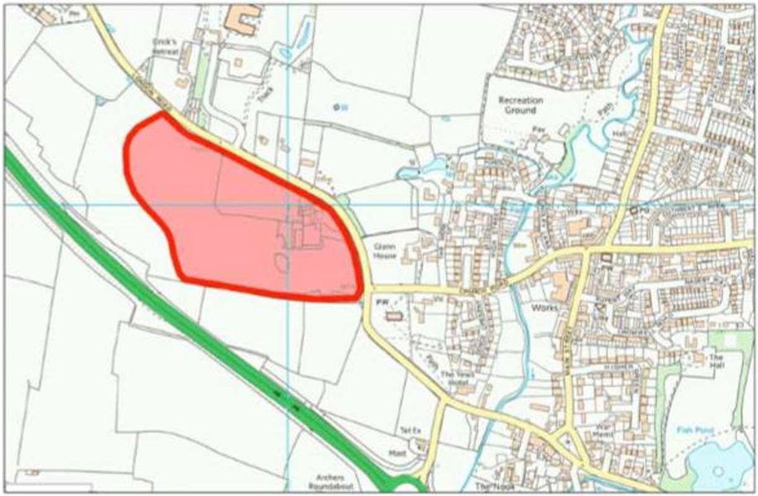  Emerging Status of the Local Plan  4. As a contextual point for the Examiner, the Harborough District Development Framework Core Strategy was adopted on November 2011 and, therefore, predates the National planning policy Framework published in March 2012. The Core Strategy cannot and does not take into account the requirements of national policy concerning matter such as boosting significantly the supply of housing. The emerging Harborough District Local Plan is seeking to grapple with the implications of the Framework albeit the programme for its preparation keeps slipping. There is a clear contextual point here for the Neighbourhood Plan in terms of what strategic policies it should be in general conformity with and what weight can be given to the emerging housing policies because they have yet to be properly formulated and tested.  5. For the record, the Parish Council (as the authors of the Neighbourhood Plan) determined in the original Submission Version (July 2016) that there was a need for a reserved housing  site in the event of an increase in housing need or a failure to deliver the existing commitments within the Neighbourhood Plan. This remains a possibility and it should be addressed by the Neighbourhood Plan on a contingency basis (see also Policy GG2 and New Policy representations). The Neighbourhood Plan needs to plan for housing.  6. It is acknowledged that, based on advice in the Planning Practice Guidance and confirmed by Case Law, it is possible to prepare a neighbourhood plan before, or at the same time as, the production of a local plan. This is the case here where the Harborough District Local Plan for the period up-to 2031 is still being prepared. However, unless a positive and pro-active plan is prepared, this Neighbourhood Plan will inevitably subside beneath the later adoption of the Local Plan or, as now looks increasing the case, a more up-to­ date evidence base, in particular the objectively assessed housing need for Harborough District.  7. Originally, the July 2016 version of the Neighbourhood Plan recognised that over the lifetime of the Plan housing provision at Great Glen may well need to increase above what is currently being assumed. Indeed, the reference to a 'minimum' number of new dwellings was a positive approach to adopt. Equally, the idea of a reserve site was both a sensible and positive approach which reflected the approach suggested in the Planning Practice Guidance and would avoid the Neighbourhood Plan becoming quickly out-of-date. Although there is some lingering acknowledgement that the housing need might increase over the plan period (page 22), the original positive approach to the preparation of the Neighbourhood Plan to plan for housing has now changed because of a resolution of Harborough District Council taken in September 2016.  8. To be clear, the Local Planning Executive Advisory Panel at the meeting on 19 September 2016 did not determine what the level of housing would be for Great Glen during the Local Plan period. I nstead, the Panel determined to recommend to the Council the potential inclusion of a Strategic Development Area on land east of Lutterworth and a similar scale of development, if needed, at North Scraptoft. The Panel is advisory and, therefore, contrary to the Parish Council's assertion there is as yet no formal resolution from either the Executive or Council and, contrary to the wording of Policy GG2, there is no confirmed housing requirement for the period 2011 to 2031 which has been exceeded at Great Glen.  9. Notwithstanding the Panel's recommendation, there is still considerable uncertainty abo+ut the housing provision which will need to be met within Harborough District during the  period up-to 2031 because the objectively assessed housing need remains untested. There is also uncertainty about the Duty to Co-operate concerning the accommodation of housing within the wider Housing Market Area. Further, there remain serious doubts whether the recommended the Strategic Development Area on land east of Lutterworth is viable and deliverable which then has the potential to undermine the recommended spatial option to accommodate growth.  10. Irrespective of the unknown and untested housing need, including the specific requirement at Great Glen, the Advisory Panel notes of the meeting also make is clear that:  'It was noted that the east of Lutterworth SDA would only contribute to part of the housing requirement and that other parts of the District including Market Harborough and many Rural Centres and Sustainable Rural Villages would also have housing allocations in the Local Plan. ' (emphasis added)  11. At the same meeting the Advisory Panel received the Sustainability Appraisal: Internal Report (September 2016) which assessed the potential spatial options. This Appraisal is complementary about the potential for further growth at Great Glen and highlighted th e potential for benefits which could accrue (emphasis added):  'Particularly negative effects (compared to other SRVs) are recorded for South Ki/worth for all four options due to the probable loss of Grade 2 agricultural land and potential effects on local wildlife habitat. Given that there are no sites identified in the SHLAA 201 it would be appropriate to adopt a windfall (infill and rounding) approach to housing delivery at South Ki/worth. There are other settlements that could adopt slightly higher targets to make up this 'shortfall' without triggering significant negative effects (for example Great Glen, or Kibworth (for the alternative SDA options Band DJ). (Paragraph 3.1.12)  'Negative effects are predicted at Ullesthorpe under Options Band C, and at Great Glen under Options Band D. These are due to low levels of growth that could limit the potential for affordable housing provision acting as a negative effect on health in the long term. Though education and health facilities are somewhat constrained at Great Glen development could potentially support new facilities at a significant level. Given that negative effects upon the environment have not been identified for Ullesthorpe and Great Glen, it ought to be possible to increase housing in these settlements for anv of the options, helping to ensure that no settlements across the district experience negative effects upon health and wellbeing. (Paragraph 5.1.10)  'Option D is predicted to have a major significant positive effect as there would be positive effects on housing and economy at the majority of settlements through the provision of greater housing choice, affordable housing and increased spending in village and town centres. There would be a major positive effect on Lutterworth  and surrounding settlements through the delivery of an SDA. Neutral effects are predicted for Great Glen and Kibworth due to the lack of growth. Although there are substantial commitments and completions at these settlements, a lack of further growth could be viewed as missed opportunities. It should be possible to increase growth at these locations without having a detrimental effect at other settlements. (Paragraph 7.1.6)  'Negative effects are predicted at Ullesthorpe for Options Band c; and only neutral effects at Great Glen and Kibworth under for Options B and D. These are due to very low levels of growth at Rural Centres: which as higher order settlements than the SRVs ought to be capable of accommodating more housing growth to meet needs in more accessible locations. Though these two settlements are both experiencing growth due to a substantial amount of commitments and completions, it is considered reasonable that a small amount of further growth could be accommodated to allow for more sensitive targets to beset at settlements where significant negative effects upon character could be experienced. (Paragraph 7.1.10)  'Given that negative effects upon the environment have not been identified for Great Glen for any of the 4 options, it ought to be possible to increase housing here for any of the options, helping to ensure that positive effects are generated for Great Glen. With regards to employment land provision, Option B provides the lowest overall figure of the four options, given that it would not involve an element of employment alongside the SDA at Scraptoft. However, it would provide access to jobs in the Leicester Urban Area. Option D would be particularly positive in terms of providing accommodation to communities in the west of the District, where there is good access to major centres of employment such as Magna Park (which may expand further). (paragraph 7.1.11)  'Conversely, there are settlements where negative or neutral effects have been identified due to low levels of growth (Ullesthorpe and Great Glen, or Kibworth under Options B and D). An increase in growth here could be accommodated whilst having fewer negative effects on the built and natural environment. ' (Paragraph 10.1.1)  12. As a matter of principle, the objectively assessed sustainability merits of Great Glen are such that the settlement remains a potential location for growth to meet a housing need with few negative effects on the built and natural environments but having positive effects. All the matters yet to be grappled with in the emerging Local Plan associated with the uncertainty around the objectively assessed housing need, the deliverability of the spatial strategy and the sustainability credentials of Great Glen demonstrate lack of the Parish Council's foresight when taking the somewhat hasty decision to remove the reserve site at Sycamores Farm. The Neighbourhood Plan should plan for housing albeit potentially only on a contingency basis.  Heritage Assets  13. During the preparation of the Neighbourhood Plan there has been an exchange of letters between the Parish Council and Historic England. The relevant commentary from the letters is as follows:  Letter dated 17 February 2016  'Having considered the proposals we do not consider that there is a need for Historic England to be involved in the development of the strategy in the area at this time. However in light of the heritage assets in that are in the area/ we consider that the conservation officer at Harborough District Council is the best placed person to assist you in the development of your Neighbourhood Plan. They can help you to consider how the strategy might address the area's heritage assets.'  Undated Request for Screening for Strategic Environmental Assessment (SEA)  'We observe that the revised Plan appears to propose a reserve housing allocation to the south of London Road with may have significant environmental effects upon the historic environment including the Grade II * Church of St Cuthbert together with other heritage assets. This site is not allocated within an adopted Local Plan nor has it been subject to SA/SEA as part of the Local Plan process.  We are of the view at this time that there may well be significant impacts on the historic environment and it is our view that a SEA is likely to be required We understand that our views together with the views of other consultation bodies should be taken into account before the overall decision on the need for SEA is made . ' (emphasis added)  Letter dated 4 October 2016  'Your Neighbourhood Plan includes a number of designated heritage assets including the Church of St Cuthbert and Stretton Hall. It will be important that the strategy you put together for this area safeguards those elements which contribute to the importance of those historic assets. This will assist in ensuring they are enjoyed by future generations of the area and make sure it is in line with national policy.  We do not have any detailed comments to make on the plan at this stage/ but we refer you to our advice letter sent in response to the SEA Screening consultation which I have attached We draw your particular attention to our advice concerning the reserve site a/location '  14. What comes through from these generic and unsubstantiated d comments is that there may be an impact on heritage assets which Historic England is unable to quantify let alone definitively be able to say there would be 'significant' impacts. However, none of the letters gives any impression that the reserved site should be deleted from the Neighbourhood Plan on historic impact grounds nor that any possible adverse impact was incapable of being appropriately mitigated. It was open to the Parish Council to have undertaken the SEA or other assessment and, indeed, Bovis Homes offered to share the Heritage Assessment which had been undertaken by specialist consultants in support of a planning application for the residential development of the reserve site. This offer was not taken-up by the Parish Council.  15. Although the merits of any planning application are not a matter for the Examiner to assess, Appendix A of these representations includes the Heritage Assessment prepared by ECUS and offered to the Parish Council. The Heritage Assessment 's summary is that:  'There are well defined ridge and furrow earthworks across the site. Review of terrain models and historical and modern aerial imagery covering the historic parish of Glen Magna has indicated that the earthworks within the site form a well preserved part of a wider relict medieval open field system that covers the majority of the parish. The degree of loss of the fields north of the village due to urban expansion and loss of ridge and furrow to the south and east from modern ploughing have affected the integrity of the landscape as a whole// and it is considered for these reasons that Great Glen was not identified as a priority township for the management and preservation of ridge and furrow during Historic England's "Turning the Plough" research programme in the 1990s and 2010s. Whilst not nationally important the ridge and furrow earthworks within the site do hold significance as a non-designated heritage asset. The scheme will result in the loss of areas of these earthwork and an impact on the legibility of the historic landscape character surrounding the village.  There is considered to be the potential for effects upon the setting of three nationally designated heritage assets/ comprising the Grade II * Listed Church of St Cuthbert the Grade II Listed The Sycamores and the Grade II Listed 39 London Road. In relation to these assets/ the site represents part of the wider agricultural hinterland of Great Glen with ridge and furrow earthworks providing evidence for the cultivation of the landscape that dates to at least the medieval period. As such the site may be considered to make a contribution to the historical interest of the listed buildings by reflecting the previous agrarian economy and livelihood of the village in an area which borders its historic core and is visible from highways and public rights of way. The site is considered to be within the setting of the Sycamores with the scheme considered to affect a limited change to its key positive attributes resulting in a slight but discernible reduction to its contribution to the heritage asset's significance. The relative contribution of the site to the setting of the Church of St Cuthbert and 39 London Road is considered to be lower, and thus the scheme will only affect a very slight change to the key positive attributes of a heritage assets' setting such that the change to the significance of the heritage assets is barely distinguishable.  The design of the scheme has been derived to reduce or mitigate potential affects to the historic environment within and surrounding the site. A rural buffer is preserved around the edge of the village and the designated assets/ which include areas of good quality ridge and furrow, such that the contribution the landscape makes to their historical interest as part of their setting will still be readily appreciable. Existing vegetation at the site boundary is to be strengthened and the scale of development limited to mainly two storeys ( with the potential for some 2 ½ storey in the centre of the site) in order to screen inter-visibility and thus reduce the effect of encroaching development on views from the designated heritage assets. Areas of ridge and furrow will be preserved within the scheme in public open spaces. It is therefore considered that the overall impact of the proposed scheme will amount to less-than substantial harm to the historic environment.' (emphasis added)  16. In short, based upon a site-specific assessment, the effect of housing development on the 'reserve site' at Sycamore Farm would have caused less than substantial harm to the significance of both the designated and non-designated heritage assets. A SEA perhaps could have been avoided or prepared based upon the readily available evidence. The generic comments of Historic England are not substantiated and, again, reinforces the lack of wisdom of the hasty resolution of the Parish Council.  17. It is also worth recalling that the SEA screening by Harborough District Council for the original version of the Neighbourhood Plan did not conclude that an SEA was required on heritage grounds, including the reserve site at Sycamores Farm. It is reasonable to assume that, reflecting the comments of Historic England, the Council's Conservation Officer who was best placed to assist with the development of the Neighbourhood Plan had an input into the screening opinion.  Reserve Site at Sycamore Farm  18. Against this context, and to maintain the flexibility and robustness of the Neighbourhood Plan, it would be appropriate at this stage to identify at least a reserve site for future housing development (i.e. re-instated what was originally proposed).  19. The site at Sycamores Farm (Site MXD/08) was the 'favoured site' in the originally Neighbourhood Plan following an independent assessment of the available Strategic Housing Land Availability Assessment sites in the Parish. The location of the site was assessed to enable traffic impacts to be minimised as the major commuter routes generated by the development would avoid the village centre. Nothing has changed in this regard.  20. Notwithstanding the comments of Historic England, based upon the Parish Council's own revised assessment at Appendix 3 of the Neighbourhood Plan (undertaken in November 2016), the land at Sycamores Farm was raked joint first of the eight sites assessed (the other joint first site is just smaller variation of an extension at Sycamores Farm). In the assessment, Site A/MXD/08 is now referred to in the following manner:  '... comprehensive analysis sets out the relative sustainability of future potential housing sites and ranks them in order of which are the most and which are the least sustainable over the term of the plan (15 years). The ranking of the sites allows comparative priorities for a site(s) to be agreed. Following the analysis the Sycamores Farm extension site B is ranked joint FIRST out of the eight prospective locations. '  21. In the alternative, the Practice Guidance acknowledges that a neighbourhood plan can deliver more development than might be included in a local plan. Accordingly, provision for additional housing in the form of an allocation or a reserve site can be made at Great Glen without conflicting with the Core Strategy's current (albeit out-of-date) housing requirement or the emerging Local Plan.  22. There is also the opportunity to include some additional land located to the south of Sycamore Farm which could provide further capacity to accommodate any increase in housing need established via the emerging Local Plan.  Policy GG1  23. It would be more appropriate for this policy to be redrafted to highlight the positive role and function of the Neighbourhood Plan in the determination of planning applications rather than the current negative drafting. The suggested drafting is:  'The determination of planning applications must be made in accordance with the development plan, which includes this Plan, unless other material considerations indicate otherwise. '  Policy GG2  24. For the reasons which have been given under the Emerging Status of the Local Plan, the Neighbourhood Plan cannot reasonably claim in Policy GG2 to have to have exceeded its housing requirement over the plan period. No housing requirement has been formally tested and established via the Harborough District Local Plan process.  25. Policy GG2 requires amendment to reflect the inclusion of a reserve site at Sycamores Farm which ca be brought forward for housing development is there is a need. The suggested amendment to Policy GG2 is:  'During the Plan period new housing development within the settlement boundary will generally be approved on infill or redevelopment sites in accordance with Policy GGJ or the conversion of existing buildings. In the event a housing need is established then the land at Sycamore Farm will be brought forward for development under Policy GG[New Policy].'  New Policy  26. For the reasons already given, Bovis Homes submit that a new policy is required include at least a reserve site in the Neighbourhood Plan to provide flexibility, including changes which may be made to the housing needs and distribution in the emerging Harborough District Local Plan. The Neighbourhood Plan needs to plan for housing.  27. Based upon a site-specific assessment which concluded that the effect of housing development would have less substantial harm to the significance of both the designated and non-designated heritage assets, the new policy should formally allocate the land adjacent to Sycamores Farm as at least a reserve housing site for up-to 100 dwelling (i.e. re-instate the policy in the original Neighbourhood Plan). Appendix B to these representations is an illustrative layout intended to provide an indication to the Examiner how development could be accommodated on the site.  28. As originally envisaged, the reserve site would come forward for housing where there is a need for more housing either because of a specific identified need or to accommodate the growth arising from the Harborough District Local Plan. If deemed appropriate and necessary, the reserve site could potentially be extended to include additional land to the south to meet existing or future housing needs.  29. In the alternative, the site could be allocated pursuant to the adoption of a positive approach to deliver new homes at Great Glen over and above the currently adopted, albeit out-of-date, housing requirement.  30. The new policy should reflect the following drafting and the minimum extent of the site as shown of the accompanying plan:  An allocation for further houses on the site at Sycamore Farm Extension as shown generally on Figure ** will be brought forward for development if:  a) It is required to remediate a shortfall in the supply of housing land; or  b) It becomes necessary to provide for additional homes in the Parish in accordance with the Harborough District Local Plan.  'Development will be permitted subject to the following criteria:  i. the development provides for around 100 dwellings of varying types and sizes/ including affordable housing in accordance with relevant development plan policies.  ii. existing footpaths shall be retained and existing links/ including between the development and the Village Centre and bus stops improved.  tii. a landscaping scheme should be implemented to provide for an improvement in biodiversity and include planting along each boundary edge of the site to provide a soft landscaped boundary to the entrance to Great Glen.  iv. all new homes shall as far as possible be within 400 metres of a bus stop on London Road. '  Figure **: Plan of Reserve Housing Site  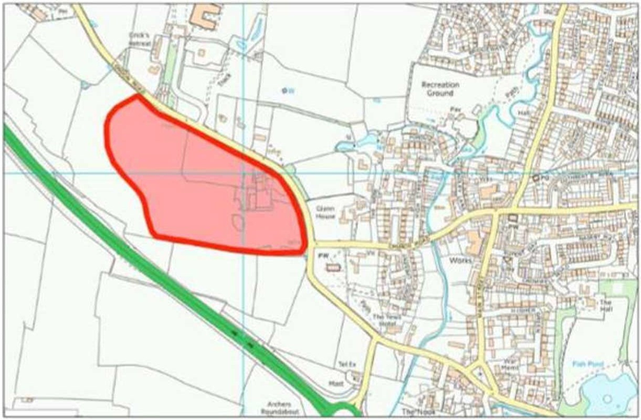  Policy GG4  31. The desire for new homes to reflect the Parish's Housing Need Survey is acknowledged by Bovis Homes, albeit any such evidence will need to be constantly up-dated to reflect the current need at a particular moment in time. There will be specific circumstances associated with the master planning of any large site which will have an effect on the precise siting and mix of homes (e.g . topography, proximity to trees, internal layout, etc.). These circumstances should be recognised and some degree of flexibility afforded where justified.  Policy GG5  32. Policy CS3 of the Harborough Core Strategy recognises that viability considerations are material as to whether or not affordable housing can be delivered as part of a development scheme. As drafted, Policy GG5 is inconsistent with the Core Strategy policy because it does not recognise viability considerations. Further, there is a need to 'future proof' Policy GG5 to recognise that the affordable housing provision may change in the emerging Local Plan.  33. For these reasons, and to avoid unnecessary duplication or potential inconsistency, the percentage of affordable housing should be deleted from this policy. Instead, Policy GG5 should focus upon the types of affordable housing which could be provided at Great Glen albeit recognising the need for an up-to-date evidence based to ensure the delivery of the homes that are required at a particular moment in time. The inclusion of starter homes as part of the affordable housing provision is welcomed by Bovis Homes.  34. Finally, via the allocation policies of some affordable housing providers there can be no certainty that priority could be given to local residents to occupy the homes. This ought to be a 'where practicable' policy requirement.  Policy GG6  35. The principle of a policy which links design to local architecture and vernacular is appropriate in a neighbourhood plan. However, there are elements of Policy GG6 which conflict with national and local policy and which have not been adequately justified.  36. Policy GG6(d) refers to garden sizes but there is no local evidence to explain succinctly the intention or rational for this standard.  37. Policy GG6(e) is potentially a misunderstanding but to require a minimum space of 22 metres between dwellings is somewhat excessive if the properties would have a flank wall to flank wall or a flank wall to rear wall relationship. Moreover, development control policies already exist within the Core Strategy to prevent unsatisfactory residential amenity issues arising. There is no local evidence to explain succinctly the intention or rational for this standard  38. Policy GG6(g) is not really a policy but is an aspirational statement.  39. Policy GG6(j) should be deleted. There are now national standards and Building Regulations dealing with these matters. In the absence of specific local evidence to explain succinctly the intention or rational of these sustainable construction and energy efficiency requirements, they should be deleted.  Policy GG7  40. This policy is inconsistent with paragraph 135 of the National Planning Policy Framework and requires amendment. The Framework only requires the effect of development on non­ designated heritage assets to be taken into account rather than development either conserving or enhancing the asset or its setting. Such non-designated heritage assets include ridge and furrow earthworks within fields at Great Glen.  41. It is also worthy of note by the Examiner that Figure 3: Historic Sites does not include the ridge and furrow as an area of historical significance. This Figure is correct in its judgement.  Policy GG12  42. Local Green Space is a restrictive and significant policy designation equivalent to Green Belt designation. Given that the National Planning Policy Framework is unambiguous in stating that a Local Green Space designation is not appropriate for most green areas or open space (paragraph 77), it is entirely reasonable to expect compelling evidence to demonstrate that any such allocation meets national policy requirements. Accordingly, it is essential that, when allocating Local Green Space, plan-makers can clearly demonstrate with robust and compelling evidence that the requirements for its allocation are met in full.  43. The Neighbourhood Plan refers to Appendix 5 as being an environmental inventory of all significant sites and features in the Parish. However, this is not the case. Appendix 5 is a plan of sites and areas of historic significance. The specific evidence about why the Local Green Spaces chosen for designation as part of this Neighbourhood Plan is limited to a few short sentences in the table at Appendix 7. Accordingly, as submitted for examination, there is not the robust and compelling evidence that paragraph 77 of the Framework requires.  44. The Planning Practice Guidance is clear that the designation of any Local Green Space will need to be consistent with local planning for sustainable development in the area. In particular, plans must identify sufficient land in suitable locations to meet identified development needs and the Local Green Space designation should not be used in a way that undermines this aim of plan making. As such, blanket designation of open countryside adjacent to settlements will not be appropriate.  45. The cumulative effect of the blanket Local Green Space designations to the south of Great Glen is the creation of a green buffer or 'local Green Belt' to preclude potential development to the south of the settlement. In short, Policy GG12 is concerned with seeking to apply a blanket Local Green Space designation to a very extensive tract of land to the south of Great Glen which is, in Bovis Homes' submission, contrary to paragraph 77 of the Framework and the Planning Practice Guidance.  46. Further, as has already been noted in the representation, the quantum of housing which might need to be accommodated at Great Glen as part of the emerging Harborough District Local Plan, has not been finally established. The cumulative extent of the blanket Local Green Space designations could undermine the aims of the emerging Local Plan by reducing the potential to accommodate development at Great Glen at the most sustainable locations. In short, the proposed Local Green Space would pre-determine decisions about the amount of developable land which may be available at Great Glen to accommodate current and emerging housing needs without clear evidence for doing so.  47. The commentary to Policy GG12 in the Statement of Basic Conditions refers to accessibility to green spaces as a fundamental pillar to health and wellbeing as a basis for the protection of locally important green spaces. However, this is not a reason for designating Local Green Spaces. For a Local Green Space to be designated, the green area in question must be demonstrably special to the local community and not just be accessible.  48. In any event, although there are rights of way crossing this Local Green Space, the land is not generally accessible to the public. The designation of a Local Green Space does not in itself confer any rights of public access over what exists at present, and there have been no discussions of the type envisaged in the Planning Practice Guidance, between the Parish Council and the landowner about how such a designation might result in greater public accessibility to the land. The Neighbourhood Plan is equally silent on this matter.  49. Policy GG12 includes the proposal to designate the grazing fields to the south west of +St Cuthbert's Church as Local Green Space. On its own, this proposal includes an extensive  tract of land - some 9.25 hectares. Appendix 7 is the only evidence included in the Submitted Version of the Neighbourhood Plan which explains the choice of this area but, as already noted, is lacking in detail; there is merely a short commentary with some form of grading which is unexplained. The inclusion of this Local Green Space appears principally to be based upon historic significance rather than beauty, recreational value, tranquillity or richness of wildlife. It is noted that there are comments about 'local' ecological interest without any context.  50. On behalf of Bevis Homes, Ecus Environmental Consultants has undertaken a Heritage Assessment of the land to the west of London Road, including the potential Local Green Space (Appendix A). Ecus recognises the presence of ridge and furrow to be of some local limited interest but such features around Great Glen have not been identified by Historic England as a priority for preservation. The reason for this omission is that there is a low proportion of medieval landscape associated with the settlement as a whole and the former open field system surrounding the settlement is no longer legible. Indeed, the commentary in Appendix 7 supports this proposition because of the reference to the current 18th century small field system rather than an open field system. The field system is not, therefore, special or of demonstrable historical importance.  51. Ecus acknowledges that the setting of the Parish Church of St Cuthbert is important. However, as a whole, the surrounding fields are not an intrinsic aspect of the setting of the Church integral to the understanding and appreciation of the building and site's significance. It is the southern part of the proposed Local Green Space (i.e. adjacent to Station Road) does enable some understanding of the historic and rural context of the Church and the village centre in terms of the approach the settlement from the A6.  52. In summary, the historical attributes of this proposed Local Green Space have been exaggerated and it is, at best, of only some local significance and fails to be demonstrably special. Similar comments apply to the landscape significance of the site, which is related to its alleged historic context. Accordingly, not all the fields which comprise the extensive tract of land to the south of Sycamore Farm possess the demonstrably special characteristics sought by paragraph 77 of the Framework and there is no compelling evidence to justify the designation of the whole area as Local Green Space. If there is a demonstrable and special purpose to this Local Green Space then, based upon Bovis Homes' assessment, it is only confined to the single field adjacent to Station Road.  53. Further, and as already noted, the designation of this extensive tract of land as Local Green Space could undermine the aims of the emerging Local Plan by reducing the potential to accommodate housing development at Great Glen at the most sustainable locations. The originally identified reserve site (now proposed by Bovis Homes for re-instatement) already demonstrates that land south of London Road is considered to be a suitable location for housing growth. The proposed Local Green Space would pre-determine decisions about whether this location is suitable and appropriate for residential purposes to meet housing need.  54. Whether all the land is needed for housing purposes is a matter to be established via the emerging Local Plan. Bovis Homes consider that, if needed, some of this land can be brought forward for residential purposes. However, there would also be a need for appropriate Green Infrastructure to be provided, and this could comprise the field adjacent to Station Road, without the need for its designation as Local Green Space.  55. As a final comment, it is unclear why there has been a need for both the Parish and District Councils to undertake their own assessments about whether land is worthy of designation as Local Greenspaces. It does not appear that these assessments have necessarily produced consistent results. Indeed, the District Council's Local Green Space Submission report (November 2014) and Green Space document (2016) do not include land south of London Road.  Policy GG14  56. Although ridge and furrow may well be of local significance it is not a designated heritage asset that justifies a blanket restraint on development. Indeed, the ridge and furrow has not been identified by Historic England as a priority for preservation. Instead, it would be appropriate for the significance of any ridge and furrow to be assessed in a Heritage Assessment accompanying a planning application. Such an approach is consistent with paragraph 135 of the Framework. For these reasons, this policy should be deleted or at least grounded properly into the requirements of the Framework's balancing exercise.  57. It is also worthy of note by the Examiner that Figure 3: Historic Sites does not include the ridge and furrow as an area of historical significance which is a correct approach. The importance or not of the ridge and furrow in respect of the reserve site sought by Bovis Homes are considered in detail at Appendix A of these representations. Based upon a site­ specific assessment which concluded that the effect of housing development at Sycamores Farm would have less than a substantial impact on this non-designated heritage asset.  Policy GG16  58. It would be helpful to know what represents a site of significant biodiversity value to which Policy GG16(a) applies. There is not a robust evidence base. Further, Policy GG16(b) should be clearly directed at biodiversity enhancements associated with a particular application site. A clear explanation is required as to the types of development proposals under Policy GG16(c) that would be considered to adversely affect the wildlife corridors.  Policy GG17  59. It is unclear what is meant by the term 'good arboricultural, ecological and amenity value' to which Policy GG17 (first paragraph) will apply. The policy is unclear and ambiguous, and it is uncertain whether a decision maker could apply the policy consistently and with confidence when determining an application - a requirement of the Planning Practice Guidance for the drafting of neighbourhood plans.  Policy GG19  60. There is a need for clarification that, in the absence of specific justification and viability considerations, Policy GG19 does not seek to impose additional burdens on developers, particularly of housing where national standards and Building Regulations apply. If there is any suggestion of the application of local standards in excess of national standards, including those in the Building Regulations, then there is no robust evidence base to explain (or indeed justify) succinctly the intention and rational for this policy.  Policy GG20  61. An explanation is required for how the parking standard for 2 spaces within the curtilage of each dwelling has been established. It is unclear how this standard could apply to, for example, 1-bedroom apartments where 2 car parking spaces would appear excessive and the 'dwelling' does not possess a curtilage.  62. Further, this policy effectively discounts the use of parking courts which are a feature of modern housing developments, whether houses or apartments. In the absence of any robust evidence and to address the poor drafting, Policy GG20 should include greater flexibility for parking provision, especially for larger schemes.  Policy GG23  63. The wording of Policy GG23 is inconsistent with paragraph 32 of the National Planning Policy Framework, which refers to residual cumulative traffic impacts having to be 'severe' rather than being 'unacceptable' in order to form a reason that might potentially justify refusal of a planning application.  Policy GG24  64. A policy seeking developer contributions must ultimately ensure that the statutory tests of the Community Infrastructure Levy Regulations are not breached and that development remains viable. Indeed, the Planning Practice Guidance is clear that the impact that infrastructure requirements may have on the viability of proposals in a neighbourhood plan and, therefore, its delivery, are important considerations. Policy GG24 should recognise that viability is an important consideration if contributions are sought via a Planning Obligation for the projects specified.  65. It is, however, interesting to note that financial contributions would be spent on affordable housing as set out in Policy GG5 which refers to payments in lieu. Such payments would be secure by a Planning Obligation and paid to the District, rather than Parish, Council. In the alternative, is Policy GG24 suggesting that contributions collected via the Community Infrastructure Levy would be used to acquire affordable housing?  New Figure and Change to Figure 4  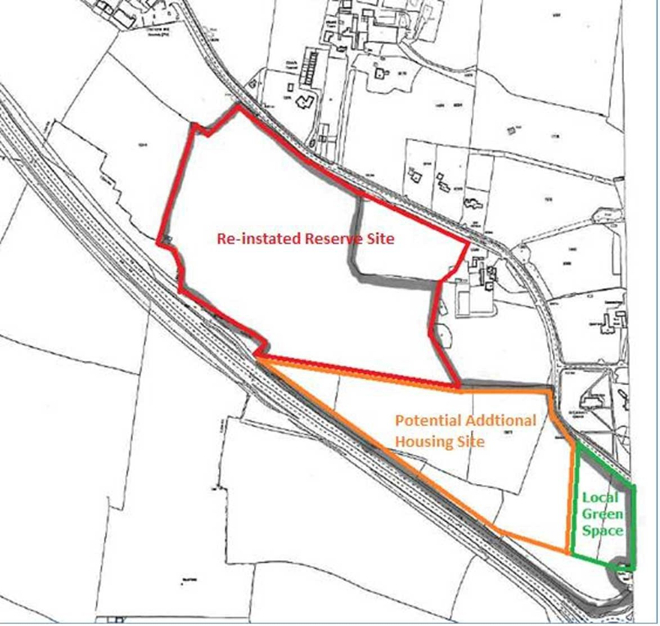  For illustrative purposes  Appendix A- Heritage Assessment submitted separately and provided to Examiner  Appendix B  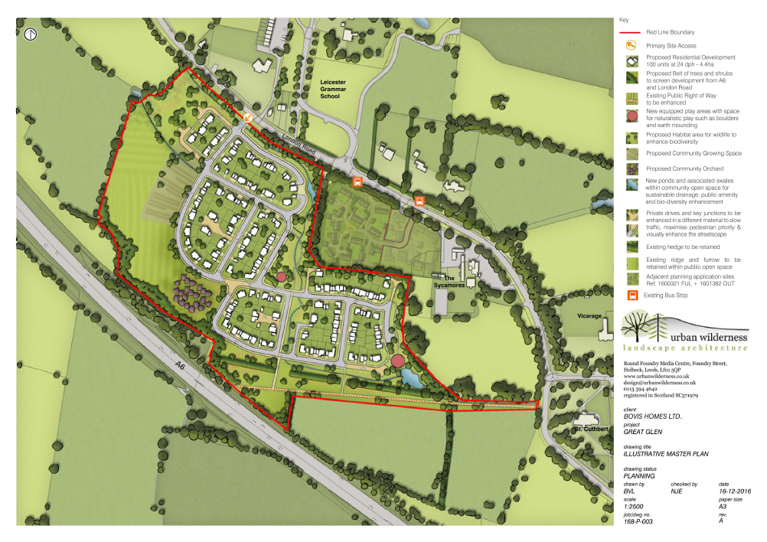
Burton Overy Parish Council |  | The plan does not make any reference to zones of separation with neighbouring parishes.  With the current rate of development in Great Glen and in particular the current planning  applications along Oaks Road by Miller Homes, Burton Overy Parish Council would  welcome a zone of separation between the parishes along the ridgeline leading from Oaks  Road and bounding the two parishes. The countryside around Burton Overy which borders  the Great Glen Parish was in an area designated as Particularly Attractive Countryside  within policy EV/4 of the Harborough District local Plan adopted in 2001. That policy and  designation have now been replaced by Policy CS17 of the Harborough Core Strategy.  The principles to protect this countryside remain the same. The importance of the  countryside around Burton Overy is recognised in Policy CS17 as being part of the  landscape area known as High Leicestershire. Burton Overy is a conservation village. Part  of its importance lies in the landscape setting in which it sits. Oaks Road leading from  Great Glen towards Burton Overy is a hill rising steeply to form part of a ridgeline which  is visible from and forms part of the landscape setting of Burton Overy. Development  along this ridge line would be seriously detrimental to the landscape setting of Burton  Overy and the surrounding attractive countryside. Provision should be made within the  plan for a zone of separation as described.
Leicestershire County council |  | Great Glen Neighbourhood Plan Comments Requested – 8th March 2017  Leicestershire County Council is supportive of the Neighbourhood plan process.  Highways  General Comments  The County Council recognises that residents may have concerns about traffic conditions in their local area, which they feel may be exacerbated by increased traffic due to population, economic and development growth.  Like very many local authorities, the County Council’s budgets are under severe pressure. It must therefore prioritise where it focuses its reducing resources and increasingly limited funds. In practice, this means that the County Highway Authority (CHA), in general, prioritises its resources on measures that deliver the greatest benefit to Leicestershire’s residents, businesses and road users in terms of road safety, network management and maintenance. Given this, it is likely that highway measures associated with any new development would need to be fully funded from third party funding, such as via Section 278 or 106 (S106) developer contributions. I should emphasise that the CHA is generally no longer in a position to accept any financial risk relating to/make good any possible shortfall in developer funding.  To be eligible for S106 contributions proposals must fulfil various legal criteria. Measures must also directly mitigate the impact of the development e.g. they should ensure that the development does not make the existing highway conditions any worse if considered to have a severe residual impact. They cannot unfortunately be sought to address existing problems.  Where potential S106 measures would require future maintenance, which would be paid for from the County Council’s funds, the measures would also need to be assessed against the County Council’s other priorities and as such may not be maintained by the County Council or will require maintenance funding to be provide as a commuted sum.  With regard to public transport, securing S106 contributions for public transport services will normally focus on larger developments, where there is a more realistic prospect of services being commercially viable once the contributions have stopped  i.e. they would be able to operate without being supported from public funding.  The current financial climate means that the CHA has extremely limited funding available to undertake minor highway improvements. Where there may be the prospect of third party funding to deliver a scheme, the County Council will still normally expect the scheme to comply with prevailing relevant national and local policies and guidance, both in terms of its justification and its design; the Council will also expect future maintenance costs to be covered by the third party funding. Where any measures are proposed that would affect speed limits, on-street parking restrictions or other Traffic Regulation Orders (be that to address existing problems or in connection with a development proposal), their implementation would be subject to available resources, the availability of full funding and the satisfactory completion of all necessary Statutory Procedures.  Specific Comments  Policy GG23: Traffic Management: Probably sits OK alongside the National Planning Policy Framework and any inference that the County Council might be committed to fund things as a result of these policies should be adequately dealt with via our standard NP response.  Community Action 34: Any inference that the County Council might be committed to fund things as a result of this Action should be adequately dealt with via our standard NP response. Likewise any need for TROs, etc.  Flood Risk Management  The County Council are fully aware of flooding that has occurred within Leicestershire and its impact on residential properties resulting in concerns relating to new developments. LCC in our role as the Lead Local Flood Authority (LLFA) undertake investigations into flooding, review consent applications to undertake works on ordinary watercourses and carry out enforcement where lack of maintenance or unconsented works has resulted in a flood risk. In April 2015 the LLFA also became a statutory consultee on major planning applications in relation to surface water drainage and have a duty to review planning applications to ensure that the onsite drainage systems are designed in accordance with current legislation and guidance. The LLFA also ensures that flood risk to the site is accounted for when designing a drainage solution.  The LLFA is not able to:  • Prevent development where development sites are at low risk of flooding or can demonstrate appropriate flood risk mitigation.  • Use existing flood risk to adjacent land to prevent development.  • Require development to resolve existing flood risk.  When considering flood risk within the development of a neighbourhood plan, the LLFA would recommend consideration of the following points:  • Locating development outside of river (fluvial) flood risk (Flood Map for Planning  (Rivers and Sea)).  • Locating development outside of surface water (pluvial) flood risk (Risk of Flooding from Surface Water map).  • Locating development outside of any groundwater flood risk by considering any local knowledge of groundwater flooding.  • How potential SuDS features may be incorporated into the development to  enhance the local amenity, water quality and biodiversity of the site as well as manage surface water runoff.  • Watercourses and land drainage should be protected within new developments to prevent an increase in flood risk.  All development will be required to restrict the discharge and retain surface water on site in line with current government policies. This should be undertaken through the use of Sustainable Drainage Systems (SuDS). Appropriate space allocation for SuDS features should be included within development sites when considering the housing density to ensure that the potential site will not limit the ability for good SuDS design to be carried out. Consideration should also be given to blue green corridors and how they could be used to improve the bio-diversity and amenity of new developments, including benefits to surrounding areas.  Often ordinary watercourses and land drainage features (including streams, culverts and ditches) form part of development sites. The LLFA recommend that existing watercourses and land drainage (including watercourses that form the site boundary) are retained as open features along their original flow path, and are retained in public open space to ensure that access for maintenance can be achieved. This should also be considered when looking at housing densities within the plan to ensure that these features can be retained.  LCC in our role as LLFA will object to anything contrary to LCC policies.  For further information it is suggested reference is made to the National Planning Policy Framework (March 2012), Sustainable drainage systems: Written statement - HCWS161 (December 2014) and the Planning Practice Guidance webpage.  Planning  Developer Contributions  If there is no specific policy on Section 106 developer contributions/planning obligations within the draft Neighbourhood Plan, it would be prudent to consider the inclusion of a developer contributions/planning obligations policy, along similar lines to those shown for example in the Draft North Kilworth NP and the draft Great Glen NP albeit adapted to the circumstances of your community. This would in general be consistent with the relevant District Council’s local plan or its policy on planning obligations in order to mitigate the impacts of new development and enable appropriate local infrastructure and service provision in accordance with the relevant legislation and regulations, where applicable.  www.northkilworth.com/wp-content/uploads/2016/01/nk-draft-low-resolution-1.pdf www.greatglen.leicestershireparishcouncils.org/uploads/175670305aeaf4865082307 4.pdf  Mineral & Waste Planning  The County Council is the Minerals and Waste Planning Authority; this means the council prepares the planning policy for minerals and waste development and also makes decisions on mineral and waste development.  Although neighbourhood plans cannot include policies that cover minerals and waste development, it may be the case that your neighbourhood contains an existing or planned minerals or waste site. The County Council can provide information on these operations or any future development planned for your neighbourhood.  You should also be aware of Mineral Consultation Areas, contained within the adopted Minerals Local Plan and Mineral and Waste Safeguarding proposed in the new Leicestershire Minerals and Waste Plan. These proposed safeguarding areas and existing Mineral Consultation Areas are there to ensure that non-waste and non- minerals development takes place in a way that does not negatively affect mineral resources or waste operations. The County Council can provide guidance on this if your neighbourhood plan is allocating development in these areas or if any proposed neighbourhood plan policies may impact on minerals and waste provision.  Education  Whereby housing allocations or preferred housing developments form part of a Neighbourhood Plan the Local Authority will look to the availability of school places within a two mile (primary) and three mile (secondary) distance from the development. If there are not sufficient places then a claim for Section 106 funding will be requested to provide those places.  It is recognised that it may not always be possible or appropriate to extend a local school to meet the needs of a development, or the size of a development would yield a new school. However, in the changing educational landscape, the Council retains a statutory duty to ensure that sufficient places are available in good schools within its area, for every child of school age whose parents wish them to have one.  Property  Strategic Property Services  No comment at this time.  Adult Social Care  Suggest reference is made to recognising a significant growth in the older population and look for developments to include bungalows etc of differing tenures. This would be in line with the draft Adult Social Care Accommodation Strategy for older people which promotes that people should plan ahead for their later life, including considering downsizing, but recognising that people’s choices are often limited by the lack of suitable local options.  Environment  No comment at this time.  Communities  Consideration of community facilities in the draft Plan would be welcomed. We would suggest where possible to include a review of community facilities, groups and allotments and their importance with your community. Consideration could also be given to policies that seek to protect and retain these existing facilities more generally, support the independent development of new facilities and relate to the protection of Assets of Community Value and provide support for any existing or future designations.  The identification of potential community projects that could be progressed would be a positive initiative.  Economic Development  We welcome the level of economic development criterion that has been covered in the Plan. It clearly illustrates how the plan strategically knits into the local economy of Great Glen, provides a general stimulus to ensure local businesses continue to prosper and that sustainable employment exists for local residents.  Superfast Broadband  High speed broadband is critical for businesses and for access to services, many of which are now online by default. Having a superfast broadband connection is no longer merely desirable, but is an essential requirement in ordinary daily life.  All new developments (including community facilities) should have access to superfast broadband (of at least 30Mbps) Developers should take active steps to incorporate superfast broadband at the pre-planning phase and should engage with telecoms providers to ensure superfast broadband is available as soon as build on the development is complete. Developers are only responsible for putting in place broadband infrastructure for developments of 30+ houses. Consideration for developers to make provision in all new houses regardless of the size of development should be considered.
Homes and Communities Agency |  | Representations on behalf of the Homes and Communities Agency (HCA) to the  Consultation on the Great Glen Neighbourhood Plan relating to programme, policies on housing and strategy and land controlled by HCA at Stretton Hall Farm  WYG is instructed by the Homes and Communities Agency (HCA) to make representations in connection with the Regulation 16 consultation period of the Great Glen Neighbourhood Plan which has recently submitted to Harborough District Council.  The HCA has a number of concerns about procedural matters which translate into objections to the key policies proposed in the Neighbourhood Plan in the context of the review process of the Harborough Local Plan. The HCA consider that proceeding with the Neighbourhood Plan on the timetable envisaged by the Parish Council is not in accordance with national policy advice on plan preparation. It could also prejudice the bringing forward of land which may be required for housing (and employment) purposes in the context of the preparation of the Harborough Local Plan at Stretton Hall Farm, between Stretton Hall and Oadby (see plan attached).  Procedural Matters  The HCA is supportive of the principle of local people preparing Neighbourhood Plans that allows a positive involvement in the planning process which may determine the future shape of communities. However, the preparation of Neighbourhood Plans can only be effectively carried out in the context of an up to date Development Plan document. It should not prejudge key decisions which need to be made through the Development Plan process about such matters as the scale and disposition of housing (and employment) development that is required to be made in a local authority area before a Neighbourhood Plan is prepared.  In this regard the NPPF at paragraph 184 reads as follows:  "The ambition of the neighbourhood should be aligned with the strategic needs and priorities of the wider local area. Neighbourhood Plans must be in general conformity of the strategic policies of the Local Plan. To facilitate this Local Planning Authorities should set out clearly their strategic policies for the area and ensure that an up to date Local Plan is in place as quickly as possible. Neighbourhood Plans should reflect these policies and neighbourhoods should plan positively to support them. Neighbourhood plans and orders should not promote less development than set out in the Local Plan or undermine its strategic policies." (our emphasis)  The Housing White Paper 'Fixing Our Broken Housing Market' sets out that one of the Government's objectives is to strengthen neighbourhood planning and design. Para 1.43 of the White Paper says that to support this process inter alia, the Government proposes to amend planning policies so that neighbourhood planning groups can obtain a housing requirement figure from their Local Planning Authority to help avoid delays to get a Neighbourhood Plan in place. So, what existing National Policy in the NPPF and the intentions of the White Paper make clear is that a Neighbourhood Plan should not be promoted in a way that is premature to decisions being made about overall housing requirements, normally in an up to date Local Plan. The finalisation of a Neighbourhood Plan should only take place once up to date housing requirements for a Local Authority area are known and strategic decisions have been made about the scale and disposition of the housing and other requirements.  In reality, therefore, what is necessary for this Neighbourhood Plan to proceed on a sensible basis is for Harborough District Council to complete the process for the adoption of an up to date Local Plan. The District Council's timetable for that is set out in its report to executive meeting of October 2016. This suggests that the submission of a Local Plan for public examination will take place during November 2017; that an Examination Hearing takes place in February 2018; an Inspector's Report received in July 2018 and the adoption of the Plan in September 2018.  The preparation of the Local Plan (see below) will need to take account of a number of different factors  in arriving at an objectively assessed housing need for the district and then make decisions as to how that requirement should be delivered. It is only at the point when the plan is submitted for examination will Great Glen Parish Council (and its consultees) have a realistic idea as to what scale of housing is being proposed within its area. And even then, the Examination before an Inspector will need to confirm this. Thus as it stands the approach taken in Policy GG2 of the Neighbourhood Plan - which suggests 'until such time as there is an increasing housing need across Harborough District or unless there is a failure to deliver the existing commitment, further housing development in the Parish will be restricted to windfall development in line with Policy GG3' is unsound.  That policy can at best be regarded as 'interim' until appropriate housing needs and requirements have been determined in the Local Plan process. This causes further difficulty if the situation arises (which may already exist) where there is not a Five Year Housing Land Supply in Harborough District or indeed no objectively assessed housing need figure has been established.  Recent case law - the Richborough case being one example, confirms that where a Council (in this case Harborough District) cannot demonstrate a Five Year Housing Land Supply then policies for housing should be considered out of date. Such policies would include GG3 (as proposed) in the Neighbourhood Plan. Unless and until housing land requirements and supply have been clarified through the normal processes of the Local Plan, the Neighbourhood Plan policies on the principle of allowing housing development (or not in this case) are therefore immediately out of date and meaningless.  Housing Requirements in Harborough District  As the report to committee of October 2016 explains, the derivation of housing requirements for the future of Harborough District is a complex matter. The Council need to calculate housing requirements emanating from its own borough using an appropriate methodology established through SHMA processes in other parts of the country - involving considerations of population projections, household formation rates, housing market factors and economic considerations -there is though the added complication of the recent conclusions of the Leicester and Leicestershire Housing Market Area Development Need Assessment - HEDNA. This document was published in February 2016 and recently considered at the examination into the North West Leicestershire Local Plan.  The conclusions of the document were that in addition to specific housing requirements in each of the districts within the Leicester and Leicestershire Housing Market Area (including Harborough) there was a need for a proportion of the requirements generated within Leicester City's area to be redistributed amongst other districts within the housing market area.  In its letter dated 13 February 2017 to the Chief Planning Officer of North West Leicestershire District Council, Leicester City Council made the observation that on the basis of the OAN figures within the HEDNA there was already a shortfall of some 2,917 dwellings arising in the City since 2011. They further added 'should rates of completions in the City remain at around 1100 per year, around 22,000 dwellings could be built between 2011 and 2031. This will leave a shortfall of around 11,840 against the HEDNA OAN to 2031.  Leicester City Council confirmed that they were in the process of doing an updated SHLAA. Early work on this indicates that there was scope to make up some of this shortfall, however, they still concluded that a shortfall of 8,834 dwellings would be difficult to provide in the City by 2031.  Therefore, a decision needs to be taken through joint collaboration between the authorities in the housing market area as to how much of the significant shortfall that could not be provided in Leicester City area should be made up in the other districts. Certain smaller authorities such as Oadby & Wigston and Melton may find it difficult to make any meaningful contribution towards this shortfall, however districts such as Harborough and indeed North West Leicestershire are likely to be required to make up a significant proportion of the shortfall.  It is also important to emphasise that a number of parties at the examination in the North West Leicestershire Local Plan had a series of concerns about the assumptions that led to the derivation of the HEDNA OAN figures. This letter is not the place to rehearse those arguments - however, it is important (as Harborough District Council will know given they attended the North West Leicestershire Examination) that the Inspector was presented with a number of technical papers that advised him that assumptions within the HEDNA OAN Report were incorrect and which resulted in the housing requirements being severely under-estimated. This was before the issue of how to redistribute any shortfall from Leicester City could be sensibly discussed. The OAN for Harborough in the HEDNA 2011- 2031 is 532 dwellings per annum or 10,600 dwellings. Further requirements for employment land are also made.  The implications of this situation relevant to the Neighbourhood Plan are therefore as follows:  1. There is no up to date Local Plan that has an objectively assessed housing need requirement within it. Until there is, all housing policies as per the Richborough case are effectively out of date;  2. No decisions have been taken in the context of deriving housing requirements for Harborough District as to how much of the overspill from Leicester City the district should receive;  3. The preparation of a Neighbourhood Plan that seeks to restrict any further housing sites until such matters are clarified is not in accordance with the policy in the NPPF. Neighbourhood Plans should be produced on the understanding of what housing requirements in the future are going to be.  In normal circumstances the HCA would examine each policy in the Neighbourhood Plan for the purposes of these representations. However, given the procedural issues, the main policies which relate to the development strategy are contrary to the NPPF - particularly Policies GGl, GG2, GG8. The other housing policies relating to windfall sites and housing mix are not specifically objected to although they are in themselves considered premature. Policy GGS on affordable housing is again premature until the outcome of the Harborough District Local Plan is known which may set a different percentage target for affordable housing than the 40% in Policy GGS. Other policies that relate to design, heritage, community facilities, local green spaces, biodiversity etc are in themselves generally acceptable as far as the objectives are in accordance with the NPPF and not likely the emerging Local Plan. Whilst the key decisions on housing (and employment) requirements remain outstanding, proceeding with the Neighbourhood Plan would be contrary to Government policy.  Site Specific Considerations  The intention of the HCA is to participate in the Harborough Local Plan adoption process and to make representations that relate to the calculation of the OAN for the district; the overspill from Leicester arising from the HEDNA and then to consider (as the District Council will) an appropriate and sustainable means of allocating suitable sites, on which to provide for increased housing (and other) requirements in the next 20 years or so. In parallel with the Local Plan process HCA will review the housing land situation in Harborough District and work with the Council to ensure that the housing objectives of national policy can be achieved.  The land which is controlled by the HCA at Stretton Hall Farm would - in circumstances where there are significant unmet housing requirements in Harborough District Council area be a suitable candidate for a sustainable housing based development. Strategically, the area is on the south eastern periphery of the City of Leicester in an area which will have potential for growth, particularly given the need to accommodate overspill from the city. Baseline assessment work has been carried out into the technical aspects of the capacity of the site and its constraints including highways and transportation. There are opportunities to improve public transport links should a significant development take place.  The area is well served by facilities including eight schools, four medical centres and two post offices  (in Great Glen and nearby Oadby). The area between Oadby and Great Glen has the capability of being considered for housing, employment and open space as part of a comprehensive masterplan that would maintain the separation of Great Glen from Oadby but provide an appropriate and sustainable housing development. High level work carried out has established that there are no insuperable ecological constraints to development. Similarly the majority of the site is in Flood Zone 1 so with the appropriate safeguards, there will be no issues relating to flood risk so the site could be developed in accordance with the Government and Environment Agency's objectives to provide as much housing as possible in areas of low flood risk.  The area between Great Glen including Stretton Hall Farm up to the eastern edge of Oadby would be a candidate for significant development on the basis that substantial housing requirements arise in Harborough District Council from that policy consideration process. Such a development could maintain the setting of Great Glen as a settlement and would not result in it being merged with either Oadby or Stretton Hall.  Given the potential that the land holds on the outskirts of Leicester in the background of the potentially serious housing land shortfall that exists it would be wrong for the Neighbourhood Plan to progress with any Policy to restrict development until key strategic decisions have been made. This will involve both Harborough District Council through its Local Plan and Oadby & Wigston and other Councils to determine the issue of overspill for Leicester.  In summary, whilst the HCA welcomes the involvement of Great Glen Parish Council in the planning process, it considers that the progression of the Neighbourhood Plan should (as is required in National Policy) be done so on the basis of knowing what the housing requirements for the area are likely to be in the future emanating from a combination of the Harborough District Local Plan preparation and the outcome of the HEDNA Report.  The proposed designations as shown on the various maps within the Neighbourhood Plan e.g. Map Proposed Local Greenspace inventory of features environment significance etc provide useful information that could well form part of the evidence base for the future planning of the area as part of either the district wide Local Plan or a future version of the Neighbourhood Plan. However, for the time being, they suffer from the same problem with prematurity pending the proper definition of housing requirements.  For these reasons, we would urge the Harborough District Council to request that Great Glen Parish Council does not progress the Neighbourhood Plan until the normal processes has determined the strategic housing requirements for the area and specifically whether a housing development in the area of Stretton Hall Farm is going to be required to meet objectively assessed housing needs and national policy priorities to significantly boost housing supply.  Figure below  Land at Stretton Hall Farm, Great Glen, Leicestershire  Site Location Plan  DATE: 19.04.2017 SCALE: 1: 15 000 @ A4  1. DO NOT SCALE FROM THIS DRAWING  2. THIS DRAWING IS TO BE CHECKED WITH ALL OTHER RELEVANT DRAWINGS.  3. ANY DISCREPANCIES CHECK WITH WYG, IF IN DOUBT ASK.  4 . DRAWING TO BE USED FOR PURPOSES OF THE ISSUE AND NOTED ON PLAN  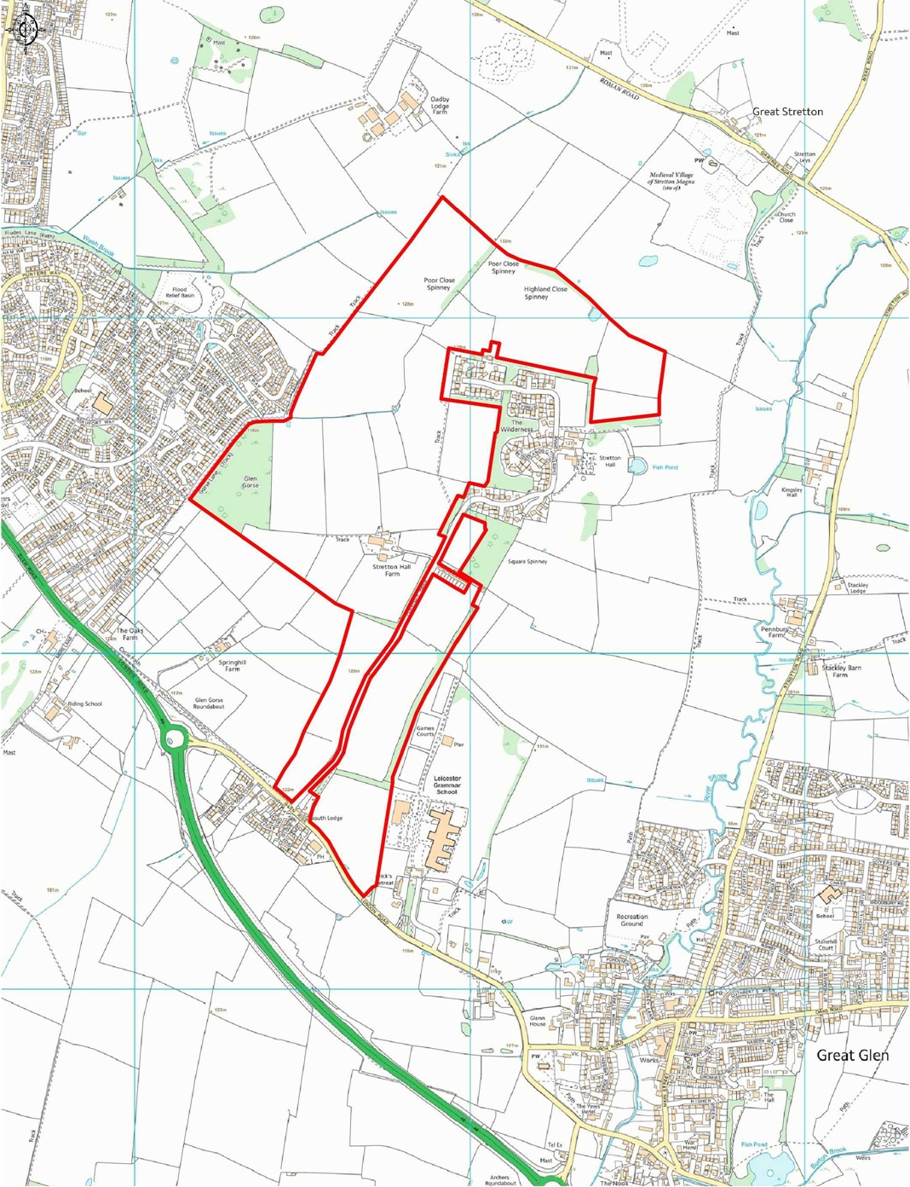
Historic England |  | Great Glen Neighbourhood Development Plan  Thank you for consulting us on the Great Glen Neighbourhood Development Plan  (re-submission document).  Further to our letter of 4 October 2016 , we note the omission of the housing  allocations and offer no further comments.  RE: GREAT GLEN NEIGHBOURHOOD PLAN 2011- 2031  Thank you for consulting Historic England on the Great Glen Neighbourhood Plan.  We previously commented on the Plan in a letter dated 4 October 2016, which we  attach. We have no further comments to make on the plan at this time, though we note  and welcome the omission of the allocation on land south of London Road. If there are  any specific issues that you feel would merit our closer involvement please advise us  of this.  4 October 2016 letter resubmitted  Neighbourhood Plan for Great Glen,  Thank you for consulting Historic England about your Neighbourhood Plan.  Your Neighbourhood Plan includes a number of designated heritage assets including the Church of St Cuthbert and Stretton Hall. It will be important that the strategy you put together for this area safeguards those elements which contribute to the importance of those historic assets. This will assist in ensuring they are enjoyed by future generations of the area and make sure it is in line with national planning policy.  We do not have any detailed comments to make on the plan at this stage, but we refer you to our advice letter sent in response to the SEA Screening consultation, which I have attached. We draw your particular attention to our advice concerning the reserve site allocation.  The historic buildings conservation officer at Harborough District Council is the best placed person to assist you in the development of your Neighbourhood Plan. They can help you to consider how the strategy might address the area’s heritage assets.  We would also recommend that you speak to the staff at Leicestershire County Council, who look after the Historic Environment Record and give advice on archaeological matters. They should be able to provide details of not only any designated heritage assets but also locally-important buildings, archaeological remains and landscapes. Some Historic Environment Records may also be available on-line via the Heritage Gateway (www.heritagegateway.org.uk  <http://www.heritagegateway.org.uk>). It may also be useful to involve local voluntary groups such as the local Civic Society, local history groups, building preservation trusts, etc. in the production of your Neighbourhood Plan.  Your local authority might also be able to provide you with general support in the production of your Neighbourhood Plan. National Planning Practice Guidance is clear that where it is relevant, Neighbourhood Plans need to include enough information about local heritage to guide planning decisions and to put broader strategic heritage policies from the local authority’s local plan into action at a neighbourhood scale. If appropriate this should include enough information about local non-designated heritage assets including sites of archaeological interest to guide decisions.  Further information and guidance on how heritage can best be incorporated into Neighbourhood Plans has been produced by Historic England. This signposts a number of other documents which your community might find useful in helping to identify what it is about your area which makes it distinctive and how you might go about ensuring that the character of the area is retained. These can be found at:-  <http://www.historicengland.org.uk/advice/planning/plan-making/improve-your- neighbourhood/>  If you have any queries about this matter or would like to discuss anything further, please do not hesitate to contact me.
Oadby and Wigston Borough Council  Coucnil |  | It is apparent that the reserve site for Sycamore Farm Extension (Site B) for 100 additional units  that was included in the previous draft of the Plan has been removed in this Submission Version of  the Great Glen Neighbourhood Plan.  Oadby and Wigston Borough Council (OWBC) would like to reserve the right to provide further  comments in relation to the potential impact of major development proposals (specifically those  that could increase vehicle movements along the A6) should such be incorporated into the Plan at  a later date.  It is also apparent that Site 19 (Glen Gorse) in Figure 5 has been designated and part of the site is  within the Borough of Oadby and Wigston. It is therefore requested that the Plan should not  designate any land within the Borough of Oadby and Wigston and therefore, the boundary for Site  19 should be contained wholly within the administrative boundary of the Great Glen  Neighbourhood Plan.  Please see annotated map below of Figure 5, Site 19, which illustrates this point.  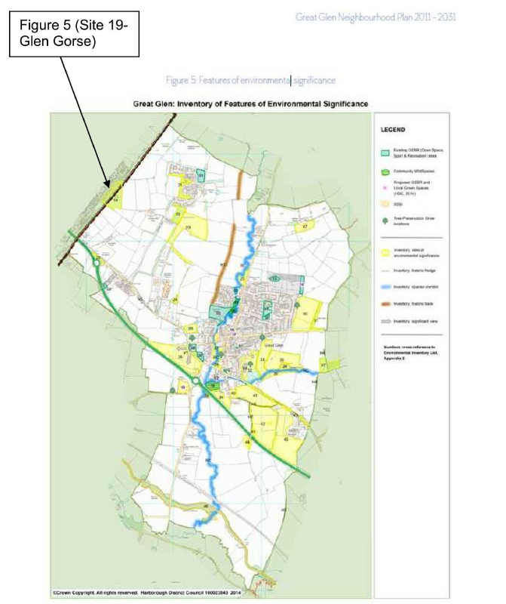
Anglian Water |  | Thank you for the notification relating to the Great Glen Neighbourhood Plan. The following response is submitted on behalf of Anglian Water.  It would appear that Great Glen Parish is located outside of our area of responsibility. Therefore we have no comments relating to the Neighbourhood Plan.  I would be grateful if you could confirm that you have received this response.
Resident | Para 3  Page 26 Policy GG5: Affordable Housing  Page 56: Protection of non-statutory important  Page 63:Para 1 | Add sentence after '...road network' as follows: In particular, Oaks Road because of necessary residential parking, is for much of its length single carriageway meaning significant routine delays for users of this important thoroughfare in the village. It can sustain no further demand.  Insert after 'Development Proposals' the following '...to be compliant with Policy GG3...'  Add: Ridge and furrow bordering Oaks Road to the north.  Add: The Library is now a Community Library operated by volunteers.
Natural England |  | Thank you for consulting Natural England on the Great Glen Neighbourhood Development Plan which has now been submitted to Harborough District Council for Examination.  Natural England is a non-departmental public body. Our statutory purpose is to ensure that the natural environment is conserved, enhanced, and managed for the benefit of present and future generations, thereby contributing to sustainable development.  We have already commented on the Great Glen Draft Neighbourhood Plan in response to a consultation from Great Glen Parish Council. Natural England does not consider that the plan will have any likely significant effects on any internationally or nationally designated nature conservation sites and welcomes the broad thrust of the plan and some of the specific policy proposals. It is consistent with the National Planning Policy Framework (NPPF) and set within the context of Harborough District Council’s existing Core Strategy and emerging Local Plan. We particularly welcome the section on the natural and historical environment and the policies contained therein which aim to protect and enhance green space and support biodiversity.
Sport England |  | Thank you for consulting Sport England on the above neighbourhood plan.  Government planning policy, within the National Planning Policy Framework (NPPF), identifies how the planning system can play an important role in facilitating social interaction and creating healthy, inclusive communities. Encouraging communities to become more physically active through walking, cycling, informal recreation and formal sport plays an important part in this process. Providing enough sports facilities of the right quality and type in the right places is vital to achieving this aim. This means that positive planning for sport, protection from the unnecessary loss of sports facilities, along with an integrated approach to providing new housing and employment land with community facilities is important.  It is essential therefore that the neighbourhood plan reflects and complies with national planning policy for sport as set out in the NPPF with particular reference to Pars 73 and 74. It is also important to be aware of Sport England’s statutory consultee role in protecting playing fields and the presumption against the loss of playing field land. Sport England’s playing fields policy is set out in our Planning Policy Statement: ‘A Sporting Future for the Playing Fields of England’.  http://www.sportengland.org/playingfieldspolicy  Sport England provides guidance on developing planning policy for sport and further information can be found via the link below. Vital to the development and implementation of planning policy is the evidence base on which it is founded.  http://www.sportengland.org/facilities-planning/planning-for-sport/forward-planning/  Sport England works with local authorities to ensure their Local Plan is underpinned by robust and up to date evidence. In line with Par 74 of the NPPF, this takes the form of assessments of need and strategies for indoor and outdoor sports facilities. A neighbourhood planning body should look to see if the relevant local authority has prepared a playing pitch strategy or other indoor/outdoor sports facility strategy. If it has then this could provide useful evidence for the neighbourhood plan and save the neighbourhood planning body time and resources gathering their own evidence. It is important that a neighbourhood plan reflects the recommendations and actions set out in any such strategies, including those which may specifically relate to the neighbourhood area, and that any local investment opportunities, such as the Community Infrastructure Levy, are utilised to support their delivery.  Where such evidence does not already exist then relevant planning policies in a neighbourhood plan should be based on a proportionate assessment of the need for sporting provision in its area. Developed in consultation with the local sporting and wider community any assessment should be used to provide key recommendations and deliverable actions. These should set out what provision is required to ensure the current and future needs of the community for sport can be met and, in turn, be able to support the development and implementation of planning policies. Sport England’s guidance on assessing needs may help with such work.  http://www.sportengland.org/planningtoolsandguidance  If new or improved sports facilities are proposed Sport England recommend you ensure they are fit for purpose and designed in accordance with our design guidance notes.  http://www.sportengland.org/facilities-planning/tools-guidance/design-and-cost-guidance/  Any new housing developments will generate additional demand for sport. If existing sports facilities do not have the capacity to absorb the additional demand, then planning policies should look to ensure that new sports facilities, or improvements to existing sports facilities, are secured and delivered. Proposed actions to meet the demand should accord with any approved local plan or neighbourhood plan policy for social infrastructure, along with priorities resulting from any assessment of need, or set out in any playing pitch or other indoor and/or outdoor sports facility strategy that the local authority has in place.  In line with the Government’s NPPF (including Section 8) and its Planning Practice Guidance (Health and wellbeing section), links below, consideration should also be given to how any new development, especially for new housing, will provide opportunities for people to lead healthy lifestyles and create healthy communities. Sport England’s Active Design guidance can be used to help with this when developing planning policies and developing or assessing individual proposals.  Active Design, which includes a model planning policy, provides ten principles to help ensure the design and layout of development encourages and promotes participation in sport and physical activity. The guidance, and its accompanying checklist, could also be used at the evidence gathering stage of developing a neighbourhood plan to help undertake an assessment of how the design and layout of the area currently enables people to lead active lifestyles and what could be improved.  NPPF Section 8: https://www.gov.uk/guidance/national-planning-policy-framework/8-promoting-healthy-communities  PPG Health and wellbeing section: https://www.gov.uk/guidance/health-and-wellbeing  Sport England’s Active Design Guidance: https://www.sportengland.org/activedesign  (Please note: this response relates to Sport England’s planning function only. It is not associated with our funding role or any grant application/award that may relate to the site.)

