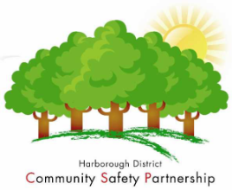
Contacts for reporting crime and disorder in your area.
999 – If there is a direct and immediate threat to life / limb or to property
Or prompt attendance is required to catch suspects in the act of committing a crime, or have just committed the crime and are in the vicinity
101 – for every other non-emergency situation - for example where no immediate police response is required or does not require police attendance at all.
0800 555 111 – Crimestoppers - If you have information about crime and want to remain anonymous.
Other options
Individual officers - If you know the identification (collar) number of a particular officer, you can use our voice messaging system to leave them a message. Dial 101 - follow the instructions and when prompted, enter the officer's identification number to leave a message.
Email - If you know who your local police officer is, you can email them with non-urgent enquiries by going to Local Policing section of the website. https://leics.police.uk/contact
Your local Police Officers are below:
Harborough North – includes Fleckney, Kibworth and Thurnby areas
Sgt 808 Gurpreet Mulley, PC 1524 Steve Winn
Lutterworth
Sgt 808 Gurpreet Mulley, PC 1261 Andy Cooper
Harborough and the Bowdens
Sgt 1687 John Weston, PC 2178 Malcolm Roberts, PC 1523 Paul Williams
Broughton Astley and Walton
Sgt 1687 Weston, PC 4480 Michelle Skingsley

ASB can also be reported during office hours to HDC Community Safety Team, or Environmental Health if a noise issue – 01858 828282 or online.
Flytipping, abandoned vehicles and nuisance dogs can be reported to HDC online or by phone. www.harborough.gov.uk/communitysafety

