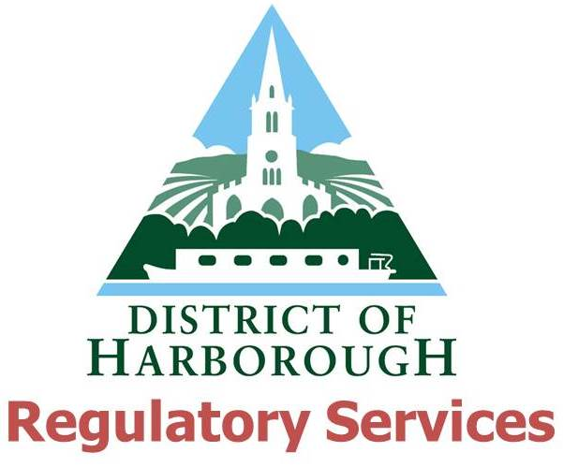
Personal Licence Checklist
Please use this checklist to ensure that you have provided all the required documentation before submitting an application. Incomplete applications will be rejected.

- Personal Licence Application form

- Proof of Right to Work in UK (see note 2 of application form for acceptable documents, copy acceptable)

- Disclosure of Convictions and Declarations form

- Basic Disclosure dated within 1 month (original must be provided, we cannot accept copies)

- Accredited licensing qualification certificate (original must be provided, we cannot accept copies)

- Two passport sized photographs, one of which must be certified as a true likeness of you by a person of standing in the community or an individual with a professional qualification.
- Payment of £37 fee

