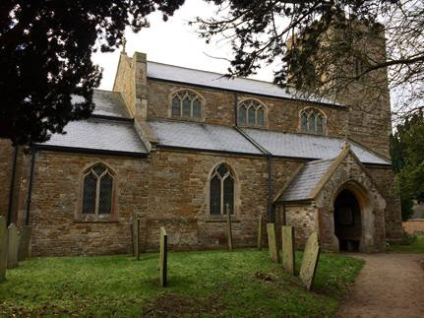
Saddington Parish Neighbourhood Plan
2018 - 2031
CONSULTATION STATEMENT

This page is intentionally left blank

Contents
1. Introduction 4
2. Regulations and Government Guidance 5
2.1 Stage 1: Deciding to make a Neighbourhood Plan 5
2.2 Stage 2: Defining the Neighbourhood Area and Neighbourhood Forum 6
2.3 Stage 3: Preparing the Plan 7
3. Development of Saddington Parish Neighbourhood Plan 8
3.1 Formulating the plan 8
3.2 Early Stakeholder Consultation 8
3.3 First Community Consultation 10
3.4 Summary of Findings from First Community Consultation Event 10
3.5 Community Questionnaire 10
3.6 Summary of findings from the Community Questionnaire 11
3.7 Theme Groups 11
3.8 Second Community Consultation 15
3.9 Summary of Findings from Second Community Consultation 15
3.10 Development of the draft Neighbourhood Plan 15
3.11 Regulation 14 Consultation 15
3.12 Summary of Findings from Regulation 14 Consultation 18
3.13 Updated submission version draft Neighbourhood Plan 18
3.14 Regulation 16 Consultation 18
3.15 Summary of Findings from Regulation 16 Consultation 18
3.16 Independent Examination 18
3.17 Local Planning Authority Approval of the Neighbourhood Plan for Referendum 19
4. Conclusion 20
Appendix A: Summary Chronology of Saddington Parish Neighbourhood Plan Consultation 21
Appendix B: Results of the First Open Consultation Event (March 2017) 26
Appendix C: Results of the Community Questionnaire (February/March 2017) 27
Appendix D: Results of the Second Open Consultation Event (October 2017) 28
Appendix E: Summary of Regulation 14 Consultation (comments/responses) 29
Appendix F: Summary of Regulation 16 Consultation Comments 30
Appendix G: Report from the Independent Examiner - August 2018 31

Appendix 1 Saddington Neighbourhood Plan Consultation Statement v3.docx

Introduction
This Consultation Statement has been prepared to fulfil the legal obligations of the Neighbourhood Planning Regulations 2012. Section 15(2) of Part 5 of the Regulations sets out what a Consultation Statement should contain. According to the Regulations, a Consultation Statement:
- Contains details of the persons and bodies who were consulted about the proposed Neighbourhood Development Plan;
- Explains how they were consulted;
- Summarises the main issues and concerns raised by the persons consulted;
- Describes how these issues and concerns have been considered and, where relevant, addressed in the proposed Neighbourhood Plan.
This document provides a record of the engagement that took place at the various stages of the plan’s evolution. The main methods used to publicise the consultation and engagement process are documented, along with the main findings from the engagement.
Figure 1: Saddington Neighbourhood Area – designated on 18 July 2016
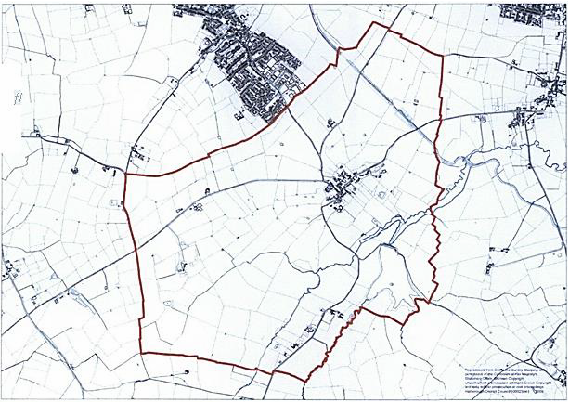

Regulations and Government Guidance

Stage 1: Deciding to make a Neighbourhood Plan
During 2009 – 2011 Saddington Parish Meeting prepared a Parish Plan that formulated local strategies and community actions for Saddington, based on consultation with the residents. From 2011 to date, the Parish Meeting with support from volunteer groups has gone about addressing the priority community actions that were identified in the Parish Plan.
The Parish Plan was a pre-cursor to the more formal Neighbourhood Plan process, and in 2015 the Parish Meeting initiated consultation with the residents of Saddington as to whether Saddington should take the decision to prepare a Neighbourhood Plan.
In December 2015 a Parish Meeting was held to discuss whether Saddington should prepare a Neighbourhood Plan. One consideration was whether Saddington and Fleckney should consider collaboration on a joint Neighbourhood Plan for Saddington and Fleckney combined, and therefore Fleckney Parish Council were invited to attendance to attend the meeting. The outcome from the December 2015 Parish Meeting was a decision not to try to include Saddington Parish within Fleckney Neighbourhood Area, and accordingly Saddington Parish Meeting formally decided to investigate what needs to be done to prepare a Neighbourhood Plan for Saddington Parish.
In January 2016 a briefing note was prepared on the background to Neighbourhood Planning and this was distributed to every house in Saddington. The note reported the intention to make a decision at the next Parish Meeting whether to prepare a Neighbourhood Plan or not.
A Parish Meeting was held in January 2016 to debate whether to prepare a Neighbourhood Plan. Matthew Bills from HDC was in attendance. It was confirmed that Saddington Parish Meeting would not be a qualified body to create a Neighbourhood Plan, and a Neighbourhood Forum would need to be established in Saddington to become the qualified body to create a Neighbourhood Plan for Saddington. The Meeting voted in favour of creating a Neighbourhood Forum to prepare a Neighbourhood Plan for Saddington Parish. An initial management committee was formed to create the Neighbourhood Forum.
Pre-designation management committee meetings held on:
Meeting 1 – 16-02-16
Meeting 2 – 15-03-16
Meeting 3 – 26-04-16
Meeting 4 – 17-05-16
During March 2016 the Management Committee sent invitations to every house and business in Saddington asking for members to form Saddington Parish Neighbourhood Forum. Forty residents and four employees applied to join the Neighbourhood Forum; this was sufficient members to formally request designation as a Neighbourhood Forum.

Stage 2: Defining the Neighbourhood Area and Neighbourhood Forum
In May 2016 a Parish Meeting was held and the progress of the formation of a Neighbourhood Forum was reported. The Neighbourhood Area for Saddington’s Neighbourhood Plan is the whole of Saddington Parish (as shown in section 1, figure 1).
The Neighbourhood Forum and Neighbourhood Area application was submitted to HDC by letter SNF-LTR-001 dated 4th May 2016. HDC acknowledged receipt of the application and by 13th May 2016 they had also confirmed that they had validated the application and would proceed with the 6 week advertising period.
A 6 week consultation was held by the Local Planning Authority ending on 1st July 2016. The Neighbourhood Forum and Neighbourhood Area application was formally approved by the Portfolio Holder for Planning Services on 18th July 2016.
After the 6 week advertising period was completed, on 8th July 2016 the inaugural Meeting of Saddington Parish Neighbourhood Forum was held to initiate the formal process of preparing the Neighbourhood Plan document. A steering committee was appointed and the Neighbourhood Forum constitution was approved by the Meeting.
The Neighbourhood Forum constitution states that the Forum Management Committee shall consist of the following members. Except where stated otherwise below, the minimum age for Forum Management Committee members shall be 18 years old.
Role | Term of Office
Chairperson | 1 year. Role to be appointed annually at each Forum Annual General Meeting. A minimum of 3 months’ notice is requested of intent to resign from the role.
Vice-Chairperson | No fixed term. A minimum of 3 months’ notice is requested of intent to resign from the role.
Treasurer | No fixed term. A minimum of 2 months’ notice is requested of intent to resign from the role.
Secretary | No fixed term. A minimum of 2 months’ notice is requested of intent to resign from the role.
Membership Secretary | No fixed term. A minimum of 2 months’ notice is requested of intent to resign from the role.
Management Committee Support Members  - minimum 4 (no upper limit within reason)  - minimum age shall be 16 years old (as of 1st September 2016) | No fixed term. A minimum of 2 months’ notice is requested of intent to resign from the role.

Stage 3: Preparing the Plan
The Forum Management Committee has lead and coordinated the Neighbourhood Plan production process, and has worked with the Neighbourhood Forum membership as a whole to produce a draft plan, ensuring that it is:
- Generally in line with local and national planning policy framework;
- In line with other legal frameworks;
- Mindful of the need to contribute to sustainable development;
- Prepared on the basis of sound governance arrangements.
Saddington Parish Neighbourhood Plan seeks to establish specific and local planning policies for the development and use of land in Saddington Parish. The neighbourhood plan establishes a vision for the future taking into account the data gathered through community engagement and consultation alongside demographic and socio-economic data. The Neighbourhood Forum appointed YourLocale as Neighbourhood Planning consultants to help create the plan.
The Neighbourhood Forum Management Committee has met on:
Meeting 1 – 14-07-16  Meeting 2 – 28-07-16  Meeting 3 – 18-08-16  Meeting 4 – 01-09-16  Meeting 5 – 06-10-16  Meeting 6 – 03-11-16 | Meeting 7 – 01-12-16  Meeting 8 – 12-01-17  Meeting 9 – 02-02-17  Meeting 10 – 07-03-17  Meeting 11 – 06-04-17  Meeting 12 – 22-06-17 | Meeting 13 – 26-07-17  Meeting 14 – 21-08-17  Meeting 15 – 03-10-17  Meeting 16 – 18-01-18
The Neighbourhood Forum has met on:
Meeting 1 – 08-07-16 (Inaugural meeting)
Meeting 2 – 20-09-16
Meeting 3 – 23-05-17 (AGM)
Meeting 4 – 14-11-17
Meeting 5 – 15-02-18
Meeting 6 – 15-05-18
Meeting 7 – 07-11-18
Minutes of all Neighbourhood Forum meetings can be found on the Saddington Parish Neighbourhood Plan website: http://plan.saddingtonvillage.net

Development of Saddington Parish Neighbourhood Plan

Formulating the plan
During July – December 2016 the Management Committee achieved the following progress:
- Prepared an activity schedule to plan the production of the Neighbourhood Plan.
- Developed the scope and objectives of the Neighbourhood Plan
- Developed a draft vision statement.
- Identified key stakeholders who need to be consulted.
- Ran a competition in the village to design a logo for the Neighbourhood Plan.
- Prepared the contents of Community Questionnaire.
- Prepared to distribute the Community Questionnaire and hold the first public open consultation event.

Early Stakeholder Consultation
The following Stakeholders were sent consultation letters February 2017 to notify them that Saddington was in the process of preparing a Neighbourhood Plan, and of the forthcoming first Open Consultation Event.
Consultation Body contacted in February 2017
A local planning authority, county council or parish council any part of whose area is in or adjoins the area of the local planning authority:
County Council - Nik Green, Communities and Places Officer, Leicestershire County Council
District Council - Matthew Bills, Harborough DC
Fleckney Parish Council: Clerk: John Flower
Wistow Parish Council: Graham Handsley
Arnesby Parish Council: Clerk: Terry Cane
Shearsby Parish Council: Clerk: Cllr Martin Reynolds
Mowsley Parish Meeting: Chairman: Roslyn Ousey
Gumley Parish Meeting: Ben Arnell
Laughton Parish Council: Clerk, Mrs Fiona Hensher
Smeeton Westerby Parish Council: Clerk: Frances Webster
Kibworth Beauchamp Parish Council: Clerk: Frances Webster
The coal authority
Deb Roberts, Planning Liaison Officer, The Coal Authority
Natural England
Miss C Jackson, Consultation Service, Natural England
Canal & River Trust
The Environment Agency
Mark Candlin, Environment Agency
Historic England/English Heritage
Historic England
Ann Plackett, English Heritage
Stewart Patience, Planning Liaison Officer, Anglian Water Ltd, Planning & Equivalence Team
Voluntary bodies some or all of whose activities benefit all or part of the neighbourhood area
Voluntary Action Leicestershire
Roy Holland. Age UK Leicestershire and Rutland
CPRE
Bodies which represent the interests of different racial, ethnic or national groups in the neighbourhood area
Leicestershire Ethnic Minority Partnership
Federation of Gypsy Liaison Groups
Bodies which represent the interests of different religious groups in the neighbourhood area
Interfaith Forum for Leicestershire equality@leics.gov.uk
Bodies which represent the interests of persons carrying on business in the neighbourhood area
Market Harborough Chamber of Commerce. http://www.harboroughchamber.co.uk/
Bodies which represent the interests of disabled persons in the neighbourhood area
Leicestershire Centre for Integrated Living.
Harborough District Disability Access Group. Nick Williams
Other bodies
East Midlands Ambulance Service
Leicestershire and Rutland Ramblers, Mark Hewitt
Leicestershire Footpath Association: Cynthia West
Leicestershire & Rutland Bridleways Association
Saddington Sailing Club, Paul Sanders
Centrebus help@centrebus.com
National Farmers’ Association: East Midlands Regional Director
Practice Manager, twoshires.medicalpractice@nhs.net
Practice Manager Kibworth Health Centre. Smeeton Road Kibworth
Councillors/MP
MP: Edward Garnier
County Councillor: Blake Pain
District Councillor: Blake Pain
Local Businesses:
The Queens Head Saddington: Chris Lewis-Sharman
The Grange Saddington Nursing Home: Kirti Thakrar
Mr Paul Sanders ServiceMaster
Landowners
David Briggs, Hillcote Farm, Saddington

First Community Consultation
An open consultation event took place in Saddington on Saturday 11th March 2017 seeking the views of the community on what the Neighbourhood Plan for Saddington should focus on. In total 44 people attended this event.
The consultation aimed:
- To inform as many people as possible of the existence of the Neighbourhood Planning process
- To seek the views of people from the community on the proposals being developed by the Neighbourhood Forum.
Comments were made which reflected a wide range of opinions. Respondents were generally in favour of any new development on a limited scale, of house designs in keeping with the character of the village, and on sites which are not on the areas of separation between Saddington and Fleckney.

Summary of Findings from First Community Consultation Event
The analysis of the results of the first community consultation event are detailed in appendix B.

Community Questionnaire
A Community Questionnaire was assembled by the Neighbourhood Forum Management Team. The questionnaire contained 8 sections with questions in each designed to addressed topics relevant to Saddington Parish:
Section One – Our Village
Section Two – Development
Section Three – Housing
Section Four – Education
Section Five – Village Facilities and Services
Section Six – Traffic and transport
Section Seven – Business and Employment
Section Eight – Demographics
The Questionnaire was distributed to every household and was also made available online in February/March 2017.
45 responses were received, which amounts to 45% of households and 17% of the total population of Saddington Parish. This demonstrates the level of commitment to the Neighbourhood Plan by a small community which, in turn, adds strength to the validity of the collected views expressed.

Summary of findings from the Community Questionnaire
The analysis of the results of the Community Questionnaire are detailed in appendix C.

Theme Groups
After the results of the Community Questionnaire and Open Event had been collated and analysed, it was possible to start to establish the main priorities and considerations for development in Saddington.
These findings were presented at the Neighbourhood Forum meeting in May 2017, and three Theme Groups were established to focus on three key areas for Saddington:
- Housing
- Environment
- Community facilities, employment and transport
The Theme Group process had to ensure that the Plan meets legal requirements and that any policies are supported by evidence. Local agendas must drive plan and local knowledge of key issues is very important. The Theme Groups met between June and September to develop the proposed policies applicable to the three areas, and cross group liaison was facilitated by the on-going Management Team meetings.
During August 2017, owners of land in Saddington as listed in the table below were written to individually to notify them of the Neighbourhood Plan and invite their participation.
Saddington Field No. | Owner
1, 2, 3, 15, 17, 18 | Mr Simon Thornton  Mrs Paula Thornton
4, 5, 19, 20, 26, 31, 32, 33, 34, 35, 36, 39, 72, 73, 74, 123, 125, 156 | Geoff Holman
6, 8, 9, 21, 22, 23, 24 | Mr Christy Coughlan
6, 8, 9, 21, 22, 23, 24 | Mrs Patricia Hubbard  Mr Jonathan Adlerstein,
10, 27 | Audrey Cooke
11, 12, 13, 14, 28, 29, 30 | Mr Stuart Gilbert  Mr Robert Gilbert  Mr Edward Gilbert
16 | Phil Beasley
37, 38, 40, 44, 45, 46, 47, 48, 49, 50, 141, 142, 143 | Mr Richard Harrison  Mrs Rachel Harrison
41, 42, 43, 136, 137, 138, 139, 140, 144, 145, 146, 147, 148, 149, 150, 151, 152, 154, 155. | David Briggs
51, 52, 53, 54, 55, 56, 57, 58, 59, 60, 80, 81, 83, 84, 85, 87, 88, 89. | John Briggs
61, 62, 63, 64, 65, 66, 68, 69 | Mr David Thornton  Mrs Gillian Thornton
67, 70, 82, 86, 90, 91, 97, 98, 99, 100, 101, 109, 110, 112, 113, 114, 115, 116, 167 | Joe Cowen
71 | Saddington Charity
102, 103, 104 | Helen Bilson
105, 106, 107 | Dale and Emma Mills
108, 158, 161, 162 | Paul Edge
111, 116, 117, 118, 119, 157 | Janice Nesbit
120 | Alan and Barbara Wright
124, 127, 128 | Ann Hecks
126 | Paul and Mandy Sanders
129, 130, 133 | Paul and Denise Johnson
131 | Rupert and Barbara Mingay
132 | Chris & Jill Carter
134, 135 | Andrew & Barbara Broadbent
153 | Liz Burton
159, 160 | Mr Richard Knight
163, 164, 165 | Ranjit Dhindsa
Village Green | Steven Short
The field number locations are shown in the diagrams over page.

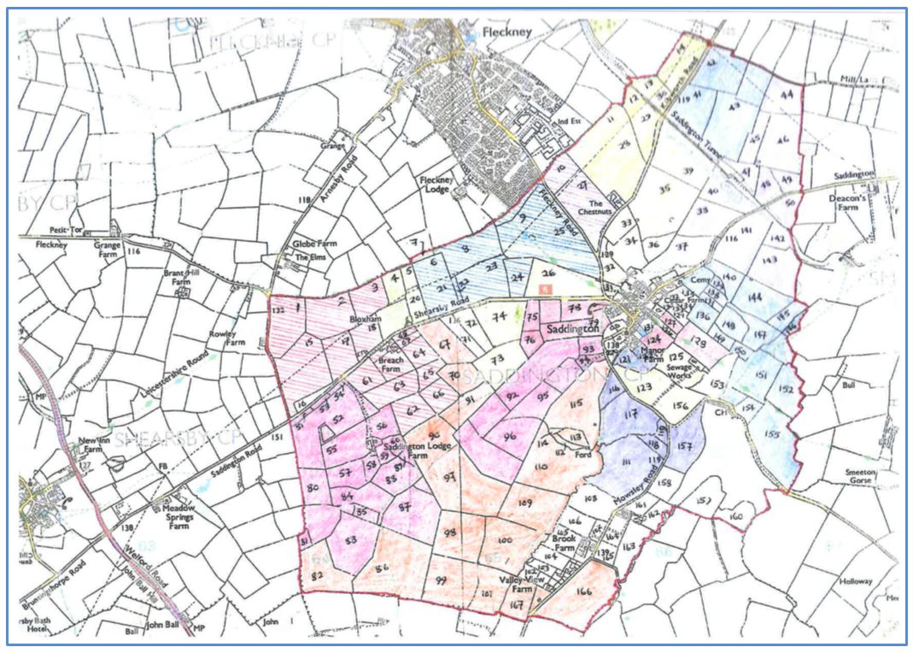
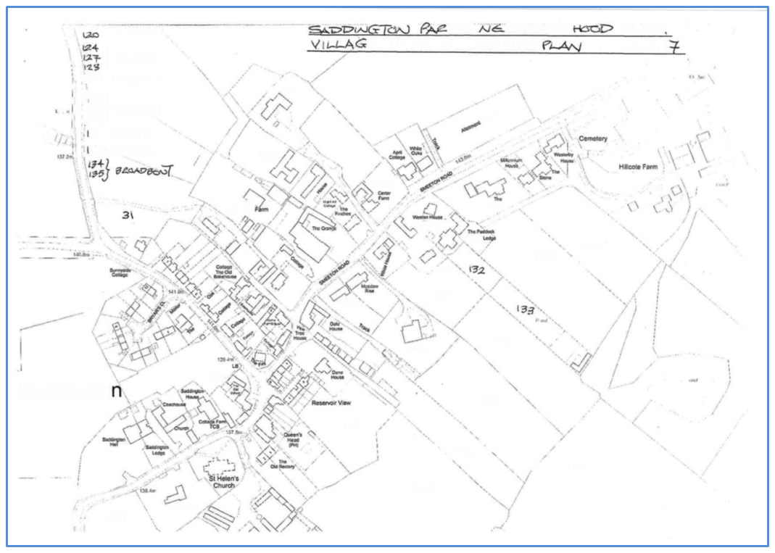
Saddington field number locations

Second Community Consultation
A second Community Open Event was held in Saddington on Saturday 28th October 2017. All residents, businesses and stakeholders were invited to attend the Open Event. The general public were also invited to attend. To promote the event a leaflet was posted to every house in Saddington, and a letter was mailed to those with an interest outside of the village.
The draft policies that had been prepared by the Theme Groups were presented at the Open Event and feedback from attendees was requested. There was overwhelming support for the draft policies and some helpful comments which will help to shape the Pre-Submission version of the Neighbourhood Plan prior to finalisation.
It is clear that transport issues are important including car parking issues and the impact of large vehicles through the village. Environmental aspects are important to the village and the need for the characteristics of Saddington to remain as they are.
There was general support for the level of new housing proposed though some concern about the environmental impact of development on the Weir Road site. A total of 42 people attended the event.

Summary of Findings from Second Community Consultation
The analysis of the results of the second community consultation event are detailed in appendix D.

Development of the draft Neighbourhood Plan
The output from the three Theme Groups, plus the stakeholder feedback from the two Open Events was used to prepare the first draft Neighbourhood Plan. The draft Pre-submission Neighbourhood Plan was sent to all Neighbourhood Forum members for review on 3rd November 2017. Feedback and comments from the Neighbourhood Forum members was used to update the final draft of the Pre-submission draft Neighbourhood Plan, and this document was formally reviewed at a meeting of the Neighbourhood Forum on 14th Nov 2017. The Neighbourhood Forum meeting approved the Pre-submission draft Neighbourhood Plan for Regulation 14 consultation.

Regulation 14 Consultation
The pre-submission consultation period started on 20th Nov 2017 and ran for just over 6 weeks up to 12th Jan 2018. All residents and businesses in Saddington, and stakeholders were informed of the 6 week consultation period.
Regulation 14 Consultation Bodies that were notified in November 2017
A local planning authority, county council or parish council any part of whose area is in or adjoins the area of the local planning authority:
County Council - Nik Green, Communities and Places Officer, Leicestershire County Council
District Council - Matthew Bills, Harborough DC
Fleckney Parish Council: Clerk: John Flower
Wistow Parish Council: Graham Handsley
Arnesby Parish Council: Clerk: Terry Cane
Shearsby Parish Council: Clerk: Cllr Martin Reynolds
Mowsley Parish Meeting: Chairman: Roslyn Ousey
Laughton Parish Council: Clerk, Mrs Fiona Hensher
Smeeton Westerby Parish Council: Clerk: Frances Webster
Kibworth Beauchamp Parish Council: Clerk: Frances Webster
The coal authority
Deb Roberts, Planning Liaison Officer, The Coal Authority
The Homes and Communities Agency
Homes and Communities Agency, Birmingham
Natural England
Miss C Jackson, Consultation Service, Natural England
The Environment Agency
Mark Candlin, Environment Agency
Historic England/English Heritage
Historic England
Ann Plackett, English Heritage
Stewart Patience, Planning Liaison Officer, Anglian Water Ltd, Planning & Equivalence Team
Network Rail Infrastructure Limited
Network Rail Infrastructure Limited, London
The Highways Agency
Ms Aoife O'Tool, Highways Agency Birmingham
Any person i. to whom the electronic communications code applies ii. who owns or controls electronic communications apparatus in the area
British Telecommunications Plc, Customer Wideband Planning Group, Nottingham
Primary Care Trust
East Leicestershire and Rutland CCG, Thurmaston, Leicester
Licence holder under the Electricity Act 1989
Mr D Holdstock, National Grid, Leamington Spa, Warwickshire
Licence holder under the Gas Act 1986
British Gas Properties, Basingstoke, Hampshire
Sewage Undertaker/lv) Water undertaker
Mr Peter Davies, Severn Trent Water Ltd, Nottingham
Stuart Patience, Planning Liaison Officer, Anglian Water Ltd, Peterborough
Voluntary bodies some or all of whose activities benefit all or part of the neighbourhood area
Voluntary Action Leicestershire
Roy Holland. Age UK Leicestershire and Rutland
CPRE
Bodies which represent the interests of different racial, ethnic or national groups in the neighbourhood area
Leicestershire Ethnic Minority Partnership
Federation of Gypsy Liaison Groups
Bodies which represent the interests of different religious groups in the neighbourhood area
Interfaith Forum for Leicestershire equality@leics.gov.uk
Bodies which represent the interests of persons carrying on business in the neighbourhood area
Market Harborough Chamber of Commerce. http://www.harboroughchamber.co.uk/
Bodies which represent the interests of disabled persons in the neighbourhood area
Leicestershire Centre for Integrated Living.
Harborough District Disability Access Group. Nick Williams
Other bodies
Leicestershire Police, Force Headquarters, St Johns, Enderby, Leicester
Leicestershire Fire and Rescue, 12 Geoff Monk Way, Birstall, Leicester
Executive Director, Seven Locks Housing, Market Harborough, Leicestershire
Councillors/MP
MP: Neil Obrien
County Councillor: Blake Pain
District Councillor: Blake Pain
Local Businesses:
The Queens Head Saddington: Chris Lewis-Sharman
Fifteen written responses were submitted to the Pre-submission draft Neighbourhood Plan. These comments have been collated on a response tracking sheet that identifies who the respondent is, which policy or section of the Plan that the comment applies to, the comment and the proposed response to the comment. Formal letters of acknowledgement of the received comments was sent to all 15 respondents following the conclusion of the consultation period.
The Neighbourhood Forum Management Team met on 18 January 2018 to review the comments, to agree the proposed responses and confirm which sections of the Neighbourhood Plan were to be updated.
A meeting of the Neighbourhood Forum on 15th February 2018 approved the responses to the Regulation 14 comments.

Summary of Findings from Regulation 14 Consultation
The comments that were received from Regulation 14 consultees and the responses from the Neighbourhood Forum are detailed in appendix E.

Updated submission version draft Neighbourhood Plan
The Pre-submission version draft Neighbourhood Plan was updated in January 2018 to incorporate the responses to the Regulation 14 consultation comments to create the Submission version draft Neighbourhood Plan.
A meeting of the Neighbourhood Forum on 15th February 2018 approved the updated draft Neighbourhood Plan for submission to Harborough District Council for Regulation 16 consultation.

Regulation 16 Consultation
The Submission version draft Neighbourhood Plan was submitted to Harborough District Council on 22nd February 2018 for the purpose of Regulation 16 consultation.
The Regulation 16 consultation period started on 11th April 2018 and ran for 6 weeks up to 23rd May 2018. Statutory stakeholders were informed of the 6 week consultation period.

Summary of Findings from Regulation 16 Consultation
The comments that were received from Regulation 16 consultees are detailed in appendix F. These comments were provided to the Independent Examiner for assessment together with the Submission version Neighbourhood Plan.

Independent Examination
Ms Liz Beth was appointed as the Independent Examiner of Saddington Parish’s Neighbourhood Plan. The examination took place during July and August 2018.
Three questions were sent from the Examiner to the Neighbourhood Forum for clarification during July 2018. The Inspector’s report was published in August 2018 and concluded that the Neighbourhood Plan meets the basic requirements, and subject to incorporation of recommended edits the Plan should go for referendum. A copy of the Independent Examiner’s report is included in appendix G.

Local Planning Authority Approval of the Neighbourhood Plan for Referendum
Following the issue of the Independent Examiner’s report, Harborough District Council met on 15th October 2018 to approve Saddington Neighbourhood Plan for Referendum.
The Neighbourhood Forum subsequently updated the Neighbourhood Plan to incorporate the recommendations from the Independent Examiner to create the Referendum Version Neighbourhood Plan. The Neighbourhood Forum met on 6th November 2018 and formally approved the Referendum version Neighbourhood as the Neighbourhood Plan for Saddington Parish that is to be put to Referendum on 10th January 2019.

Conclusion
Saddington Parish Neighbourhood Forum has prepared a Neighbourhood Plan for the Saddington Parish Neighbourhood Area and having passed Independent Examination and approval by the Local Planning Authority during 2018 the Referendum Version Neighbourhood Plan is now ready to be submitted for Referendum.
The referendum question will be a straight “yes” or “no” on the entire Plan, as set out by Neighbourhood Planning Regulations. People will not be able to vote for or against individual policies. If 50% or more of those voting vote for the Plan, it will be brought into force (‘Made’) and become part of District-wide planning policy.
This Consultation Statement and the supporting Appendices are provided to comply with Section 15(2) of part 5 of the 2012 Neighbourhood Planning Regulations.
Christopher Carter
Chairman, Saddington Parish Neighbourhood Forum
28th October 2018

Appendix A: Summary Chronology of Saddington Parish Neighbourhood Plan Consultation
From the inception of the Neighbourhood Plan preparation process there has been continuous consultation and information sharing with the residents and businesses within Saddington, and with the broader groups of stakeholders. The table below provides a summary record of the main consultation and information sharing events that have taken place as part of the Neighbourhood Plan preparation process.
Consultation/ Information/ Event | Distribution/Attendance | Evidence Record
December 2015: Parish Meeting with Fleckney Parish Council in attendance to discuss collaboration on a joint Neighbourhood Plan.  Decision taken not to include Saddington Parish within Fleckney Neighbourhood Area. | Parish Meeting attendance.  Note of Meeting distributed to members of Saddington email forum. | Notes of Parish Meeting dated  Tuesday 1st December 2015
Jan 2016: Saddington Neighbourhood Plan - briefing note.  Identified the intention to make a decision at the Parish Meeting whether to prepare a Neighbourhood Plan or not. | Posted to every household in Saddington. | Saddington Neighbourhood Plan - briefing note (Jan 2016).docx
January 2016: Discussion at Parish Meeting to decide whether to prepare a Neighbourhood Plan. Matthew Bills in attendance.  Formal decision taken to create Neighbourhood Forum to prepare a Neighbourhood Plan for Saddington Parish.  Initial management committee formed to create the Neighbourhood Forum. | Parish Meeting attendance.  Note of Meeting distributed to members of Saddington email forum. | Notes of Parish Meeting dated 26th January 2016
Invitations to form/join Saddington Parish Neighbourhood Forum sent out in March 2016. | Posted to every household and business in Saddington. | Saddington forum residents invite.pdf
Pre-designation management committee meetings held on:  Meeting 1 – 16-02-16  Meeting 2 – 15-03-16  Meeting 3 – 26-04-16  Meeting 4 – 17-05-16 | Attendees at management committee meetings.  Progress reported at Parish Meeting. | Notes of pre-designation management committee meetings held on:  Meeting 1 – 16-02-16  Meeting 2 – 15-03-16  Meeting 3 – 26-04-16  Meeting 4 – 17-05-16
May 2016: Parish Meeting reports on progress of formation of Neighbourhood Forum. | Parish Meeting attendance.  Note of Meeting distributed to members of Saddington email forum. | Notes of Parish Meeting dated  Tuesday 3rd May 2016
The Neighbourhood Forum and Neighbourhood Area application were submitted to HDC | Harborough District Council | Letter SNF-LTR-001 dated 4th May 2016.
20 May 2016: Saddington Parish Neighbourhood Forum Notice – public notice posted by HDC confirming the Neighbourhood Forum. | HDC’s website. Available to public. | Saddington Parish Neighbourhood Forum Notice.docx
8 July 2016: Inaugural Meeting #1 Saddington Parish Neighbourhood Forum | Meeting is open to all members of the Neighbourhood Forum.  Notes of Neighbourhood Forum Inaugural Meetings are distributed to all members of SPNF | Minutes #1 - Inaugural Meeting Saddington Parish Neighbourhood Forum 08-07-16.docx
Saddington Parish Neighbourhood Forum applied to be designated on 4th May 2016. A 6 week consultation was held by the Local Planning Authority ending on 1st July 2016. The Forum application was approved by the Portfolio Holder for Planning Services on 18th July 2016. | Public domain record on HDC Neighbourhood Planning website. | HDC Neighbourhood Planning website.
Neighbourhood Forum Constitution | All members of the Neighbourhood Forum.  Approved at the NF Inaugural Meeting | Saddington Parish Neighbourhood Forum constitution - 8 July 2016.pdf
20 Sept 2016: Saddington Parish Neighbourhood Forum Meeting#2 | Meeting is open to all members of the Neighbourhood Forum. | Minutes #2 - Saddington Parish Neighbourhood Forum Meeting 20-09-16.docx
23 June 2017: Saddington Parish Neighbourhood Forum Annual General Meeting (#3) 2017 | Notes of Neighbourhood Forum Inaugural Meetings are distributed to all members of SPNF | Minutes #3 - Saddington Parish Neighbourhood Forum Annual General Meeting 23-06-17.docx
Community Questionnaire, Feb/March 2017 | A paper copy of the Community Questionnaire was distributed to all residents and businesses in Saddington Parish.  An on-line version was also available on a Surveymonkey page. | Saddington Parish Neighbourhood Plan - Questionnaire v5 03-02-17.docx  https://www.surveymonkey.co.uk/r/saddington  Results are given in:  Saddington Questionnaire Analysis March 2017.pdf  (Appendix C to this document)
Stakeholders consultation letters sent out Feb 2017 | All stakeholders that have been identified on the Stakeholder list were notified of the NP and open event. | Saddington Stakeholder list (08-02-17).doc
Community Open Event#1, 11th March 2017 | All residents, businesses and stakeholders were invited to attend the Open Event. The general public were also invited to attend. | Community Open Event#1, 11th March 2017, Saddington.  Results are given in:  Saddington Consultation Summary 11 March 2017.pdf (Appendix B to this document)
Publicly accessible web-site was set up in May 2017 as a location to publish draft documents as they are prepared. | Public access | http://plan.saddingtonvillage.net
SPNF Management Committee meetings held on:  Meeting 1 – 14-07-16  Meeting 2 – 28-07-16  Meeting 3 – 18-08-16  Meeting 4 – 01-09-16  Meeting 5 – 06-10-16  Meeting 6 – 03-11-16  Meeting 7 – 01-12-16  Meeting 8 – 12-01-17  Meeting 9 – 02-02-17  Meeting 10 – 07-03-17  Meeting 11 – 06-04-17  Meeting 12 – 22-06-17  Meeting 13 – 26-07-17  Meeting 14 – 21-08-17  Meeting 15 – 03-10-17  Meeting 16 – 18-01-18 | Attendees at management committee meetings.  Notes of SPNF Management Committee meetings are distributed to all members of SPNF. | Notes of SPNF Management Committee meetings held on:  Meeting 1 – 14-07-16  Meeting 2 – 28-07-16  Meeting 3 – 18-08-16  Meeting 4 – 01-09-16  Meeting 5 – 06-10-16  Meeting 6 – 03-11-16  Meeting 7 – 01-12-16  Meeting 8 – 12-01-17  Meeting 9 – 02-02-17  Meeting 10 – 07-03-17  Meeting 11 – 06-04-17  Meeting 12 – 22-06-17  Meeting 13 – 26-07-17  Meeting 14 – 21-08-17  Meeting 15 – 03-10-17  Meeting 16 – 18-01-18
SPNF meetings held on:  Meeting 1 – 08-07-16 (Inaugural meeting)  Meeting 2 – 20-09-16  Meeting 3 – 23-05-17 (AGM)  Meeting 4 – 14-11-17  Meeting 5 – 15-02-18  Meeting 6 – 15-05-18 (AGM)  Meeting 7 – 06-11-18 | Attendees at Neighbourhood Forum committee meetings.  Notes of SPNF meetings are distributed to all members of SPNF. | Notes of SPNF meetings held on:  Meeting 1 – 08-07-16  Meeting 2 – 20-09-16  Meeting 3 – 23-05-17 (AGM)  Meeting 4 – 14-11-17  Meeting 5 – 15-02-18  Meeting 6 – 15-05-18  Meeting 7 – 06-11-18
Landowners, letter sent out 15th August 2017 | All owners of land in Saddington were written to individually to notify them of the NP and invite their participation. | List of landowners: Saddington Parish Land Ownership (06-08-17).docx  Letter dated 15th August 2017.
Community Open Event#2, Saturday 28 October 2017 | All residents, businesses and stakeholders were invited to attend the Open Event. The general public were also invited to attend.  To promote the event a leaflet was posted to every house in Saddington, the event was notified on the Saddington email forum and a letter was mailed to those with an interest outside of the village. | Community Open Event#2, 28th October 2017, Saddington.  Saddington Consultation Analysis Oct 2017.pdf (Appendix D this document)
Pre-submission draft Neighbourhood Plan | Sent to the Neighbourhood Forum members for review 03-11-17. | Email dated 3 Nov 2017.
14 Nov 2017: Saddington Parish Neighbourhood Forum Meeting#4 | Meeting is open to all members of the Neighbourhood Forum. Main agenda item is approval of the Pre-submission draft Neighbourhood Plan. | Minutes #4 - Saddington Parish Neighbourhood Forum Meeting 14-11-17.docx
Saddington pre-submission Neighbourhood Plan (19-11-17) | All residents, businesses and stakeholders were informed of the existence of the draft NP. | 01 Saddington pre-submission Neighbourhood Plan approved version (19-11-17).docx  Copies of all documents for consultation can be found at:  http://plan.saddingtonvillage.net
Pre-submission consultation period 20 Nov 2017 – 12 Jan 2018 | All residents, businesses and stakeholders were informed of the 6 week consultation period. | Stakeholder list: Saddington Stakeholder list 20 November 2017.doc  Saddington Stakeholder list November 2017.doc  Landowner list: Saddington Parish Land Ownership (11-09-17).docx
Pre-submission consultation record (20 Nov 2017 – 12 Jan 2018) and responses. | 15 written responses received and addressed in updated NP.  Acknowledgment letters sent to all 15 respondents  The comments and responses were circulated to all members of the Neighbourhood Forum for approval at the NF Meeting #5. | 00 Pre-submission comments Nov 17 - Jan 18 Final.pdf  (Appendix E to this document)
Saddington submission version Neighbourhood Plan (09-02-18) | The submission version Neighbourhood Plan was circulated to all members of the Neighbourhood Forum for approval at the NF Meeting #5. | 00 Saddington submission version Feb 2018 final version (09-02-18).pdf  Copies of all documents for consultation can be found at:  http://plan.saddingtonvillage.net
Strategic Environmental Assessment screening report | The Strategic Environmental Assessment screening report was prepared by HDC in Jan 2018 on our behalf and it is circulated by HDC to statutory stakeholders for review. | Saddington NDP SEA Screening Jan 2018.pdf
15 Feb 2018: Saddington Parish Neighbourhood Forum Meeting#5 | Meeting is open to all members of the Neighbourhood Forum. Main agenda item is approval of the Reg 14 comments and responses, and the Submission version Neighbourhood Plan.  Subject to the incorporation of three minor editorial updates that were discussed at the meeting, the Neighbourhood Forum approved the Submission Neighbourhood Plan and the Regulation 14 comments/ responses to be submitted to HDC for regulation 16 consultation. | Minutes #5 - Saddington Parish Neighbourhood Forum Meeting 15-02-18.docx  Saddington Neighbourhood Plan submission version (17-02-18).docx
Submission of Neighbourhood Plan to HDC for Regulation 16 consultation. | Mr Matthew Bill, HDC Neighbourhood and Green Spaces Officer | Letter SNF-LTR-008, 22nd February 2018
Regulation 16 consultation (11th April – 23rd May 2018) | This process was managed by Harborough District Council. Statutory consultees were notified. | Regulation 16 was promulgated by HDC at http://www.harborough.gov.uk/neighbourhood-planning and http://www.harborough.gov.uk/consultation
Regulation 16 consultation record responses | 9 written responses were received and these were provided to the Independent Examiner in July 2018 for assessment. | Saddington_Summary_of_responses_Reg_16_March_2018.pdf Saddington NP Examination report 12 Aug18.pdf (Appendix F to this document)
Independent Examination – July-August 2018 | Ms Liz Beth was appointed as the Independent Examiner for Saddington Parish Neighbourhood Plan.  Three questions were sent from the Examiner to the Neighbourhood Forum. | Saddington NP Examination report 12 Aug18.pdf (Appendix G to this document)
Approval of Saddington Neighbourhood Plan for Referendum by Harborough District Council. | Following the issue of the Independent Examiner’s report, Harborough District Council met on 15 October 2018 to approve Saddington Neighbourhood Plan for Referendum. | Minutes of HDC meeting.
Saddington Neighbourhood Plan Referendum version (October 2018) | The referendum version Neighbourhood Plan was circulated to all members of the Neighbourhood Forum for approval at the Neighbourhood Forum Meeting #7. | 0 Saddington Neighbourhood Plan Referendum version 27 10 18.pdf  Copies of all documents for referendum can be found at:  http://plan.saddingtonvillage.net
Saddington Parish Neighbourhood Plan Referendum  10th January 2019 | This process is managed by Harborough District Council.

Appendix B: Results of the First Open Consultation Event (March 2017)

Appendix C: Results of the Community Questionnaire (February/March 2017)

Appendix D: Results of the Second Open Consultation Event (October 2017)

Appendix E: Summary of Regulation 14 Consultation (comments/responses)

Appendix F: Summary of Regulation 16 Consultation Comments
Summary of representations submitted by Harborough District Council to the Independent Examiner pursuant to Regulation 17 of Part 5 of The Neighbourhood Planning (General) Regulations 2012
Saddington_Summary_of_responses_Reg_16_March_2018.pdf

Appendix G: Report from the Independent Examiner - August 2018

Saddington NP Examination report 12 Aug18.pdf

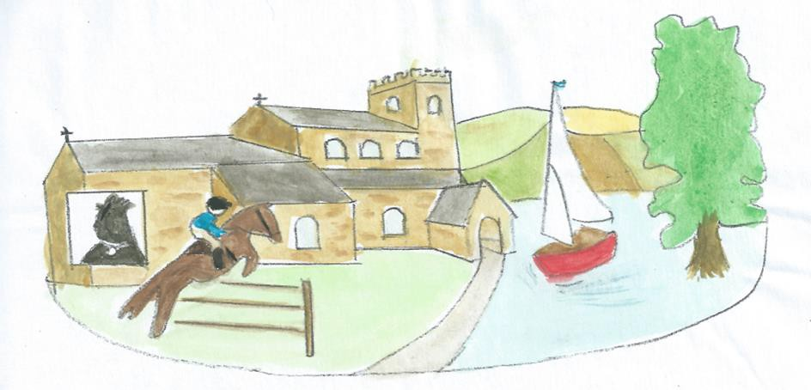
Saddington, a lovely village

