APPLICATION FORM FOR REGISTRATION OF
NON-COMMERCIAL SOCIETY

If you are completing this form by hand, please write legibly in block capitals using ink.

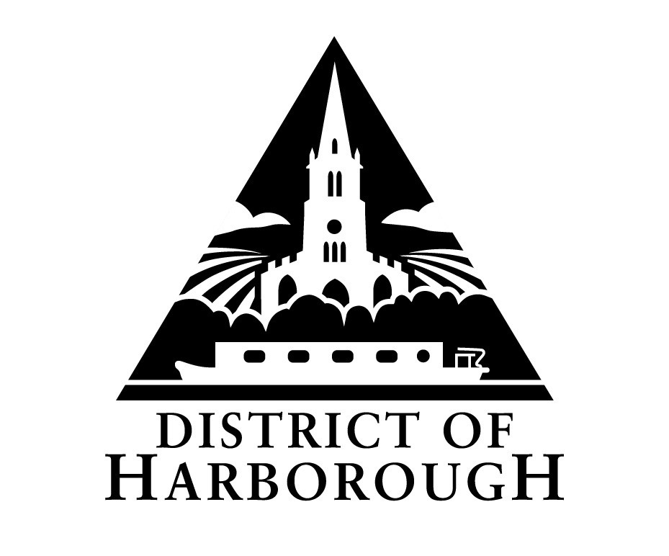
To: Licensing Section
Harborough District Council
Adam and Eve Street
Market Harborough
LE16 7AG

SECTION A – Details of society applying for registration

- Name of society ………………………………………………………………………

- Address (including postcode) of office or head office of society

………………………………………………………………………………………….

………………………………………………………………………………………….

………………………………………………………………………………………….

- Telephone number of society ……………………………………………………….

4. Please state the purpose(s) for which the society is established and conducted.

………………………………………………………………………………………….

………………………………………………………………………………………….

5. If the society is a registered charity, please give the society’s unique charity
registration number.

………………………………………………………………………………………….

- Has the society held an operating licence under the Gambling Act 2005 in the period of five years ending with the date of this application?

Yes □ No □

- If the answer to question 6 is ‘Yes,’ has the operating licence been revoked in the period of five years ending with the date of this application?
Yes □ No □
- If the answer to question 7 is ‘Yes,’ please state the reasons for revocation and enclose a copy of the notice of revocation if one is available.

……………………………………………………………………………...................

……………………………………………………………………………...................

……………………………………………………………………………...................

- Has the society applied for and been refused an operating licence in the period of five years ending with the date of this application?
Yes □ No □

SECTION B – General Information about person applying on behalf of society

10. Name ………………………………………………………………………………….

11. Capacity ……………………………………………………………………………….

12. Address (including postcode)

………………………………………………………………………………………….

………………………………………………………………………………………….

13. Daytime telephone number ……………………………………………..................

SECTION C – Contact details for correspondence associated with this application

- Please tick one box as appropriate to indicate address for correspondence in relation to this application:
Address in section A □
Address in section B □
Address in section C □

Address (including postcode)

………………………………………………………………………………………………

……………………………………………………………………………………………….

Telephone number ………………………………………………………………………..

Email address (if the applicant is happy for correspondence in relation to this application to be sent via e-mail)

………………………………………………………………………………......................
SECTION D – Declaration

- Please complete the following declaration and checklist:

I (Full Name)……………………………………………………………………………….

- make this application on behalf of the society referred to in Section A and have authority to act on behalf of that society.

- enclose payment of the registration fee of £40.

- confirm that, to the best of my knowledge, the information contained in this application is true. I understand that it is an offence under section 342 of the Gambling Act 2005 to give information which is false or misleading in, or in relation to, this application.

Signature……………………………………………………………………………………..

Date…………………………………………………………………………………………..

Capacity ……………………………………………………………………………………..

Note to societies applying for registration:

The application will be refused if in the period of five years ending with the date of the application:

- an operating licence held by the society has been revoked under section 119 (1) of the Gambling Act 2005, or

(b) an application for an operating licence made by the society has been refused.

The application may be refused if the local authority think that:

- the society is not a non-commercial society,

- a person who will or may be connected with the promotion of the lottery has been convicted of a relevant offence, or

- ) information provided in or with the application is false or misleading.

