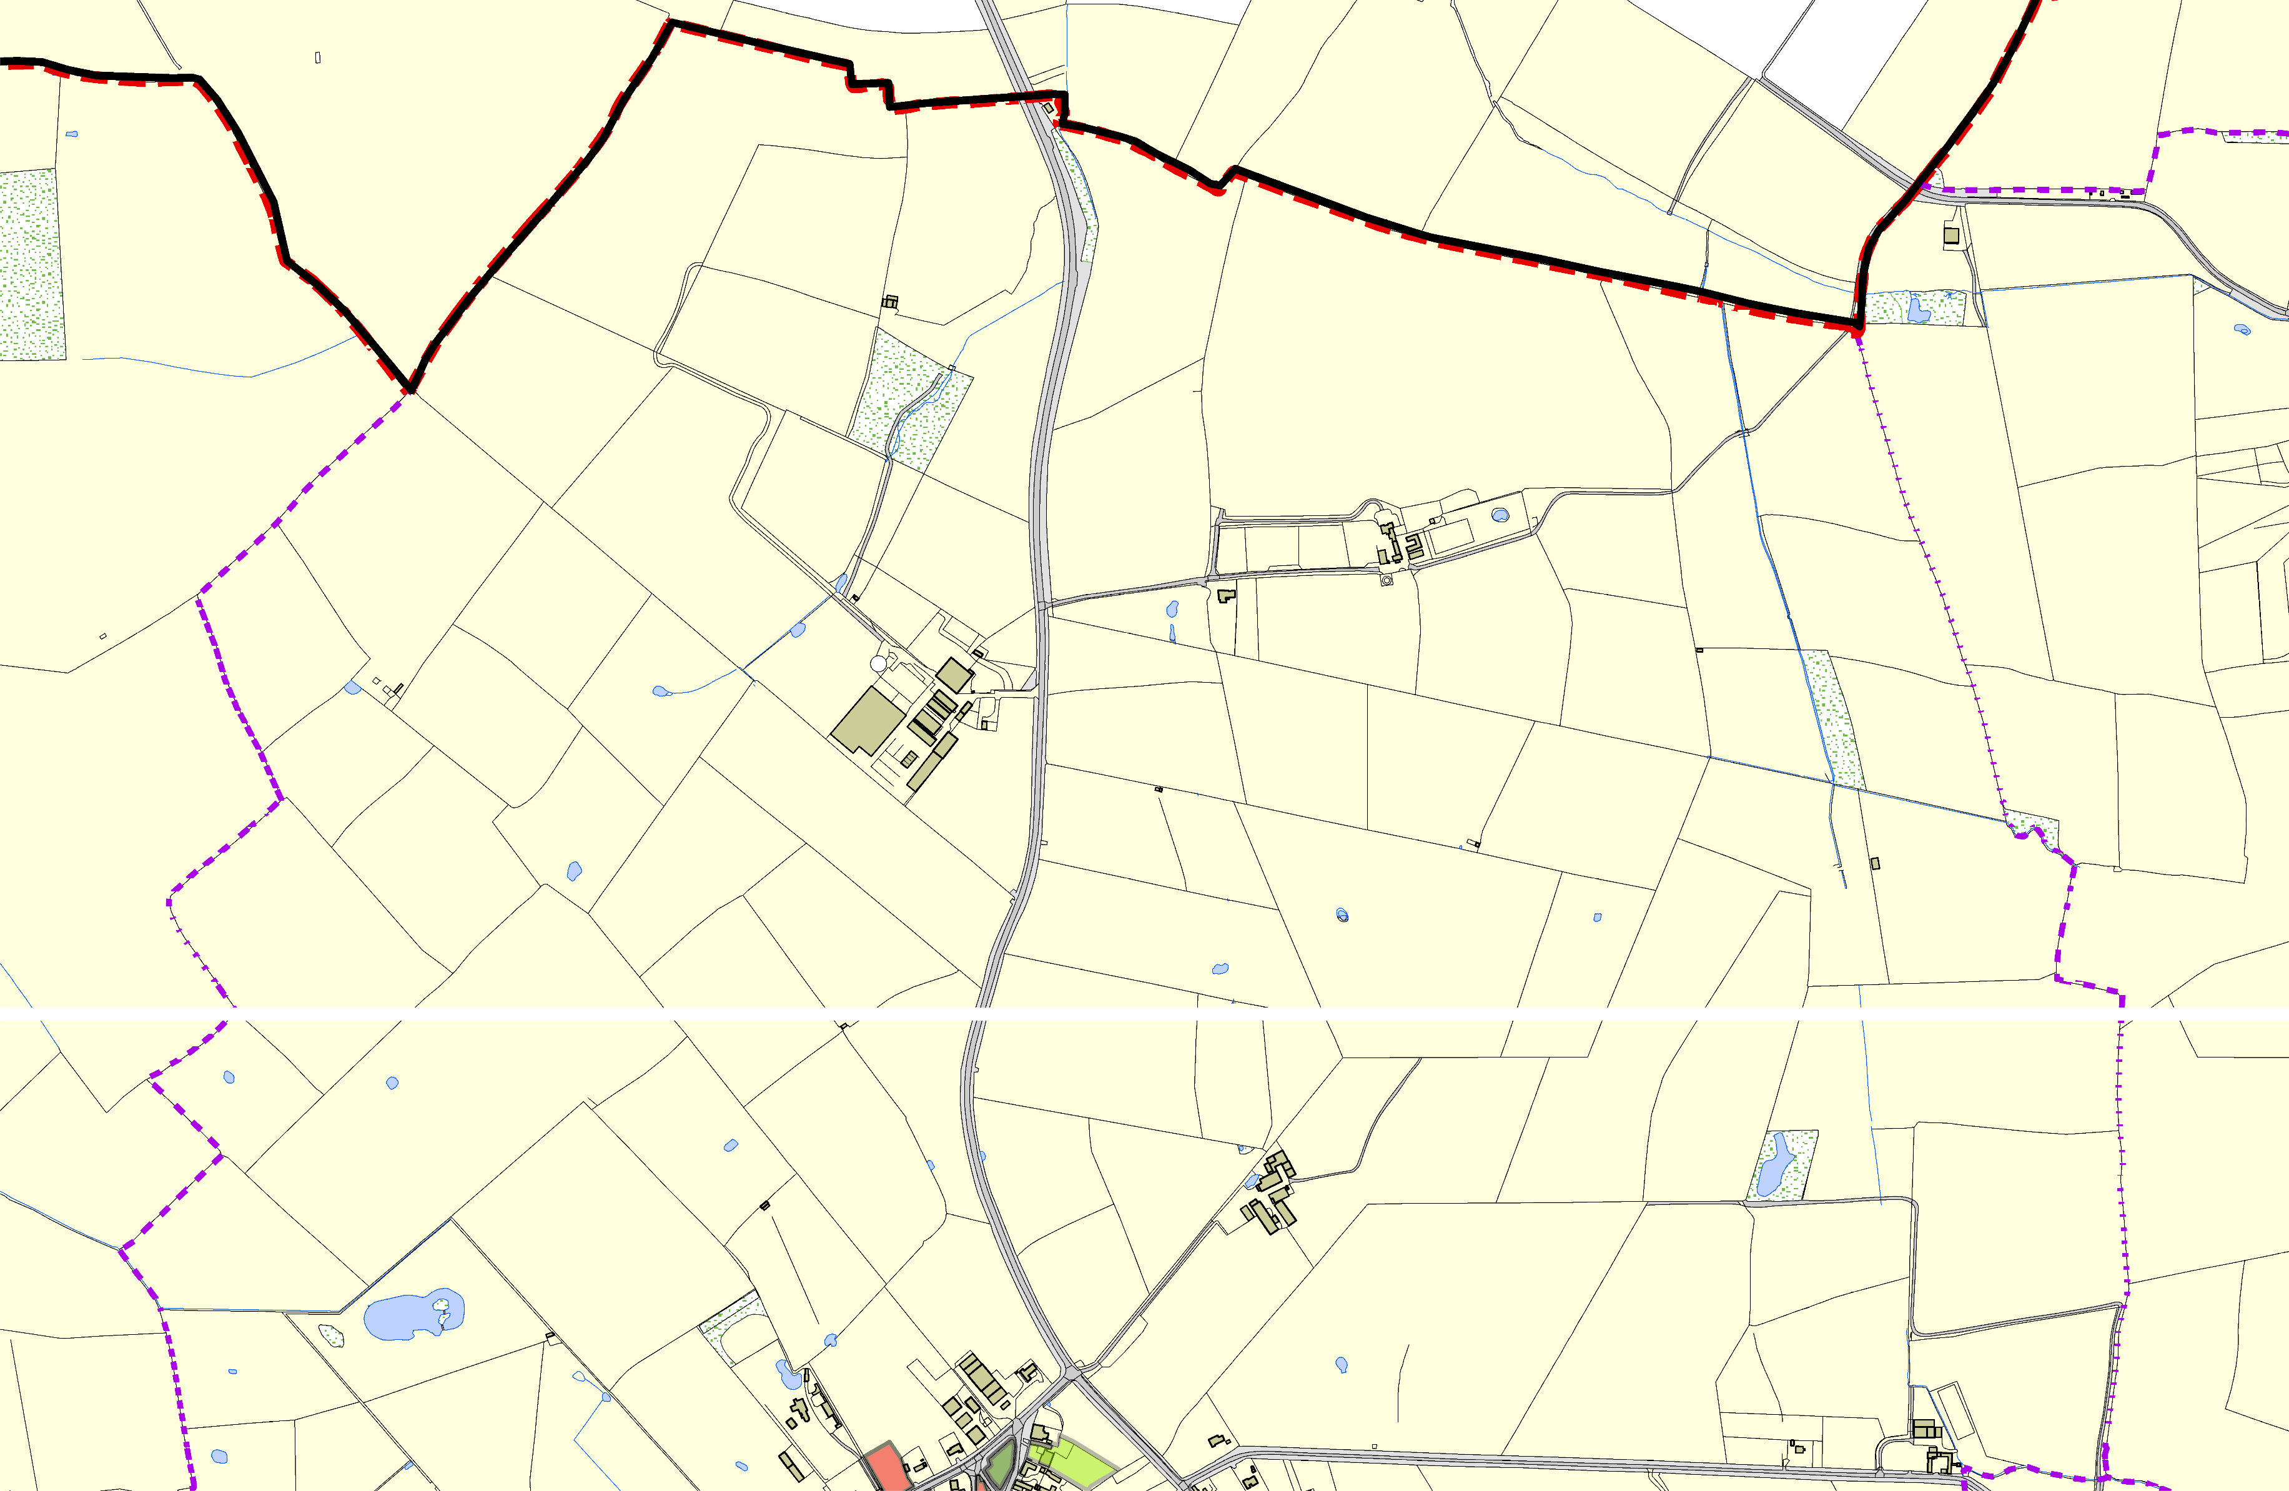
Arnesby OSSR sites, LGS sites and Wildlife Sites Note the LGS sites are proposals only at Sept 2015

Legend

LGS not designated designation of LGS Wildlife_sites_Harboro_region1

Open Space, Sport and Recreation Sites

Arnesby Ba
©Crown Copyright. All rights reserved. Harborough District Council 100023843 2014

ptist Chapel
LLGGSS//AARRNN//110- L- aSntdonbeeletwigeheAnrTnheesbLyaurels and Mill House Arnesby LGS/ARLNG/S3/A- ORNrc/h2a-rdB/eAellsootmneGnat rAdrennesAbrnyesby

