Arnesby OSSR sites, LGS sites and Wildlife Sites Note the LGS sites are proposals only at Sept 2015

Arnesby Baptist Chapel
LLGGSS//AARRNN//110- L- aSntdonbeeletwigeheAnrTnheesbLyaurels and Mill House Arnesby LGS/ARN/2 - Beeson Garden Arnesby
LGLSG/ASR/ANR/N4 /-3O-rOchrcahrda/rdA/lAlolltomtmenetnAt rAnrensebsyby
LGS/ARN/5 - The Firs Arnesby
Village Green, St Peters Road - Arnesby
LGS/ARN/6 - Paddock, Mill Hill Road Arnesby Village Hall
Village Green Mill Hill Road - Arnesby LGS/ARN/9 - Westfield, Lutterworth Road

LGS/PM/4 - Field adjacent to Tythe Barn Peatling Magna
LGS/ARN/7 - Orchard, Mill Hill Road Arnesby Arnesby Parish Church
LGS/ARN/8 - Paddock St Peters Road Arnesby

Arnesby Allotments

Boundary Ash 2, Bruntingthorpe

Boundary Ash 1, Bruntingthorpe

Legend

Shearsby Churchyard

LGS not designated
designation of LGS

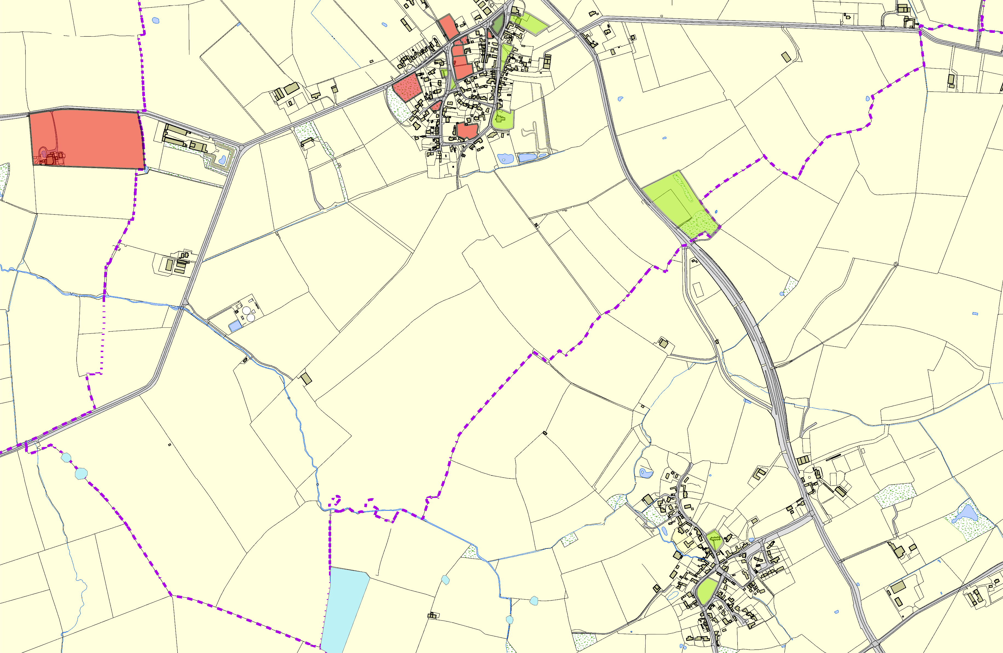
Thorpe Hill Farm, Shearsby; Mature Ash E

Thorpe Hill Farm, Shearsby; Mature Ash G
Thorpe Hill Farm, Shearsby; Field A
Hill Farm, Shearsby; Mature Ash D
Thorpe
©Crown Copyright. All rights reserved. Harborough District Council 100023843 2014

Shearsby Village Green

Wildlife_sites_Harboro_region1
Open Space, Sport and Recreation Sites

