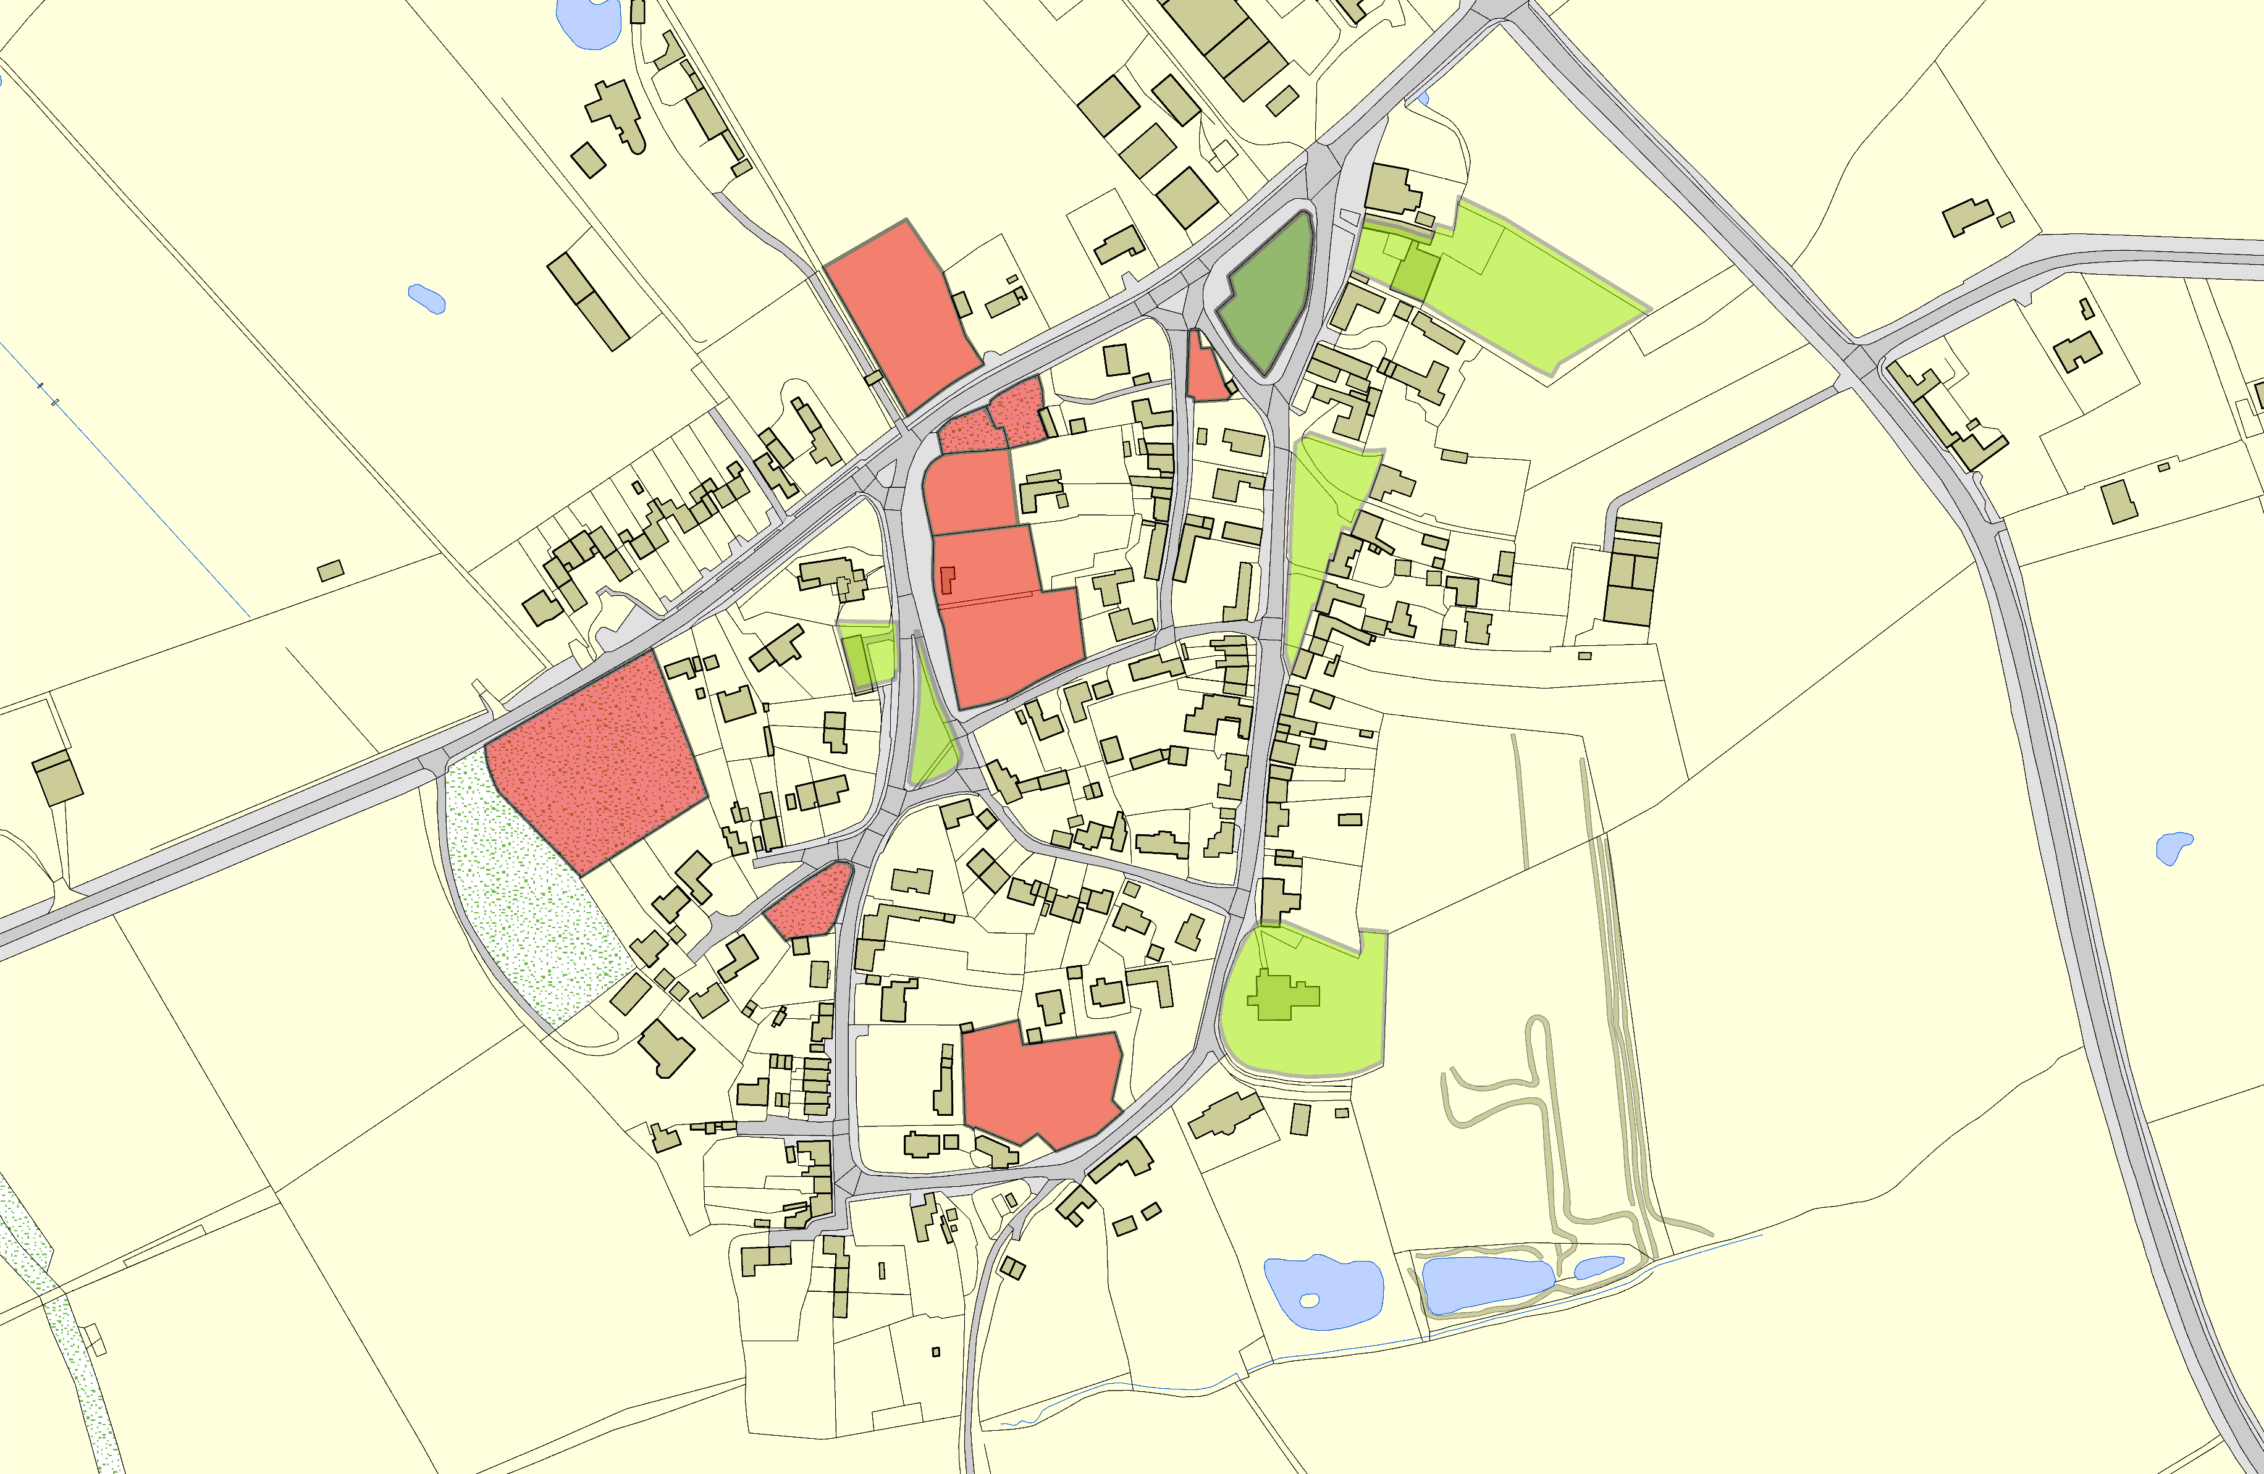
Arnesby OSSR sites, LGS sites and Wildlife Sites Note the LGS sites are proposals only at Sept 2015

LGS/ARN/10 - Stoneleigh Arnesby Arnesby Baptist Chapel LGS/ARN/1 - Land between The Laurels and Mill House Arnesby

LGS/ARN/2 - Beeson Garden Arnesby

LGS/ARN/3 - Orchard/Allotment Arnesby LGS/ARN/4 - Orchard/ Allotment Arnesby

LGS/ARN/5 - The Firs Arnesby
Village Green, St Peters Road - Arnesby

LGS/ARN/6 - Paddock, Mill Hill Road

Arnesby Village Hall

Village Green Mill Hill Road - Arnesby

LGS/ARN/9 - Westfield, Lutterworth Road

LGS/ARN/7 - Orchard, Mill Hill Road Arnesby

Arnesby Parish Church

LGS/ARN/8 - Paddock St Peters Road Arnesby

Legend

LGS not designated designation of LGS Wildlife_sites_Harboro_region1
©Crown Copyright. All rights reserved. Harborough District Council 100023843 2014
Open Space, Sport and Recreation Sites

