Ashby Magna OSSR sites, LGS sites and Wildlife Sites Note the LGS sites are proposals only at Sept 2015

St Mary's Churchyard - Willoughby Village Hall and Playground - Willoughby

Willow Pond Grassland (field pond) Willow Pond Grassland 2

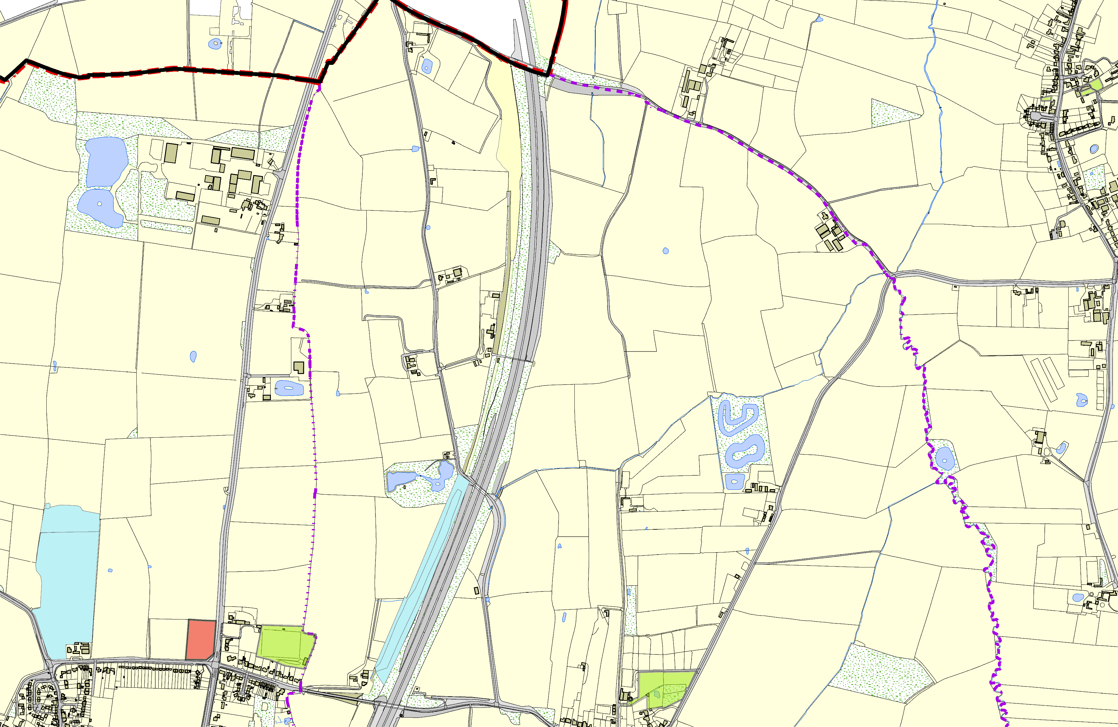
Crack Willow in field pond 2

Willow Pond Grassland

Ashby Magna Track and Embankment - Scrub Ashby Magna Track & Embankment - Grassland

LGS/DB/D - Parish Coucnil Field Dunton Bassett Football Ground - Dunton Bassett
©Crown Copyright. All rights reserved. Harborough District Council 100023843 2014

Ashby Magna Open Space
Legend

LGS not designated designation of LGS Wildlife_sites_Harboro_region1
Open Space, Sport and Recreation Sites

