**Ashby Magna OSSR sites, LGS sites and Wildlife Sites Note the LGS sites are proposals only at Sept 2015**

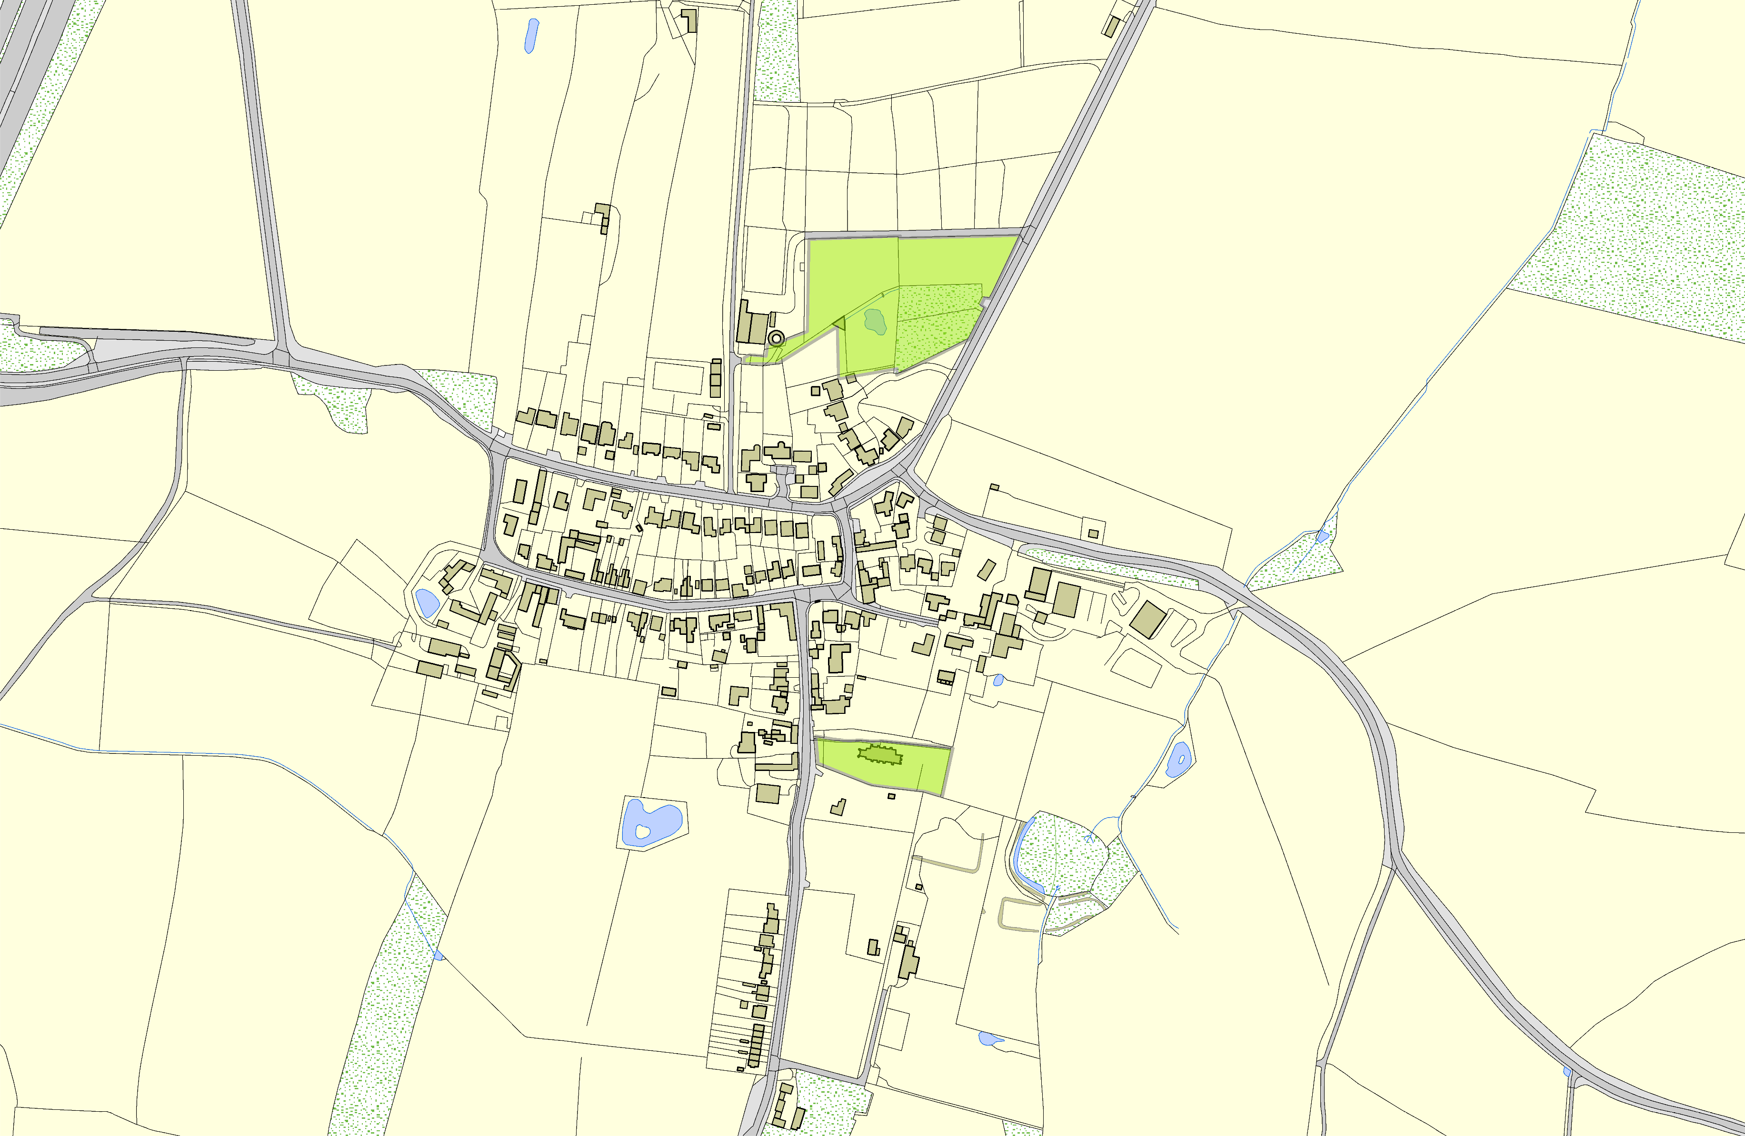

Ashby Magna Open Space

St Mary's Church - Ashby Magna

**Legend**

LGS not designated designation of LGS Wildlife_sites_Harboro_region1

Open Space, Sport and Recreation Sites

**©Crown Copyright. All rights reserved. Harborough District Council 100023843 2014**