Ashby Magna OSSR sites, LGS sites and Wildlife Sites Note the LGS sites are proposals only at Sept 2015

Willow Pond Grassland

Ashby Magna Track & Embankment - Grassland Ashby Magna Track and Embankment - Scrub

LGS/DB/D - Parish Coucnil Field Dunton Bassett Football Ground - Dunton Bassett

Ashby Magna Open Space

LGS/DB/A - Playground Dunton Bassett

Dunton Bassett Cricket Ground

All Saints Churchyard - Dunton Bassett

St Mary's Church - Ashby Magna

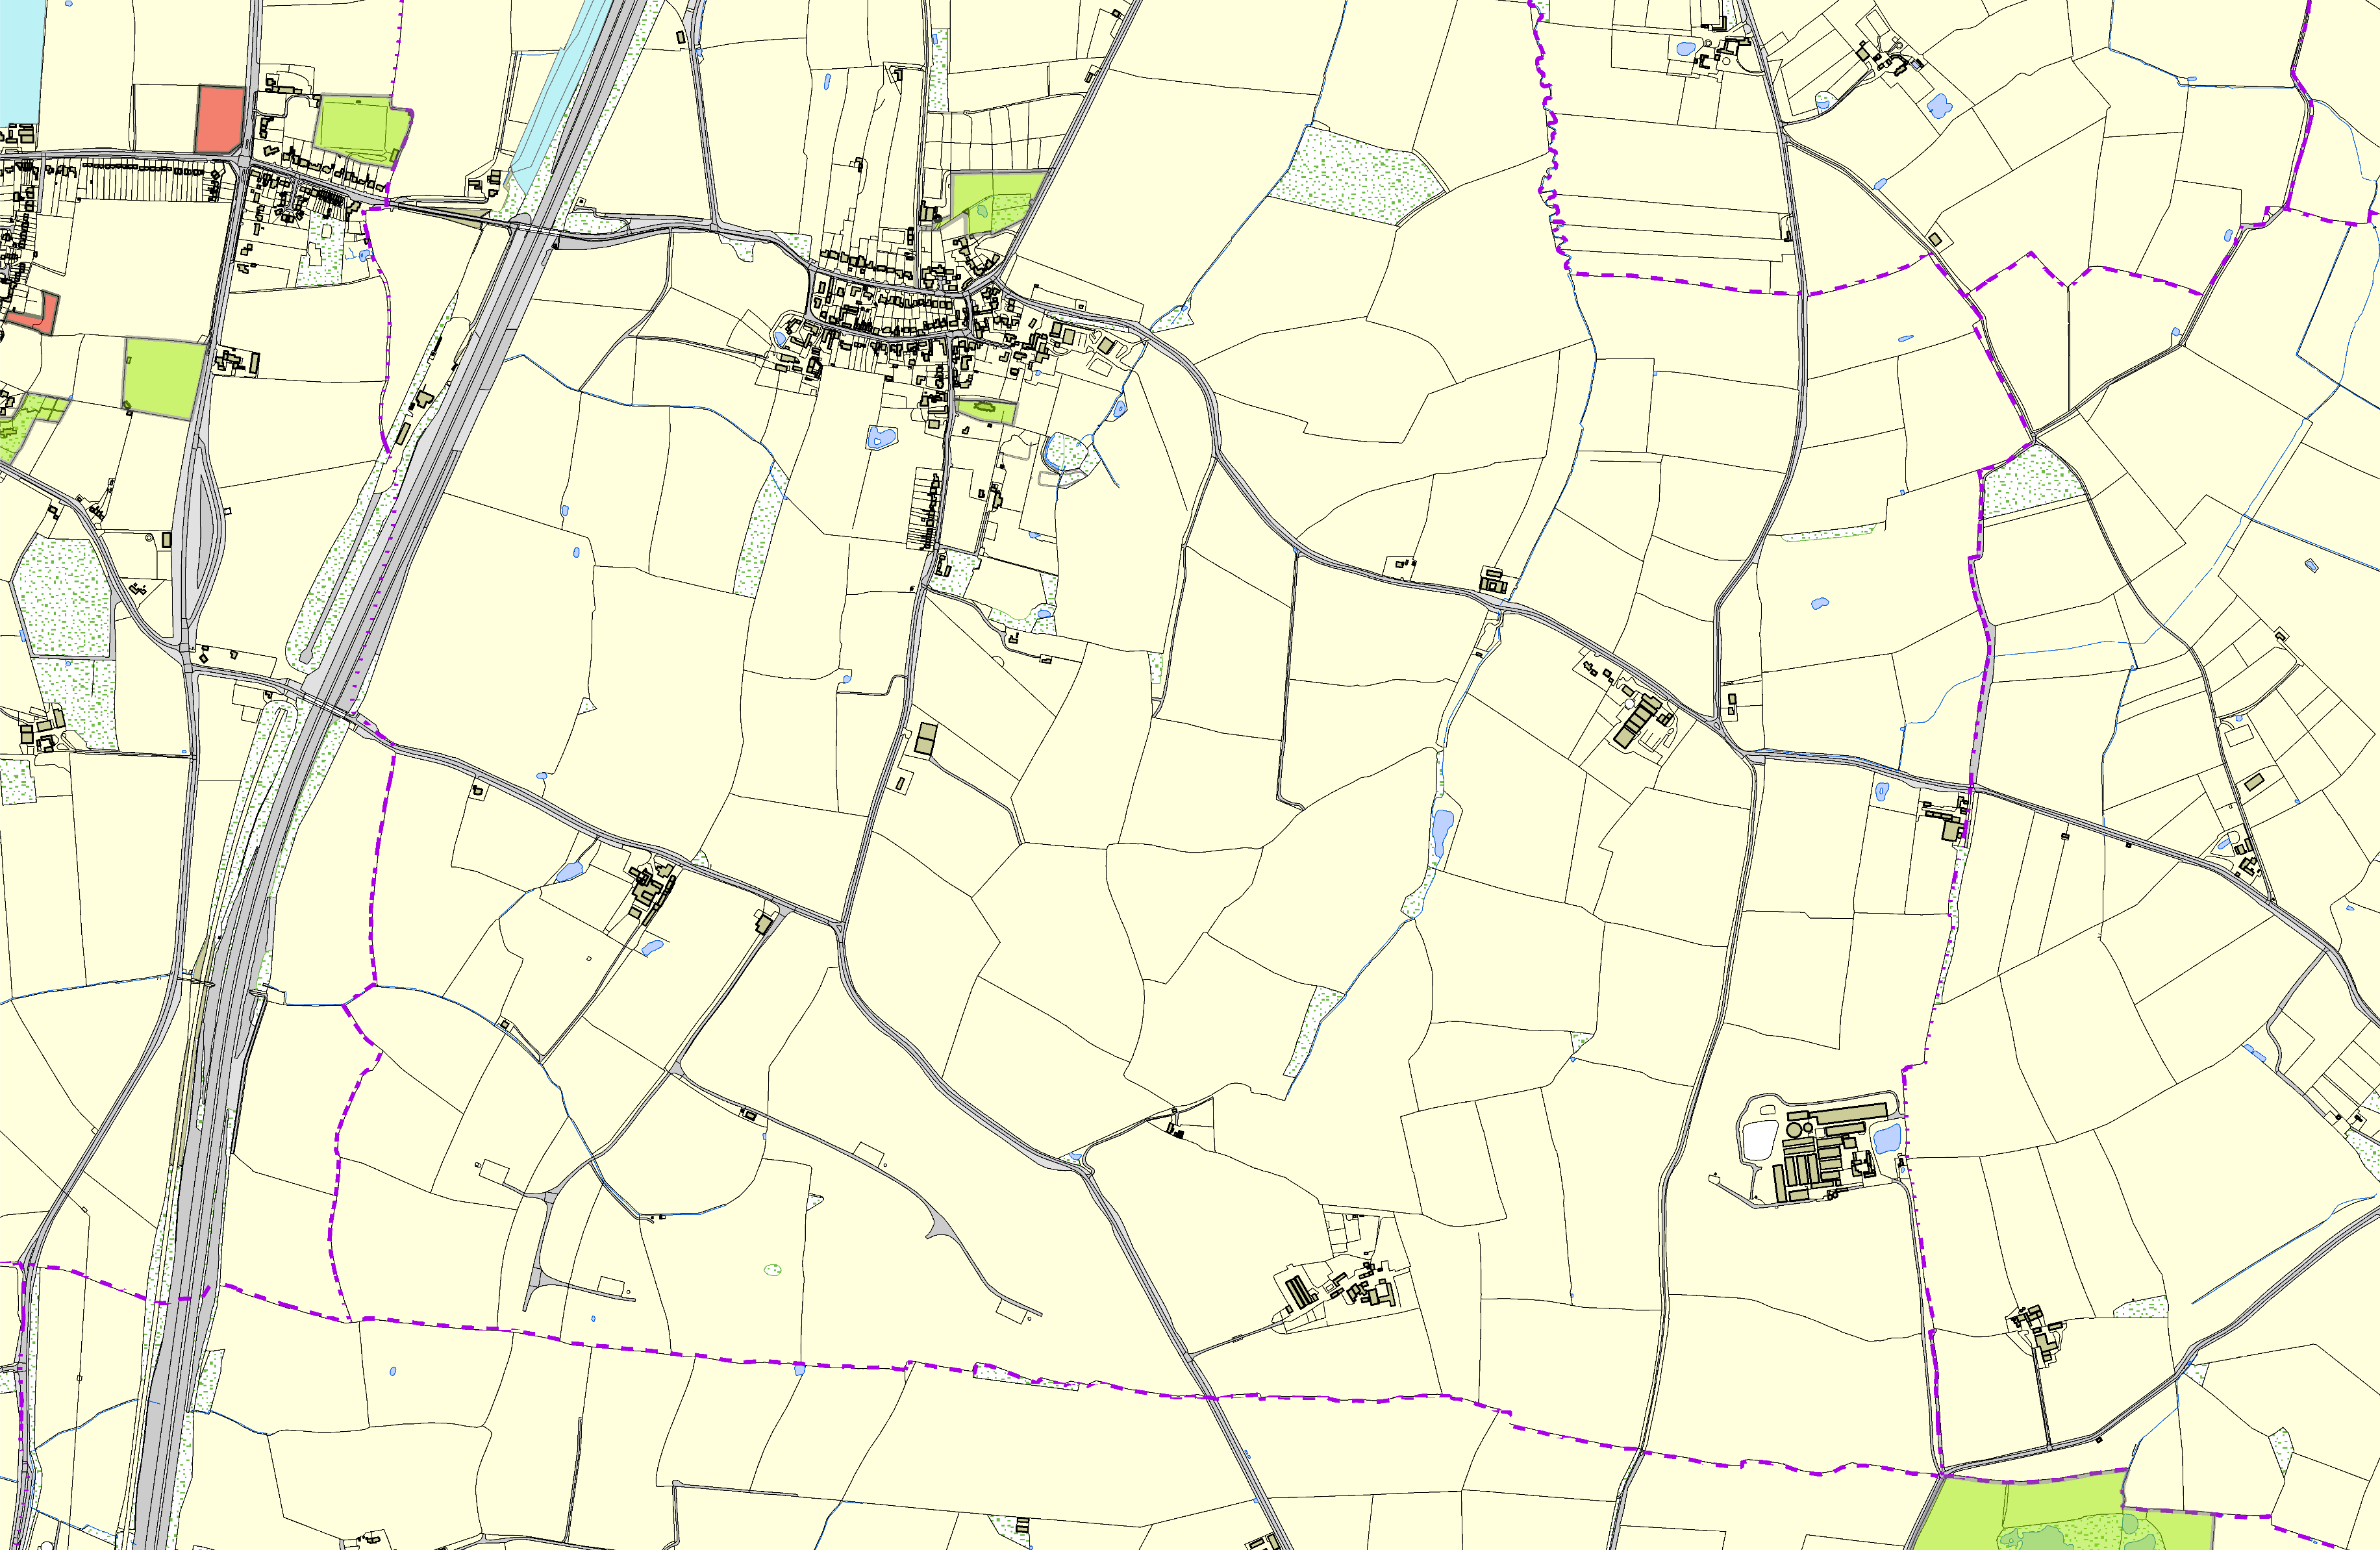

©Crown Copyright. All rights reserved. Harborough District Council 100023843 2014
Mill Farm Fishery - Gilmorton

