Ashby Parva OSSR sites, LGS sites and Wildlife Sites Note the LGS sites are proposals only at Sept 2015

Playing Fields - Leire

Dunton Bassett Quarry; Site BDunton Bassett Quarry; Site A Dunton Bassett Quarry; Site A

Jubilee Walk

Dunton Bassett Grassland

Wet Woodland, Dunton Bassett - Woodland

Hollow Willow
Buttercup Slope

Ullesthorpe Marsh, Ullesthorpe; Area 3 Ullesthorpe Railway

Frolesworth Road H dgerows - Pond

Beech Tree

Potamogeton Pond, Ashby Parva

Ullesthorpe Marsh, Ullesthorpe; Area 4

Ashby Parva Churchyard
Potamogeton Pond Meadow
Ashby Parva Meadows; Site A

Ullesthorpe Golf Course

Goodacre Meadows 1 Goodacre Meadows 2
Goodacre Meadows 2
Legend

Not recommended for LGS Designation Recommended for LGS designation Wildlife Sites

Ullesthorpe Playing Field

Open Space, Sport and Recreation Sites
OS MM Boundary
DESCTERM
!!!!!!!!!!!!!!!!!!!!! County

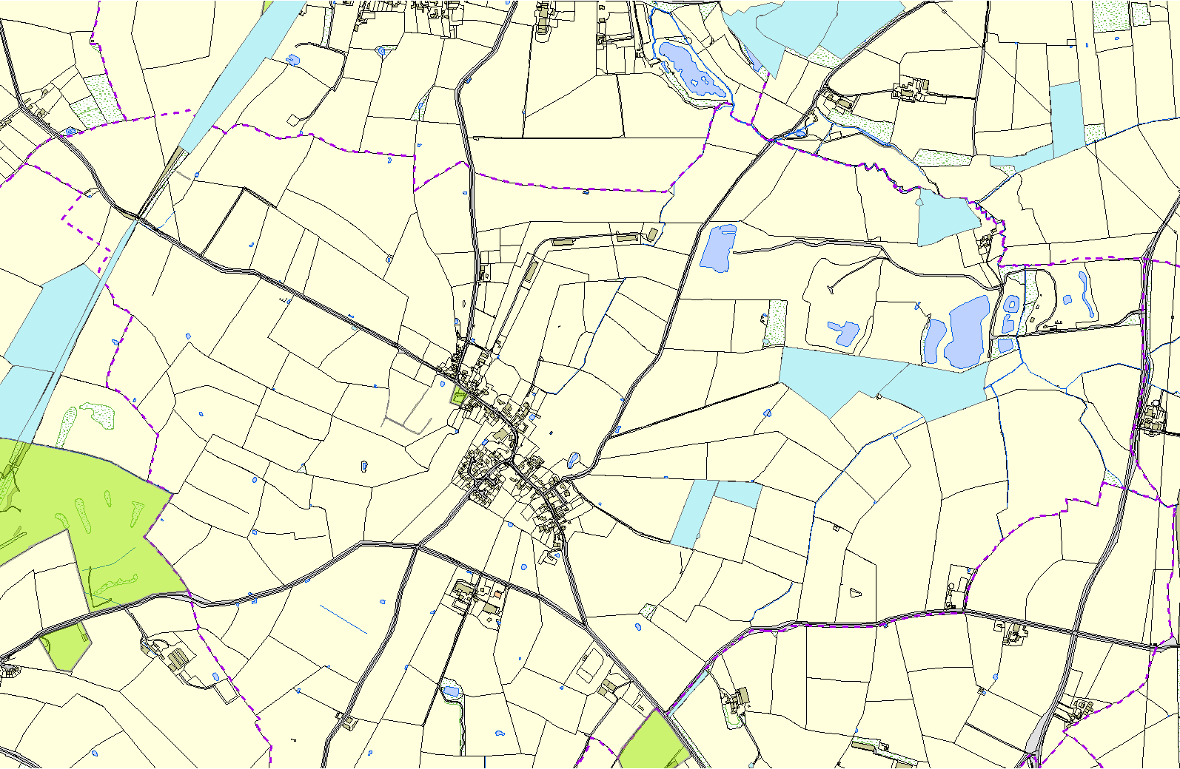
Hedgerow, Bitteswell

Rugby Club - Bitteswell
©Crown Copyright. All rights reserved. Harborough District Council 100023843 2014

Oa

District Electoral Parish

