Bringhurst OSSR sites, LGS sites and Wildlife Sites Note the LGS sites are proposals only at Sept 2015

Legend

Not recommended for LGS Designation

Recommended for LGS designation

Wildlife Sites

Open Space, Sport and Recreation Sites

OS MM Boundary
DESCTERM
!!!!!!!!!!!!!!!!!!!! County

Bringhurst Cemetery

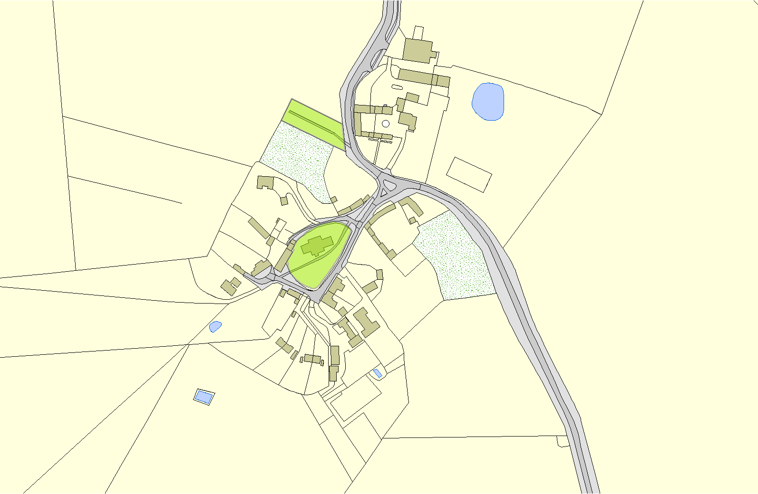
District Electoral Parish

St Nicholas Church - Bringhurst

©Crown Copyright. All rights reserved. Harborough District Council 100023843 2014

