Bringhurst OSSR sites, LGS sites and Wildlife Sites Note the LGS sites are proposals only at Sept 2015

Legend

LGS/GRTE/1 - Clarkes Piece Gt Easton

Not recommended for LGS Designation

Recommended for LGS designation Wildlife Sites

Bringhurst School

Open Space, Sport and Recreation Sites
OS MM Boundary
DESCTERM
!!!!!!!!!!!!!!!!!!!! County

Bringhurst Cemetery

Amenity Green Space St James Park, Drayton

District

Electoral Parish

St Nicholas Church - Bringhurst

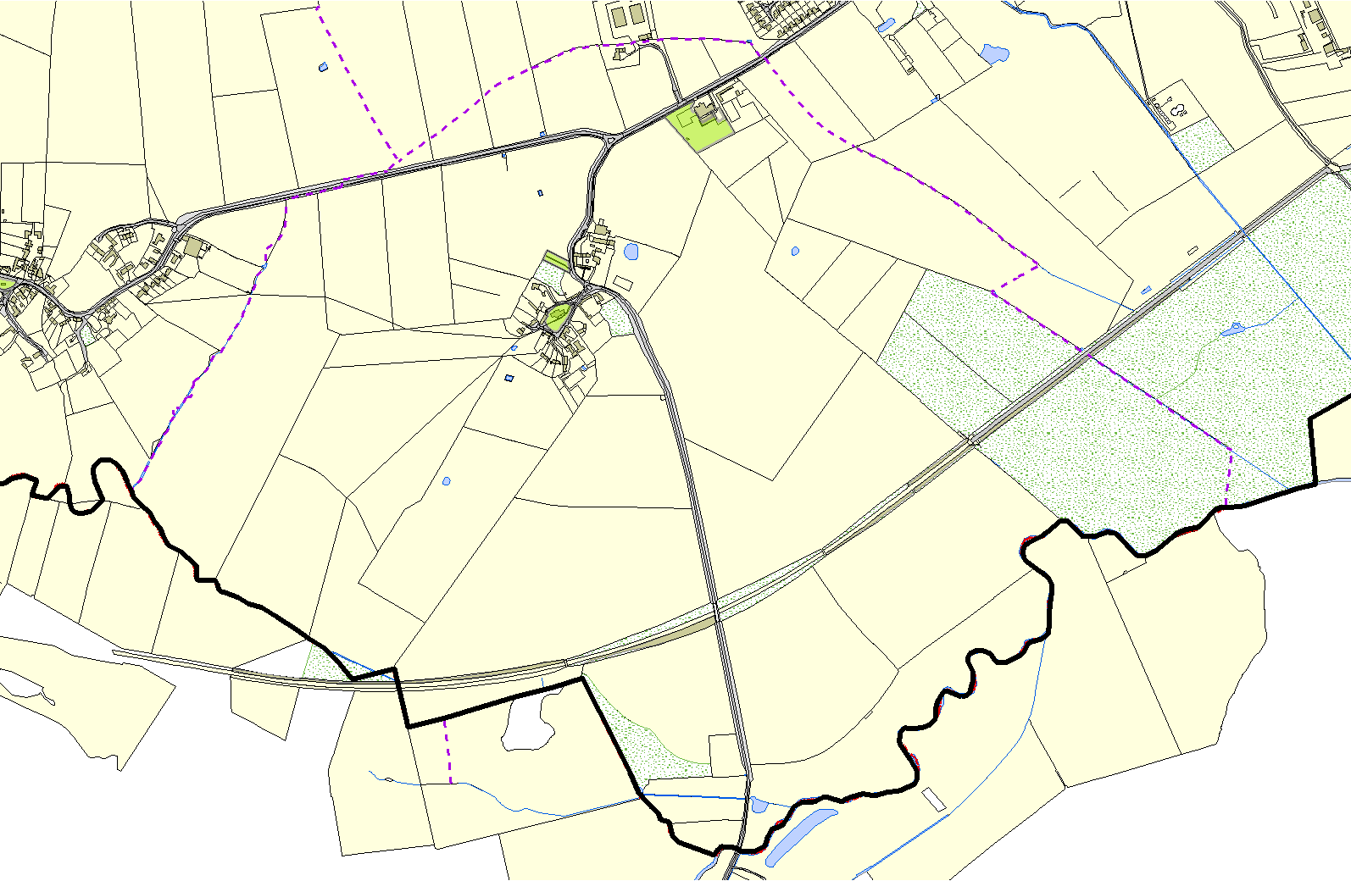

©Crown Copyright. All rights reserved. Harborough District Council 100023843 2014

