# Broughton Astley OSSR sites, LGS sites and Wildlife Sites Note the LGS sites are proposals only at Sept 2015

LGS/BA/1 - Land behind Sutton in the Elms Baptist Church

Sutton in the Elms Cemetery - Broughton Astley

Western Willows Allotments - Broughton Astley

Coventry Road/Broughton Way Junction Green Space - B

Uppingham Drive/Warwick Road - Broughton Astley

Broughton Astley Grassland/ Hay Field

Falcon Close, Broughton Astley

Leicester Road, Broughton Astley Leicester Road, Broughton Astley

Leicester Road, Broughton Astley

Primethorpe Meadows; Site B

**Legend**

Gorham Rise, Broughton Astley Gorham Rise, Broughton Astley

Gorham Rise, Broughton Astley

Malling Avenue, Broughton Astley

Blenheim Crescent Amenity Green - Broughton Astley

Amsden Rise, Broughton Astley Amsden Rise, Broughton Astley

Primethorpe Meadows; Site A Grassland, Broughton Astley

## Not recommended for LGS Designation Recommended for LGS designation

Grassland, Broughton Astley

Hobby Close Green Space - Broughton Astley

## Wildlife Sites

Open Space, Sport and Recreation Sites

**OS MM Boundary**

**DESCTERM**

!!!!!!!!!!!!!!!!!!!!! County

## District Electoral

Orchard School - Broughton Astley

LGS/BA2 - Land behind Frolesworth Road Recreation GrounMdemorial Gardens - Broughton Astley

LGS/BA/3 - Land south of Thomas Estley College

Thomas Estley Community College - Broughton Astley

## Parish

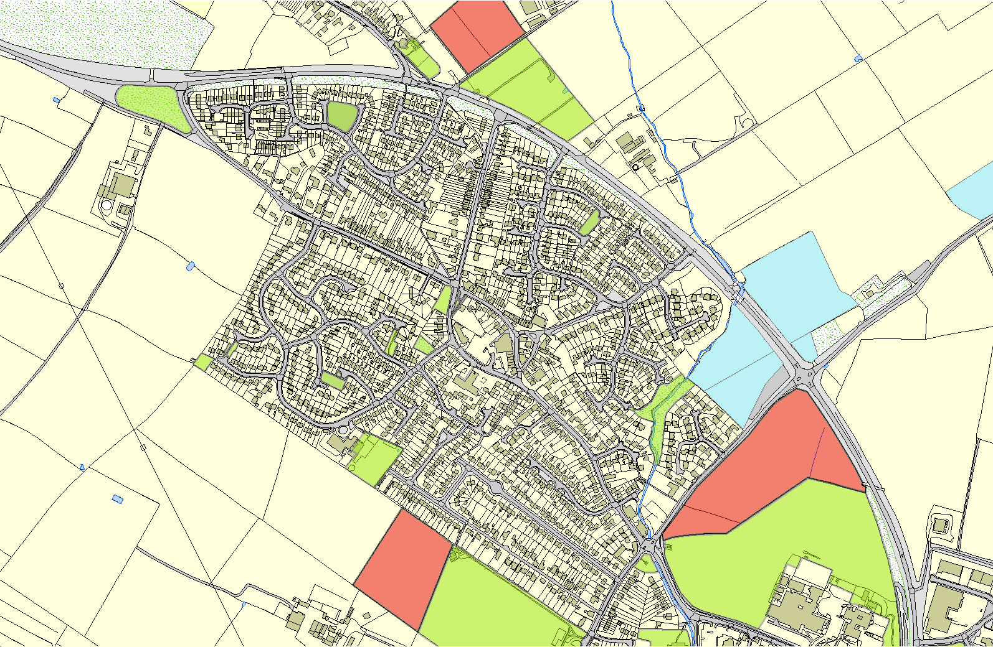

Road - Recreation Ground, BA

Frolesworth

**©Crown Copyright. All rights reserved. Harborough District Council 100023843 2014**

St Marys Churchyard - Brougton Astley

Croft Way/Swanington Road - Broughton Astley