# Broughton Astley OSSR sites, LGS sites and Wildlife Sites Note the LGS sites are proposals only at Sept 2015

Thomas Estley Community College - Broughton Astley

Frolesworth Road - Recreation Ground, BASt Marys Churchyard - Brougton Astley

Thomas Estley Community College - Broughton Astley

Croft Way/Swanington Road - Broughton Astley

Cottage Lane Play Area - Broughton Astley

Manton Close, Broughton Astley

Frolesworth Road Recreation Play Area - Broughton Astley

Holbeck Drive, Broughton Astley Holbeck Drive, Broughton Astley

Streamside Close Green Space - Broughton Astley

Harris Close, Broughton Astley Harris Close, Broughton Astley

Wyvern Close, Broughton Astley Croft Way, Broughton Astley

Staton Road Amenity Green Space - Broughton Astley Cotton Close, Broughton Astley

Townsend Close, Broughton Astley

Arkwright Farm, Burnside Road Balancing Lagoon

Sitch Close, Broughton Astley

Kiln Close, Broughton Astley

**Legend**

Burnside Road, Broughton Astley Burnside Road, Broughton Astley

Byre Crescent, Play Area - Broughton Astley

## Not recommended for LGS Designation

Recommended for LGS designation

Devitt Way Green Space - Broughton Astley

Devitt Way (Community Facility) - Broughton Astley

## Wildlife Sites

Open Space, Sport and RecreatiPoicnkeriSngiRteoasd Open Space - Broughton Astley

# OS MM Boundary

**DESCTERM**

Hall Farm Crescent, Broughton Astley

Coltsfoot Way / Clump Hill - Broughton Astley

Speedwell Drive, Broughton Astley

Orchid Place, Broughton Astley

Orchid Place, Broughton Astley

!!!!!!!!!!!!!!!!!!!!! County

## District Electoral

Hallbrook School - Broughton Astley

Coltsfoot Way / Clump Hill - Broughton Astley

Coltsfoot Way / Clump Hill - Broughton Astley

Broughton Lake Near Green space

## Parish

Foxglove Close, Broughton Astley

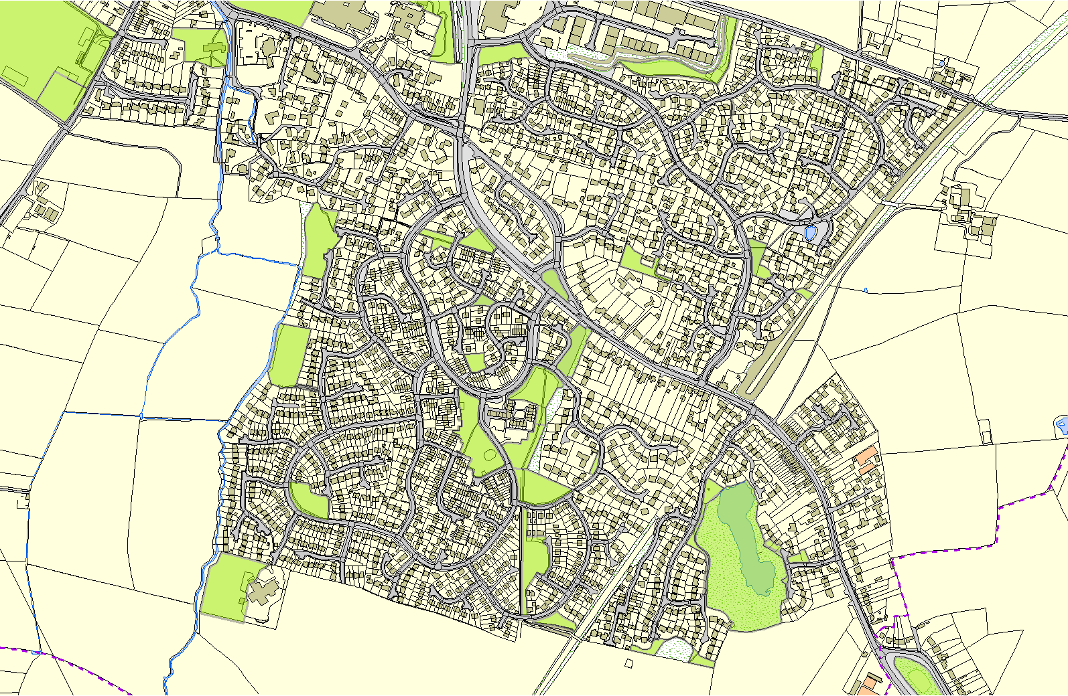

Dunton Road Natural Green Space - Broughton Astley

**©Crown Copyright. All rights reserved. Harborough District Council 100023843 2014**