# Broughton Astley OSSR sites, LGS sites and Wildlife Sites Note the LGS sites are proposals only at Sept 2015

**Legend**

## Not recommended for LGS Designation Recommended for LGS designation

Wildlife Sites

Open Space, Sport and Recreation Sites

**OS MM Boundary**

**DESCTERM**

!!!!!!!!!!!!!!!!!!!!! County

## District Electoral

Parish

Mill Cana , Mill on the So r Mill Canal, Mill on the Soar

Mill Canal, Mill on the Soar

Fishing lake + fringe - fen vegetation Mill on Soar Species rich area former paddock Mill on Soar

LGS/BA/1 - Land behind Sutton in the Elms Baptist Church Sutton in the Elms Cemetery - Broughton Astley

Western Willows Allotments - Broughton Astley Coventry Road/Broughton Way Junction Green Space - B

Uppingham Drive/Warwick Road - Broughton Astley

Broughton Astley Grassland/ Hay Field

Falcon Close, Broughton Astley

Leicester Road, Broughton Astley Leicester Road, Broughton Astley

Gorham Rise, Broughton Astley Malling Avenue, Broughton Astley Gorham Rise, Broughton Astley

Amsden Rise, Broughton Astley

Prim thorpe Meadows; Site B

Primethorpe Meadows; Site A Grassland, Broughton Astley

Grassland, Broughton Astley

Hobby Close Green Space - Broughton Astley

Orchard School - Broughton Astley

**©Crown Copyright. All rights reserved. Harborough District Council 100023843 2014**

LGS/BA/3 - Land south of Thomas Estley College

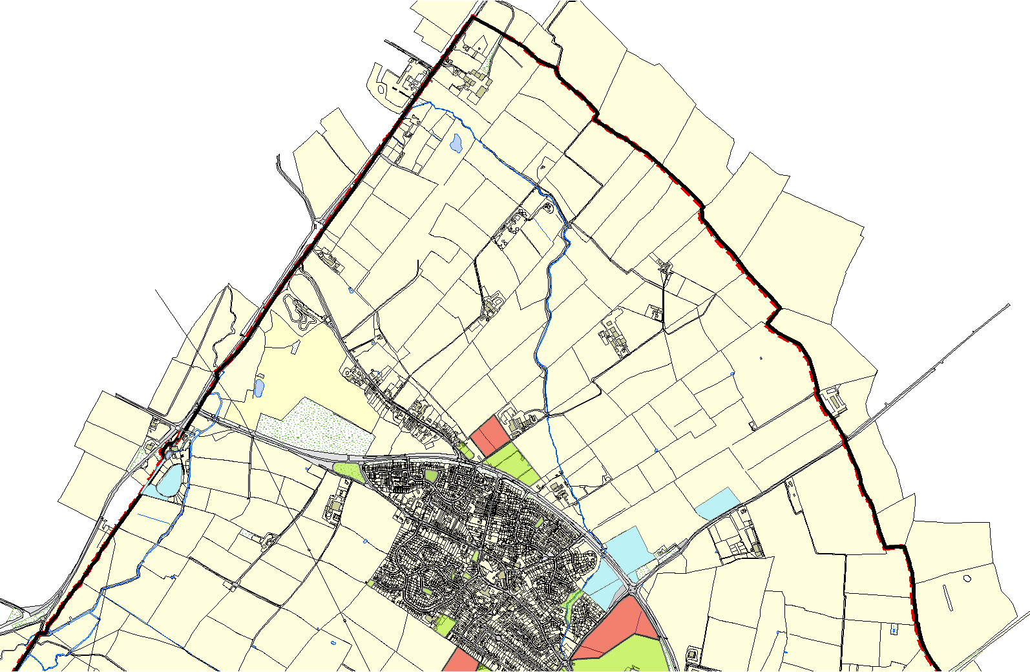

Thomas Estley Community College - Broughton Astley LGS/BA2 - Land behind Frolesworth Road Recreation Ground

Memorial Gardens - Broughton Astley