# Broughton Astley OSSR sites, LGS sites and Wildlife Sites Note the LGS sites are proposals only at Sept 2015

Leicester Road, Broughton Astley Gorham Rise, Broughton AstleyMalling Avenue, Broughton Astley

Gorham Rise, Broughton Astley

Amsden Rise, Broughton Astley

Pr methorpe Meadows; Site B Grassland, Broughton Astley Grassland, Broughton Astley

Hobby Close Green Space - Broughton Astley

Orchard School - Broughton Astley

LGS/BA/3 - Land south of Thomas Estley College

Thomas Estley Community College - Broughton Astley behind Frolesworth Road Recreation Ground

LGS/BA2 - Land

M

emorial Gardens - Broughton Astley

Frolesworth Road - Recreation Ground, BA

St Marys Churchyard - Brougton AstleyCroft Way/Swanington Road - Broughton Astley Manton Close, Broughton Astley

Cottage Lane Play Area - Broughton Astley

Frolesworth Road Recreation Play Area - Broughton Astley

Holbeck Drive, Broughton Astley

Frolesworth Road Cemetery - Broughton Astley

Harris Close, Broughton Astley Streamside Close Green Space - Broughton Astley

Harris Close, Broughton AstleyWyvern Close, Broughton Astley Croft Way, Broughton Astley

Staton Road Amenity Green Space - Broughton Astley Townsend Close, Broughton Astley Cotton Close, Broughton Astley

**Legend**

## Not recommended for LGS Designation

Arkwright Farm, Burnside Road Balancing LagoonKiln Close, Broughton Astley Burnside Road, Broughton AstleyByre Crescent, Play Area - Broughton Astley

Devitt Way Green Space - Broughton Astley

Devitt Way (Community Facility) - Broughton Astley

Coltsfoot Way / Clump Hill - Broughton Astley

## Recommended for LGS designation

Pickering Road Open Space - Broughton Astley

Speedwell Drive, Broughton Astley

Orchid Place, Broughton Astley

Coltsfoot Way / Clump Hill - Broughton Astley Broughton Lake Near Green space

## Wildlife Sites

Open Space, Sport and Recreation Sites

**OS MM Boundary**

**DESCTERM**

!!!!!!!!!!!!!!!!!!!!! County

Hallbrook School - Broughton Astley

Orchid Place, Broughton Astley

Coltsfoot Way / Clump Hill - Broughton Astley

Foxglove Close, Broughton Astley

Dunton Road Natural Green Space - Broughton Astley

Allotments at Dunton Bassett

## District Electoral

Parish

St

Nicholas Churchyard - Frolesworth

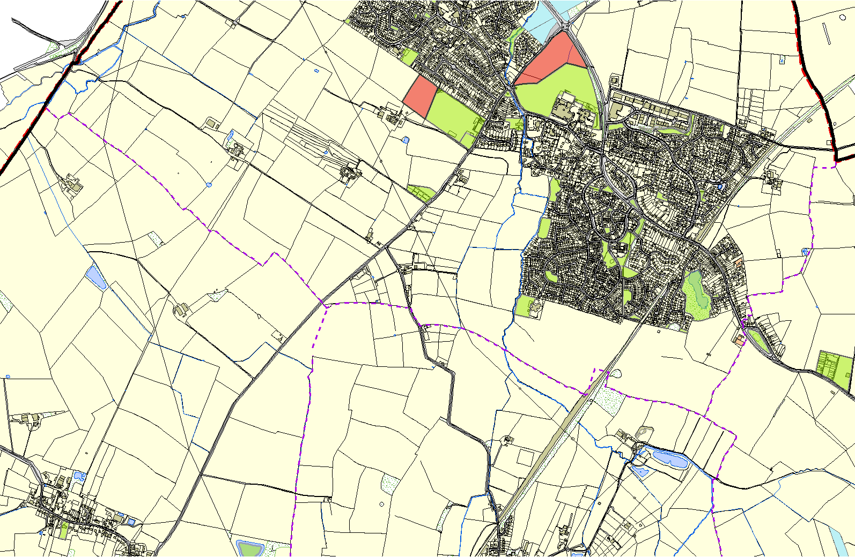

**©Crown Copyright. All rights reserved. Harborough District Council 100023843 2014**

Frolesworth Irrigation Lake 2

Spring-fed marshy grassland Dunton Bassett