Burton Overy OSSR sites, LGS sites and Wildlife Sites Note the LGS sites are proposals only at Sept 2015
Pheasant Woodland

Old Oak

Stackley House Grassland

Ancient Ash

LegLGeS/GnRTdG/4 - Bund to Miller Homes Site (GG2)

Not recommended for LGS Designation Recommended for LGS designation
LGS/BO/5a - land to west of Scotland Lane 2 LLGGSS/B/BOO/5/2b--Plaansdtutorewleasntdoef aSsctootlfaSncdoLtlaanned 1Lane

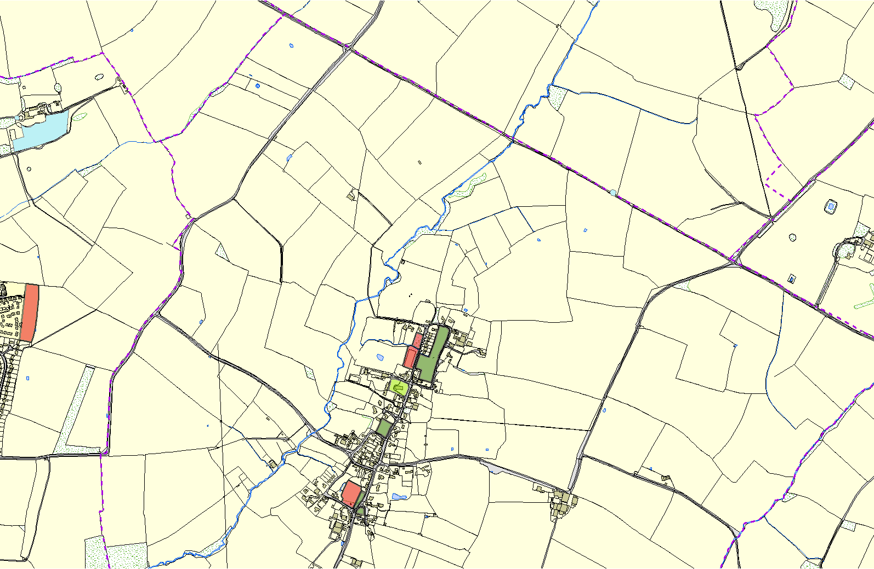
Wildlife Sites

Open Space, Sport and Recreation Sites
OS MM Boundary
DESCTERM
!!!!!!!!!!!!!!!!!!!! County

District Electoral Parish
©Crown Copyright. All rights reserved. Harborough District Council 100023843 2014

St Andrews Church - Burton Avery

LGS/BO/1 - Main Street Pasture

LGS/BO/4 - Traffic Island Bell Lane

LGS/BO/7b - Old Heather Garden 1 LGS/BO/7a - The Old Heather Garden
LGS/BO3 - Main Street Spinney

