# Claybrooke Magna OSSR sites, LGS sites and Wildlife Sites Note the LGS sites are proposals only at Sept 2015

**Legend**

H oad Allotments - Claybrooke Magna Claybrooke Magna Village Green

igh Cross R

Not recommended for LGS DesignationMilestone Hollow - Claybrooke Magna

Harrisons Field Childrens Playground - Claybrooke

## Recommended for LGS designation

Wildlife Sites

Open Space, Sport and Recreation Sites

**OS MM Boundary**

**DESCTERM**

!!!!!!!!!!!!!!!!!!!! County

## District Electoral

## Parish

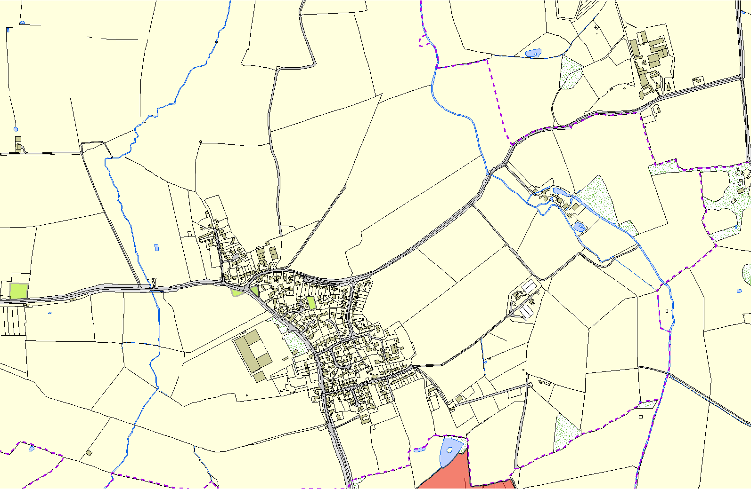

**©Crown Copyright. All rights reserved. Harborough District Council 100023843 2014**

LGS/CLAPA/2 - Park Field Ullesthorpe Road