# Cold Newton OSSR sites, LGS sites and Wildlife Sites Note the LGS sites are proposals only at Sept 2015

**Legend**

Not recommended for LGS Designation

Recommended for LGS designation Wildlife Sites

Village Green - Cold Newton

Open Space, Sport and Recreation Sites

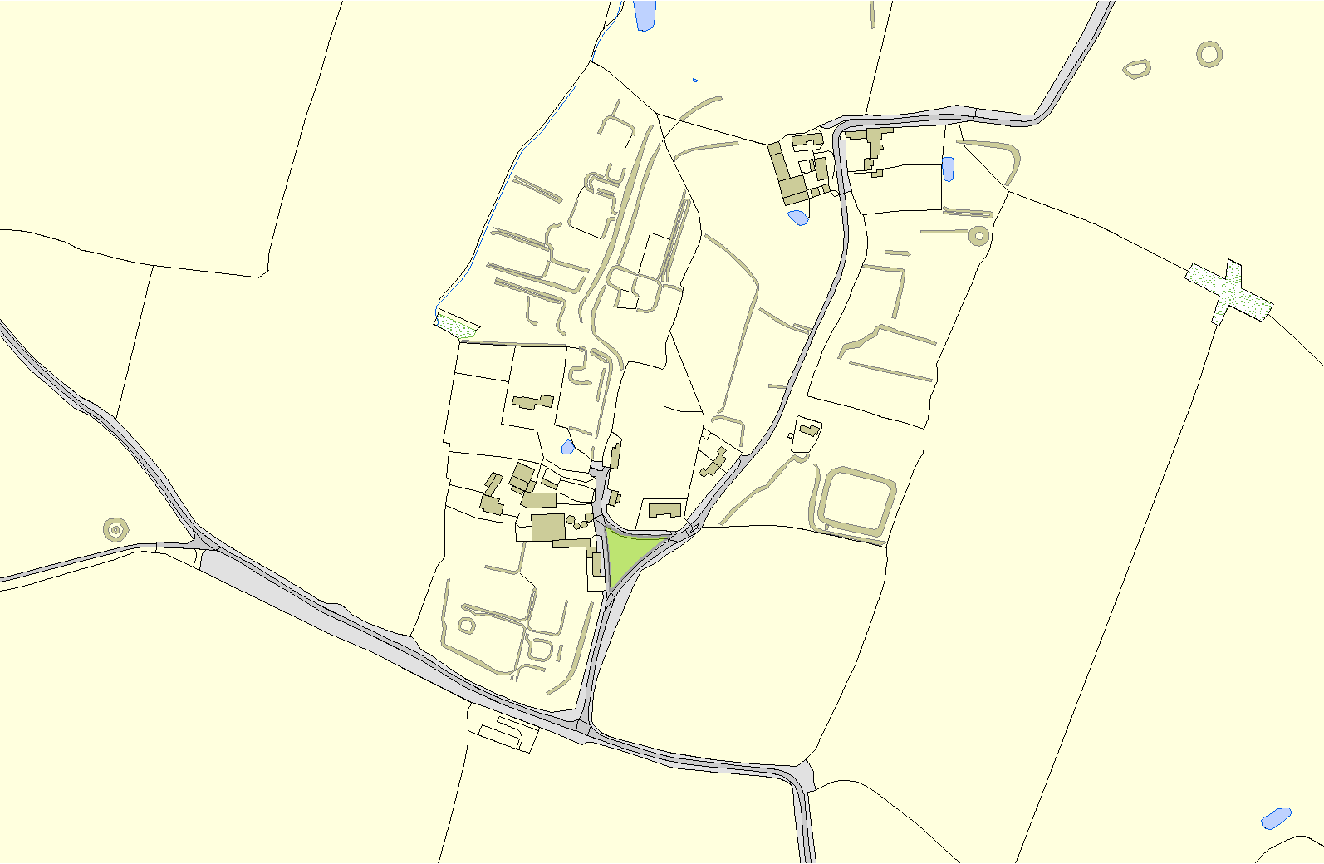

# OS MM Boundary

**DESCTERM**

!!!!!!!!!!!!!!!!!!!! County

District Electoral

Parish

**©Crown Copyright. All rights reserved. Harborough District Council 100023843 2014**