# Cold Newton OSSR sites, LGS sites and Wildlife Sites Note the LGS sites are proposals only at Sept 2015

Village Green - Cold Newton

Hammer's Lodge Farm, Cold Newton

Cold Newton Railway (East)

Quenby Wood

**Legend**

## Not recommended for LGS Designation Recommended for LGS designation Wildlife Sites

The Hills Meadow, Cold Newton

## Open Space, Sport and Recreation Sites

**OS MM Boundary**

**DESCTERM**

Scrub, Grassland & Flush, Quenby Hall

!!!!!!!!!!!!!!!!!!!! County

## District

Scrub, GraEsslleancdt&oFrluaslh, Quenby Hall

The Wigglies (East) The Wigglies (West)

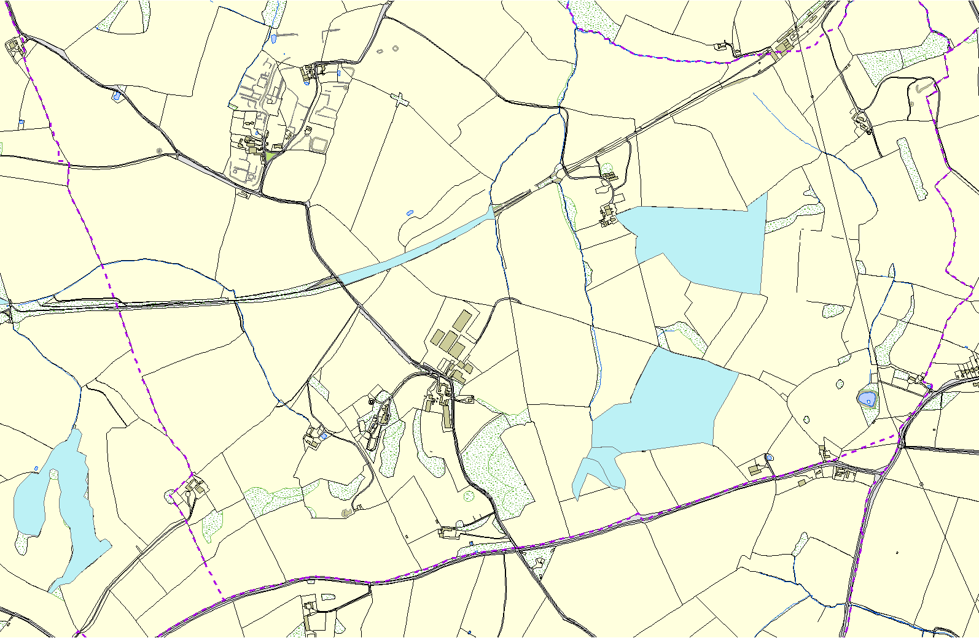

## Parish

**©Crown Copyright. All rights reserved. Harborough District Council 100023843 2014**