# Cold Newton OSSR sites, LGS sites and Wildlife Sites Note the LGS sites are proposals only at Sept 2015

The Hills Meadow, Cold Newton

The Wigglies (East)

**Legend**

The Wigglies (West)

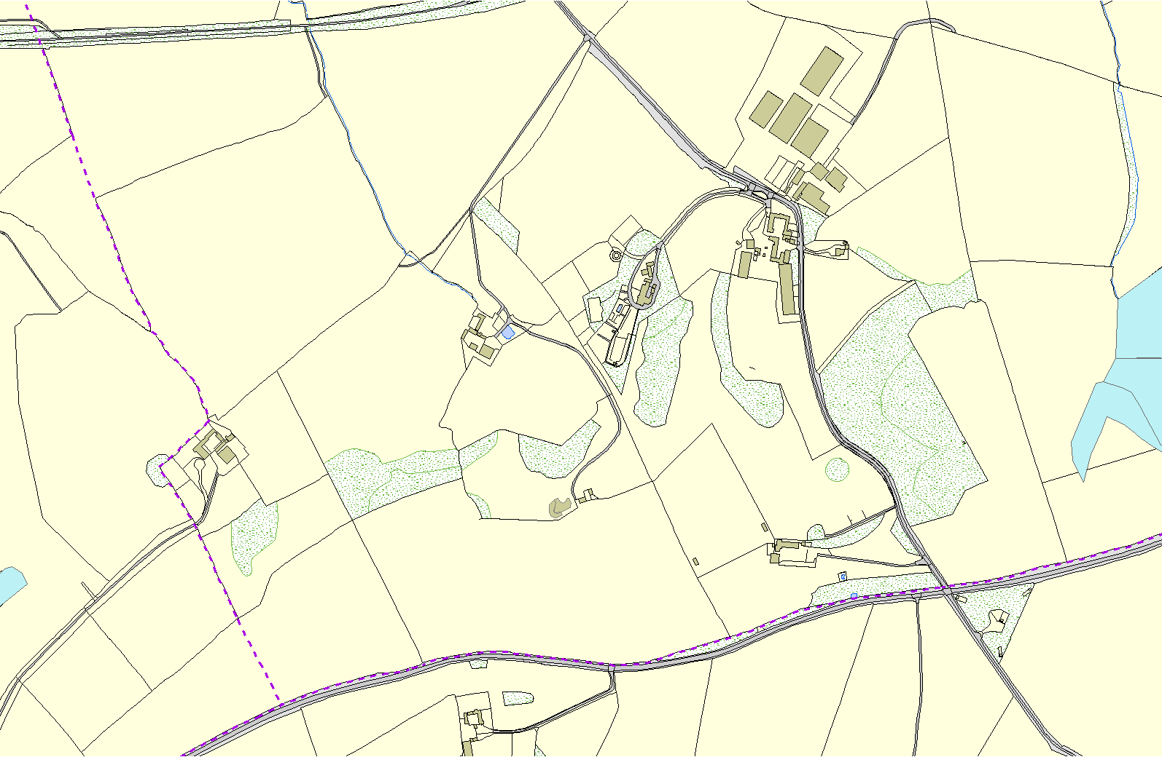

Not recommended for LGS Designation

Recommended for LGS designation Wildlife Sites

Open Space, Sport and Recreation Sites

# OS MM Boundary

Scrub, Grassland & Flush, Quenby Hall

**DESCTERM**

!!!!!!!!!!!!!!!!!!!! County

District Electoral

Parish

**©Crown Copyright. All rights reserved. Harborough District Council 100023843 2014**