# Cranoe OSSR sites, LGS sites and Wildlife Sites Note the LGS sites are proposals only at Sept 2015

**Legend**

Not recommended for LGS Designation

Recommended for LGS designation Wildlife Sites

Open Space, Sport and Recreation Sites

# OS MM Boundary

**DESCTERM**

!!!!!!!!!!!!!!!!!!!!! County

District Electoral

Glebe Farm Hallaton; Area B

Glebe Farm Hallaton; Area A Glebe Farm Hallaton; Area C

Parish

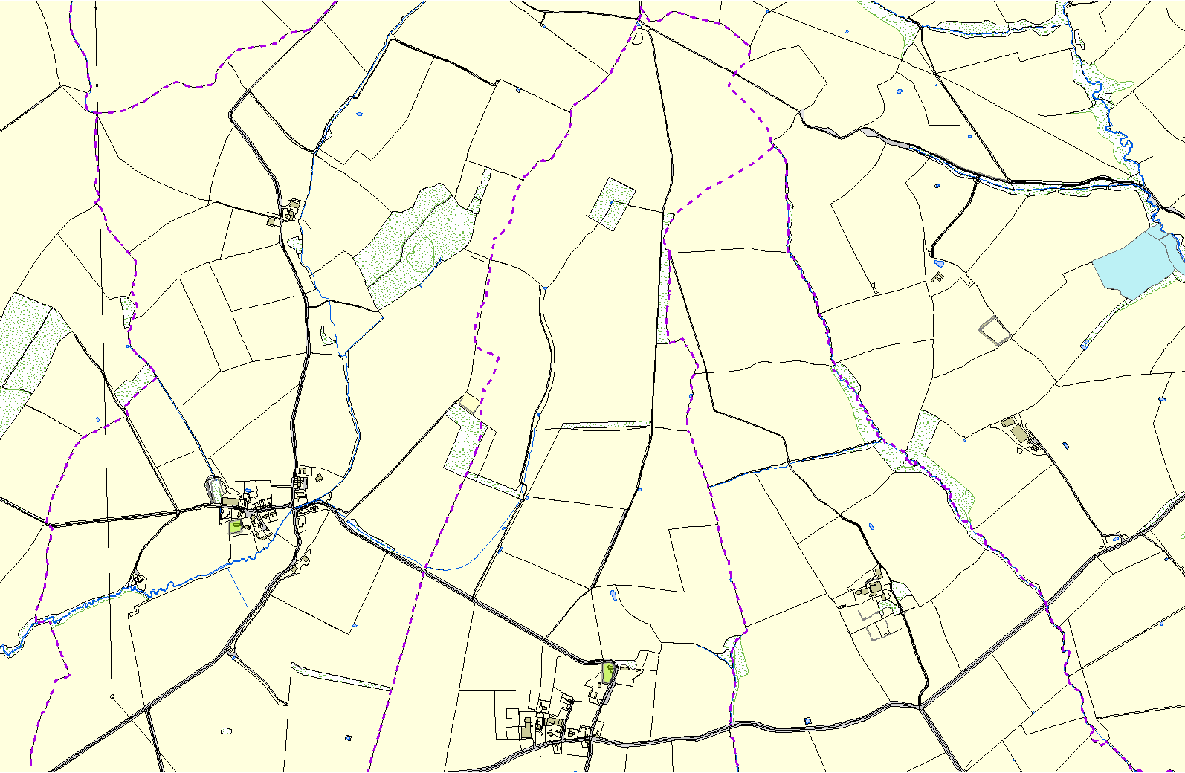

Church in Glooston

St Michael & All Angels Churchyard, Cranoe

**©Crown Copyright. All rights reserved. Harborough District Council 100023843 2014**