Drayton OSSR sites, LGS sites and Wildlife Sites Note the LGS sites are proposals only at Sept 2015

Legend

Not recommended for LGS Designation

Recommended for LGS designation Wildlife Sites
Open Space, Sport and Recreation Sites

OS MM Boundary
DESCTERM
!!!!!!!!!!!!!!!!!!!! County
District Electoral

Parish

Amenity Green Space St James Park, Drayton

Amenity Green Space St James Park, Drayton

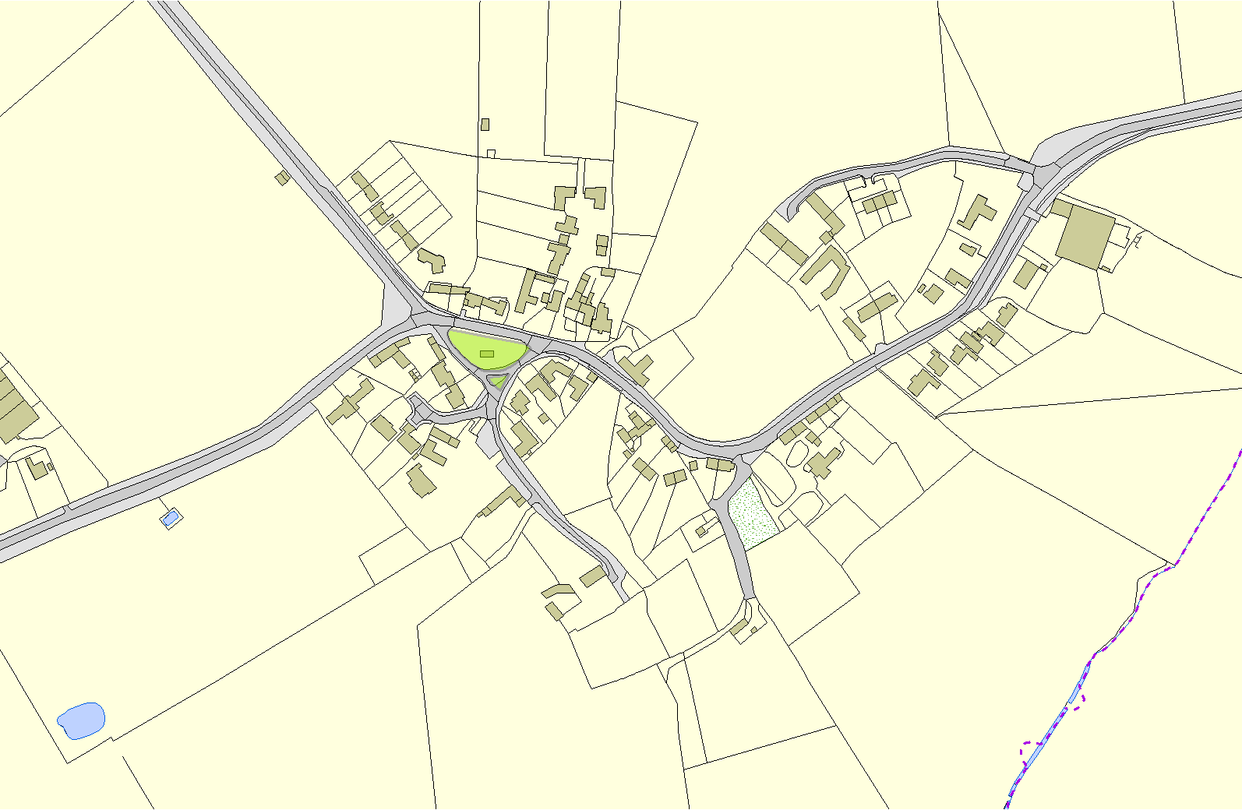

©Crown Copyright. All rights reserved. Harborough District Council 100023843 2014

