Dunton Bassett OSSR sites, LGS sites and Wildlife Sites Note the LGS sites are proposals only at Sept 2015

LGS/DB/C - Wild Area nxt to Leicestershire Round Footpath

LGS/DB/B - Primary School Playing Field
LGS/DB/A - Playground Dunton Bassett

Dunton Bassett Cricket Ground

Spring-fed marshy grassland Dunton Bassett

All Saints Churchyard - Dunton Bassett
LGS/DB/E - Little Lunnon triangle

Land at Leire Lane - Dunton Bassett
Legend

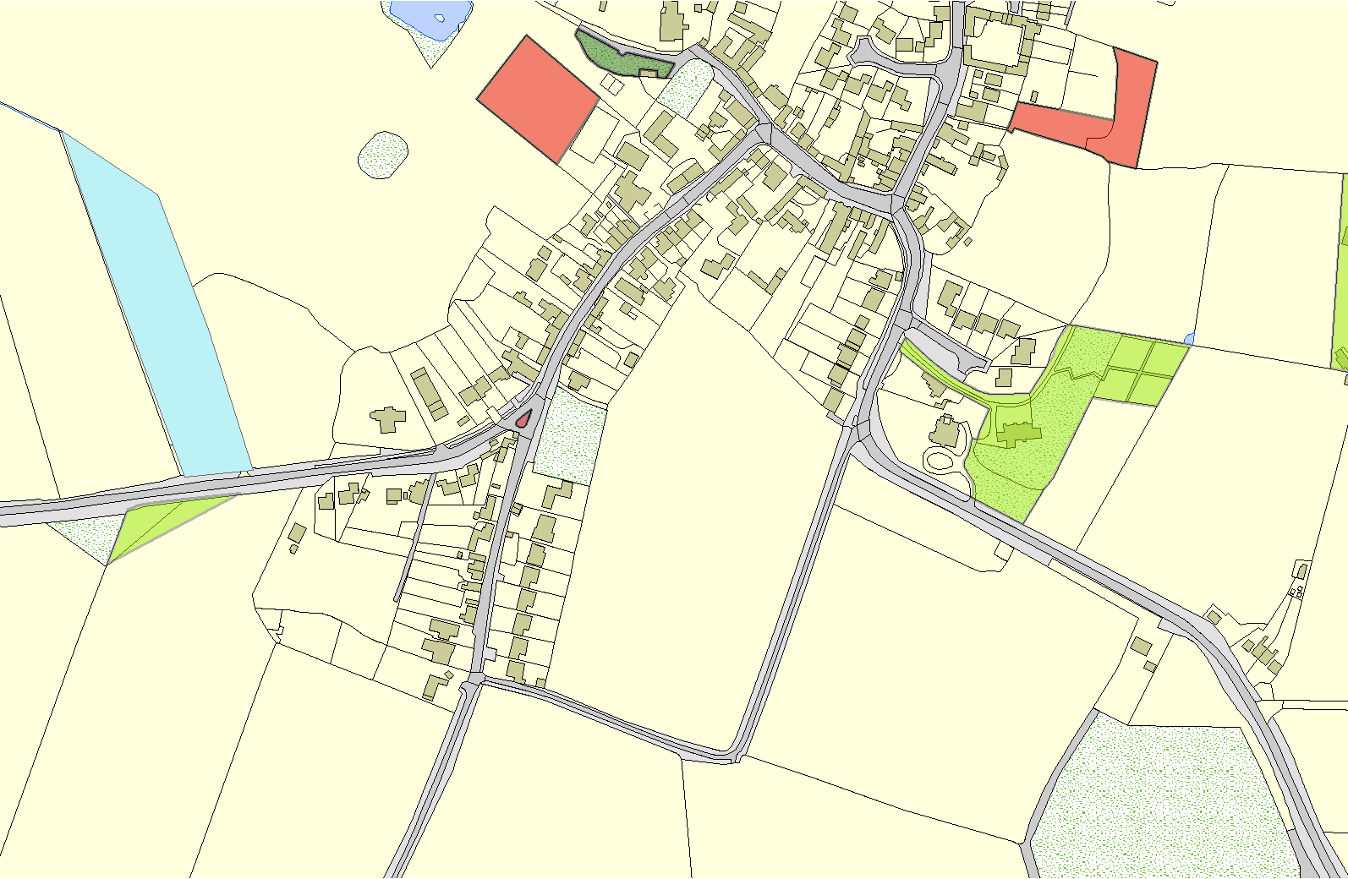

Not recommended for LGS Designation

Recommended for LGS designation

Wildlife Sites

Open Space, Sport and Recreation Sites
OS MM Boundary
DESCTERM
!!!!!!!!!!!!!!!!!!!!! County

District

Electoral Parish
©Crown Copyright. All rights reserved. Harborough District Council 100023843 2014

