Dunton Bassett OSSR sites, LGS sites and Wildlife Sites Note the LGS sites are proposals only at Sept 2015
Holbeck Drive, Broughton Astley

Harris Close, Broughton Astley Harris Close, Broughton Astley
Wyvern Close, Broughton AstleyCroft Way, Broughton Astley Staton Road Amenity Green Space - Broughton Astley

Cotton Close, Broughton Astley
Townsend Close, Broughton Astley

Kiln Close, Broughton Astley Sitch Close, Broughton Astley
Byre Crescent, Play Area - Broughton Astley

Devitt Way Green Space - Broughton Astley
Devitt Way (Community Facility) - Broughton Astley
Hall Farm Crescent, Broughton Astley
Coltsfoot Way / Clump Hill - Broughton Astley
Speedwell Drive, Broughton Astley

Orchid Place, Broughton Astley Coltsfoot Way / Clump Hill - Broughton Astley Broughton Lake Near Green space
Orchid Place, Broughton Astley

Coltsfoot Way / Clump Hill - Broughton Astley

Foxglove Close, Broughton Astley

Dunton Road Natural Green Space - Broughton Astley

Legend
Allotments at Dunton Bassett

Not recommended for LGS Designation Recommended for LGS designation Wildlife Sites
Open Space, Sport and Recreation Sites
OS MM Boundary
DESCTERM
!!!!!!!!!!!!!!!!!!!!! County

District Electoral
Willow Pond Grassland (field pond)
Willow Pond Grassland 2

C ack Willow in field pond 2

Willow Pond Grassland

LGS/DB/C - Wild Area nxt to Leicestershire Round Footpath

Ashby Magna Track and Embankment - Scrub Ashby Magna Track & Embankment - Grassland

LGS/DB/D - Parish Coucnil Field Dunton Bassett Football Ground - Dunton Bassett

Parish
LGS/DB/B - Primary School PlayinLgGFSie/DldB/A - Playground Dunton Bassett

Spring-fed marshy grassland Dunton Bassett
Dunton Bassett Cricket Ground

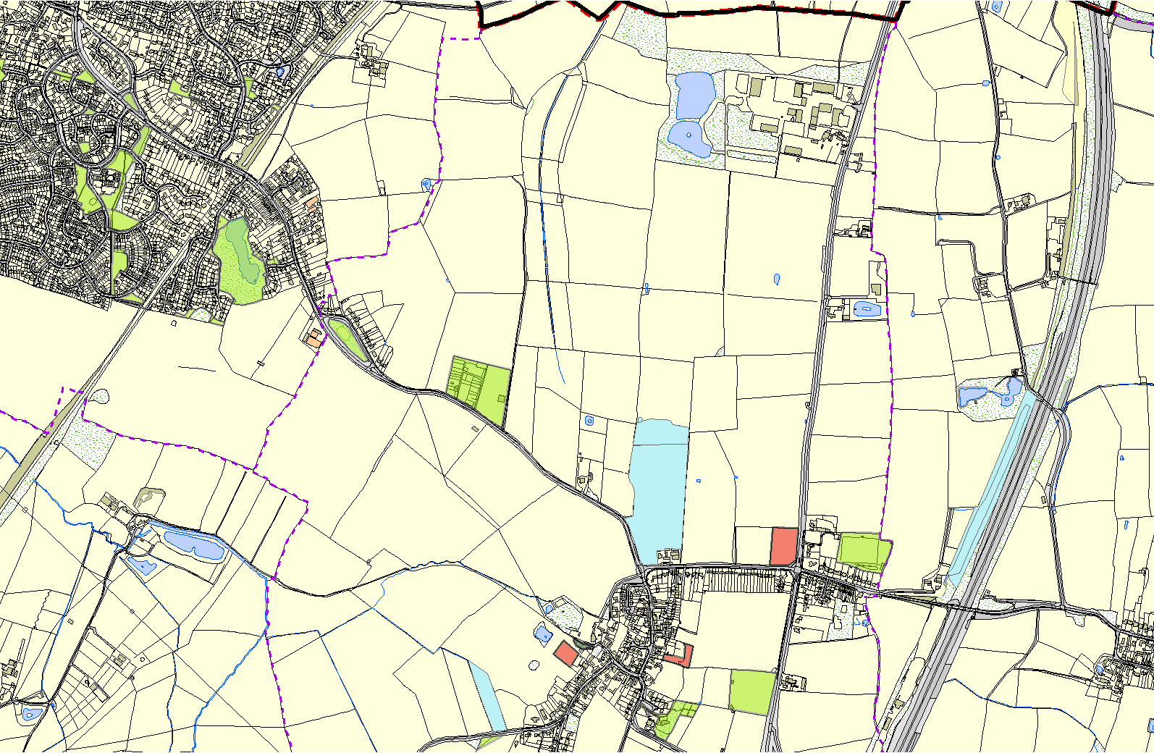
LGS/DB/EA-llLSittaleinLtsunCnhounrcthriyaanrgdle- Dunton Bassett
©Crown Copyright. All rights reserved. Harborough District Council 100023843 2014

Land at Leire Lane - Dunton Bassett

