East Langton OSSR sites, LGS sites and Wildlife Sites Note the LGS sites are proposals only at Sept 2015

Legend

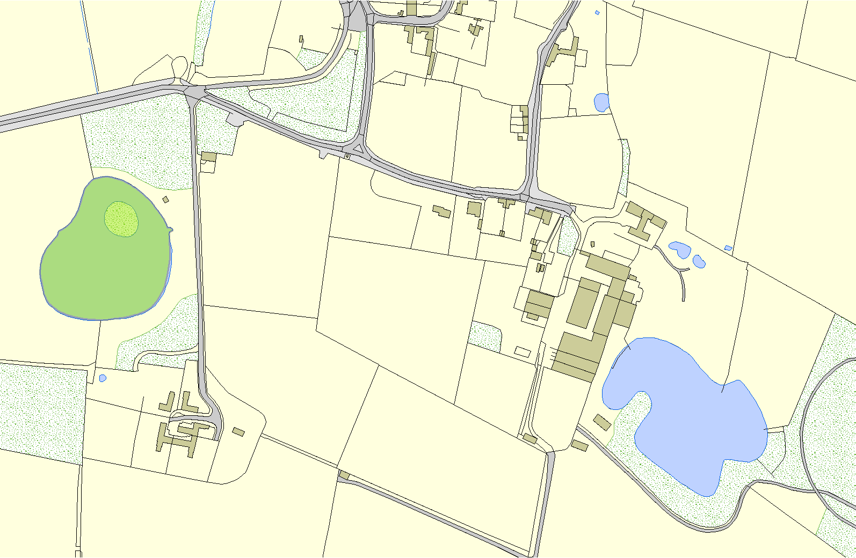
Not recommended for LGS Designation

Recommended for LGS designation

Wildlife Sites
Open Space, Spor and Recreation Sites

OS MM Boundary
DESCTERM
!!!!!!!!!!!!!!!!!!!!! County

District Electoral
Parish

Fishing Lake - East Langton

©Crown Copyright. All rights reserved. Harborough District Council 100023843 2014

