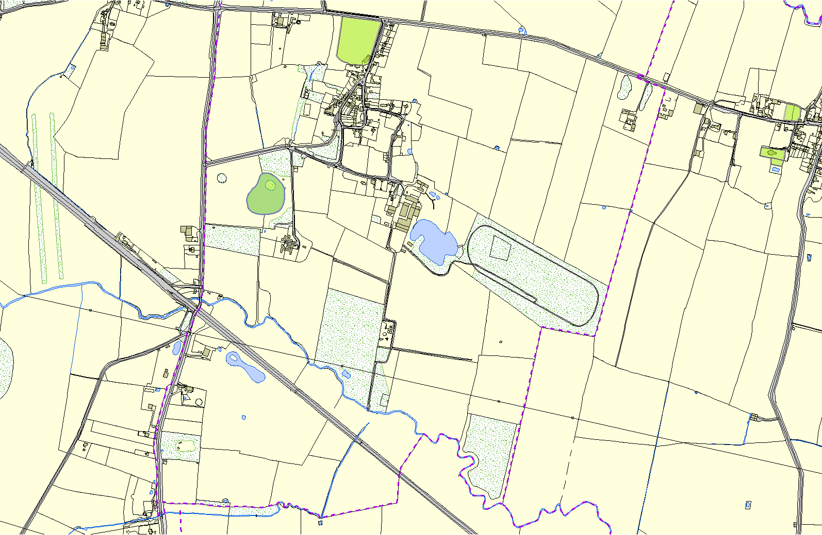
East Langton OSSR sites, LGS sites and Wildlife Sites Note the LGS sites are proposals only at Sept 2015

East Langton Cricket Club

Coronation Gardens - East Langton

Allotment Gardens on Main Street - Thorpe Langton

St Leonards Church - Thorpe Langton Back of Church - Thorpe Langton

Fishing Lake - East Langton

Legend

Not recommended for LGS Designation Recommended for LGS designation
Wildlife Sites

Open Space, Sport and Recreation Sites
OS MM Boundary
DESCTERM
!!!!!!!!!!!!!!!!!!!!! County

District Electoral
©Crown Copyright. All rights reserved. Harborough District Council 100023843 2014
Parish

