Leighfield Forest

East Norton OSSR sites, LGS sites and Wildlife Sites Note the LGS sites are proposals only at Sept 2015

Legend

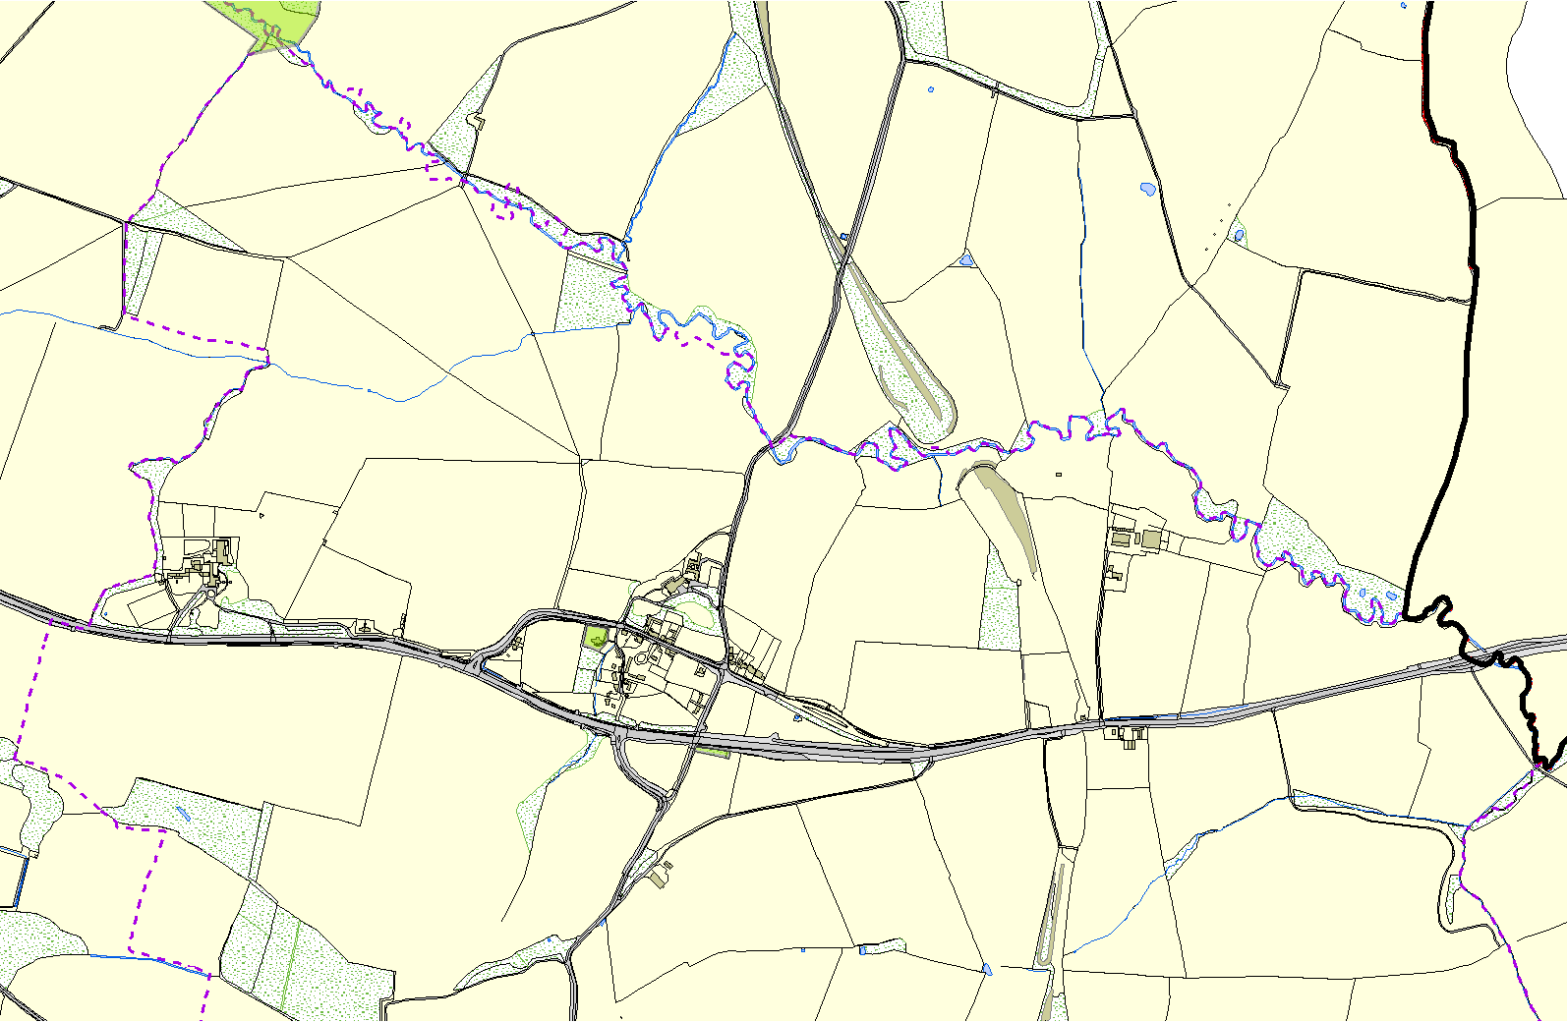
Not recommended for LGS Designation Recommended for LGS designation
Wildlife Sites

Open Space, Sport and Recreation Sites

OS MM Boundary
DESCTERM
!!!!!!!!!!!!!!!!!!!! County
District Electoral
Parish

Churchyard - East Norton

Allotments - East Norton

©Crown Copyright. All rights reserved. Harborough District Council 100023843 2014

