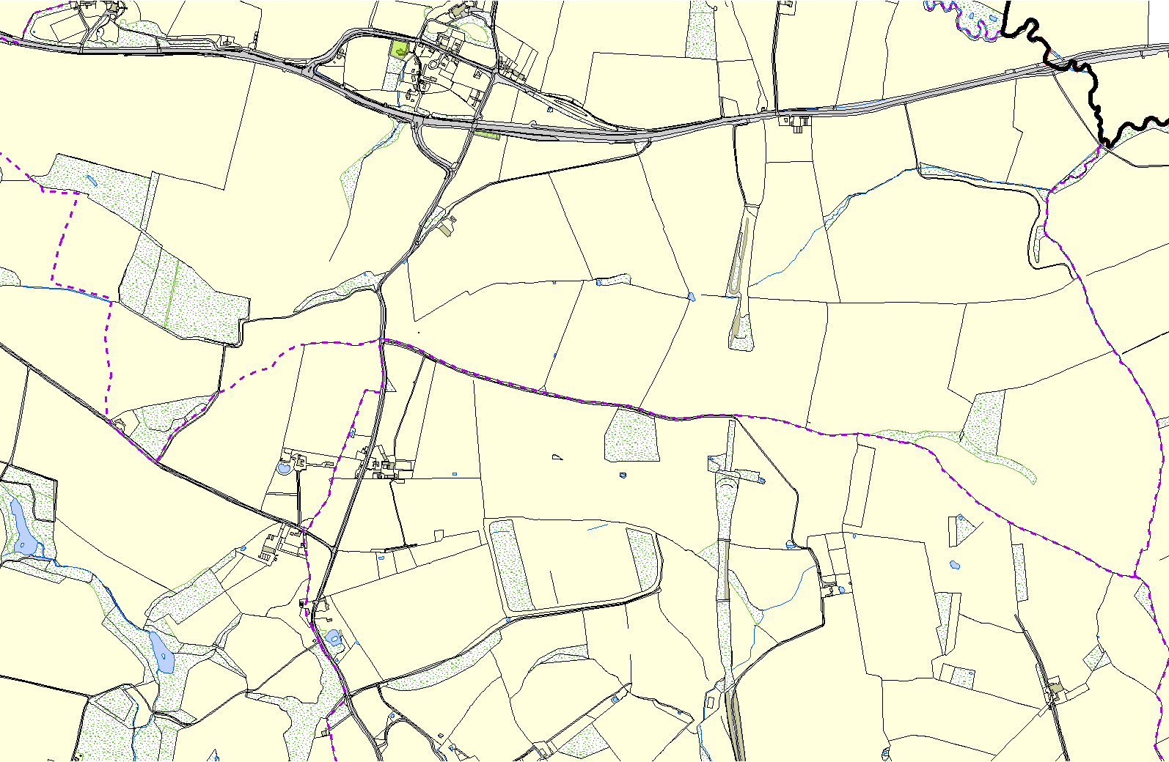
East Norton OSSR sites, LGS sites and Wildlife Sites Note the LGS sites are proposals only at Sept 2015

Churchyard - East Norton

Allotments - East Norton

Legend

Not recommended for LGS Designation

Recommended for LGS designation

Wildlife Sites
Open Space, Sport and Recreation Sites

OS MM Boundary
DESCTERM
!!!!!!!!!!!!!!!!!!!!! County

District Electoral
Parish

©Crown Copyright. All rights reserved. Harborough District Council 100023843 2014

