Fleckney OSSR sites, LGS sites and Wildlife Sites Note the LGS sites are proposals only at Sept 2015

LGS/FLECK/1 - Extension to Leicester Road Recreation Ground

Longgrey Amenity Green Space Fleckney

Leicester Road, Recereation Ground - Fleckney

Childrens Play Area - Fleckney

Fleckney Bowls Club

Fleckney Green - Batchelor Road

Legend
Tarmac Area, Kerley - Fleckney

Not recommended for LGS Designation

School Field Fleckney

Recommended for LGS designation Wildlife Sites
Open Space, Sport and Recreation Sites
OS MM Boundary
DESCTERM
!!!!!!!!!!!!!!!!!!!! County

Tarmac Area, Coleman Road - Fleckney

Fleckney Open Space - Leicester Road

Natural Area Beside Stream - Fleckney

District

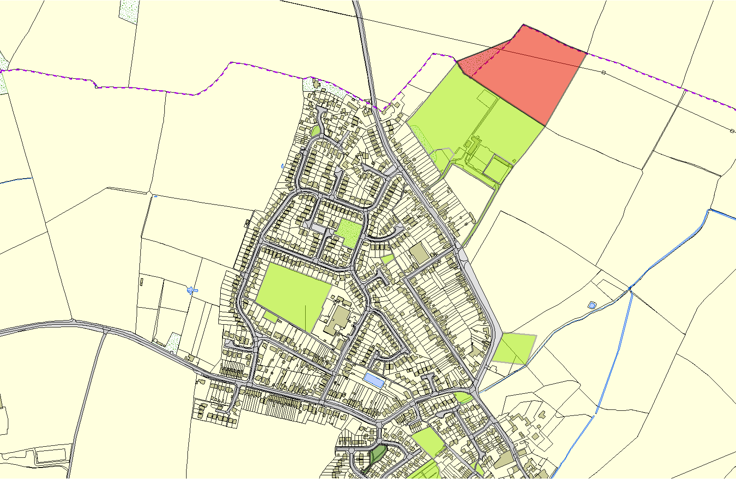
Electoral Parish
Fleckney Band Hall LGS/FLECK/2 - Amenity Area, Priest meadow Estate
Forge Close, Fleckney Cemetery and Churchyard - Fleckney Forge Close, Fleckney
©Crown Copyright. All rights reserved. Harborough District Council 100023843 2014

