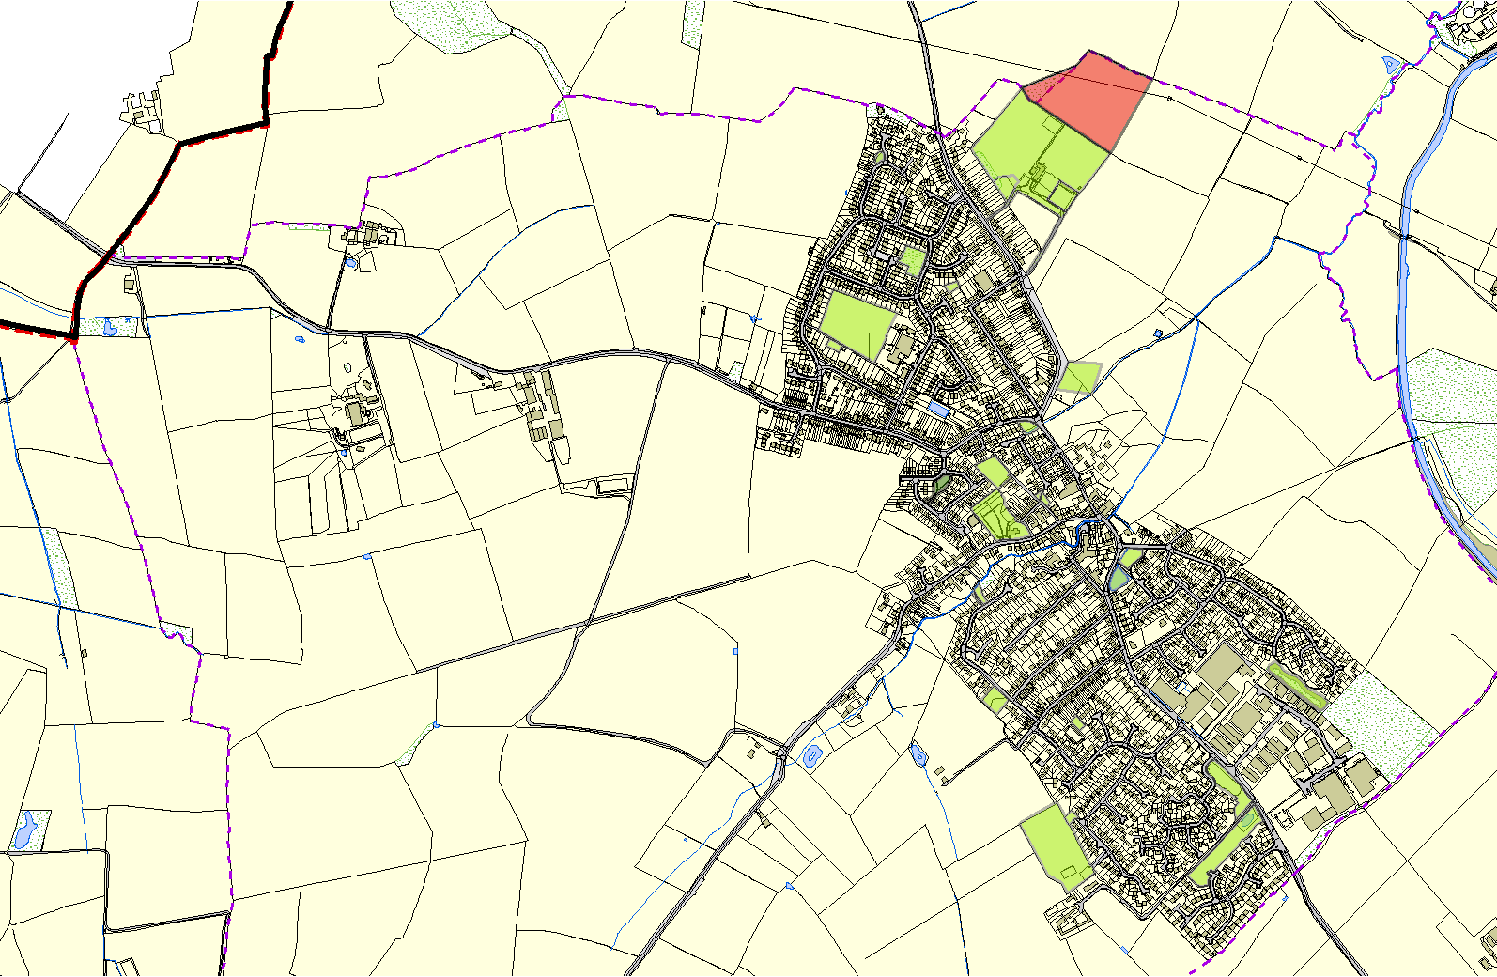
Fleckney OSSR sites, LGS sites and Wildlife Sites Note the LGS sites are proposals only at Sept 2015
LGS/FLECK/1 - Extension to Leicester Road Recreation Ground

Longgrey Amenity Green Space FleckneyLeicester Road, Recereation Ground - Fleckney

Childrens Play Area - Fleckney
Fleckney Bowls Club

Fleckney Green - Batchelor Road Tarmac Area, Kerley - Fleckney

School Field Fleckney Tarmac Area, Coleman Road - Fleckney

Fleckney Open Space - Leicester Road

Natural Area Beside Stream - Fleckney

Fleckney Band Hall LGS/FLECK/2 - Amenity Area, Priest meadow Estate
Forge Close, Fleckney
Cemetery and Churchyard - Fleckney

Legend Fleckney Village Green
Fleckny Duckpond
 |  | Not recommended for LGS Designation | Edward Road, Fleckney Edward Road, Fleckney
 |  | Recommended for LGS designation
 |  | Wildlife Sites
Open Area Industrial Estate - Fleckney
 |  | Open Space, Sport and Recreation Sites | Edward Road Play Area - Flekcney
OS MM Boundary  DESCTERM |  |  | Crossleys, Fleckney | Flood Relief Area - Fleckney The Meer, Fleckney
!!!!!!!!!!!!!!!!!!! County |  |  | Lodge Road, Fleckney | Flood Relief Area 2 - Fleckney
District

Electoral
Parish

©Crown Copyright. All rights reserved. Harborough District Council 100023843 2014

!

