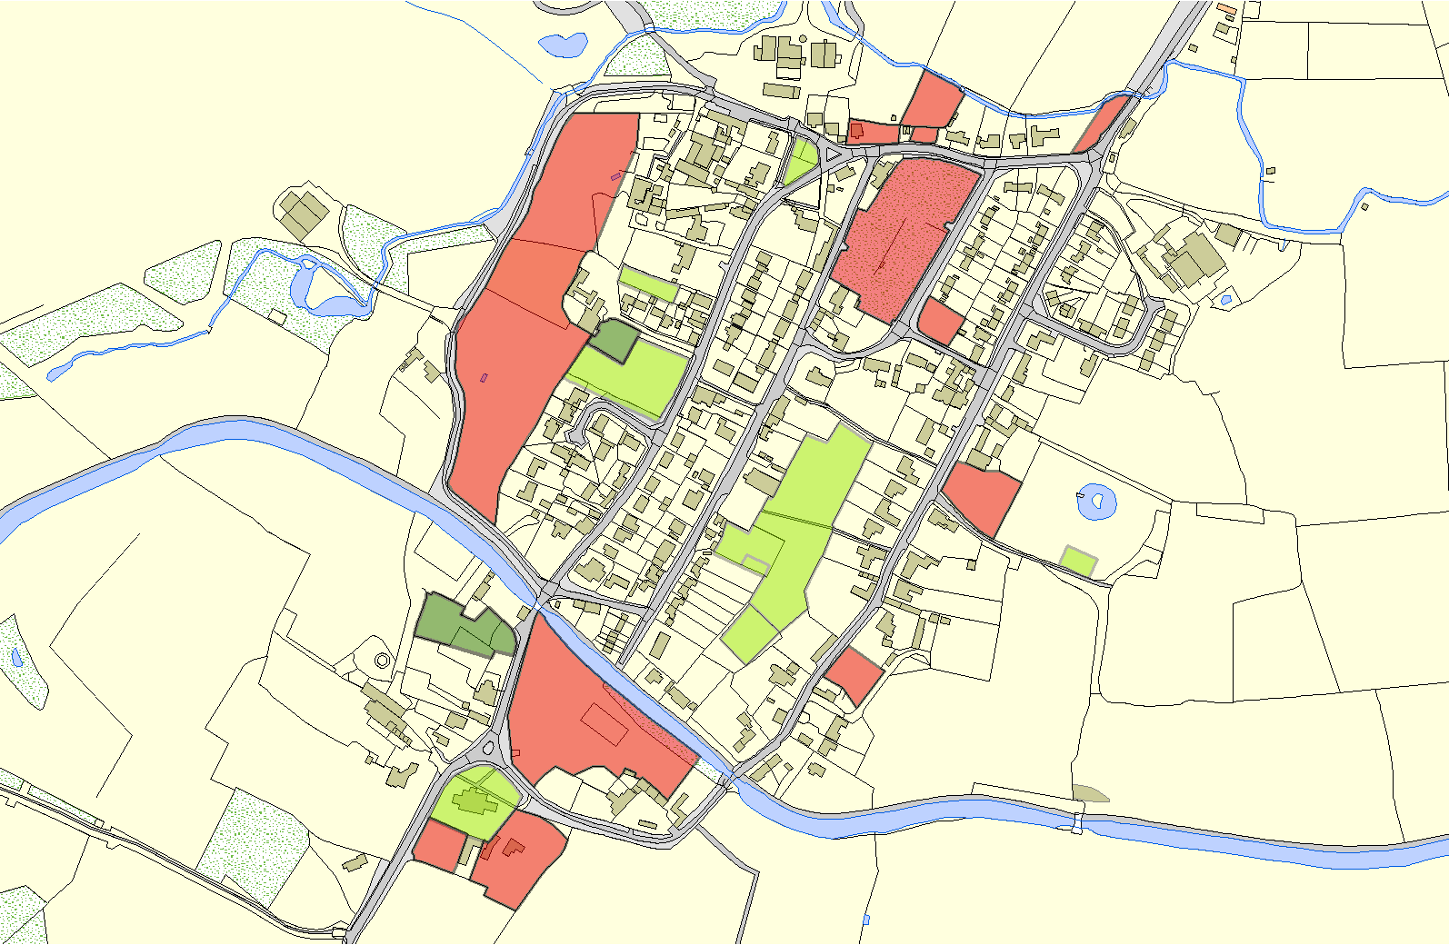
Foxton OSSR sites, LGS sites and Wildlife Sites Note the LGS sites are proposals only at Sept 2015
LGS/FOX/12c - Paddock behind Nos 16 to 28 Main Street Foxton
LGS/FOX/9 - Land at junction of Main Street and Swingbridge Street LGS/FOX/1L2GbS- /GFaOrXd/e1n2oaf -NPuamdbdeorc2k8bMetawineeSntrNeeotsF1o6xatonnd 28 Main Street Foxton

Foxton Allotments

LGS/FOX/1 - Land bounded by Vicarage Drive, Middle Street and Main Street

Baptist Cemetery - Foxton LGS/FOX/11 - Three Historic Paddocks Foxton
LGS/FOX/7 - Land on corner of Vicarage Drive and Hog Lane
LGS/FOX/6 - Shoulder of Mutton garden

Shoulder of Mutton Paddock - Foxton

LGS/FOX/10 - Chestnuts Garden Foxton

Robert Monk Recreation Ground - Foxton
Legend
Robert Monk Play Area - Foxton Softwell at Foxton
 |  | Not recommended for LGS Designation
 |  | Recommended for LGS designation
 |  |  | LGS/FOX/3 - Black Horse garden | Tennis Club at Foxton
 |  | Wildlife Sites
 |  | Open Space, Sport and Recreation Sites |  |  | LGS/FOX/5 - Foxton Lodge Garden
OS MM Boundary LGS/FOX/2 - Manor House Gardens Foxton
DESCTERM
!!!!!!!!!!!!!!!!!!! County |  |  | Church Cemetery - Foxton
District  Electoral |  |  | LGS/FOX/4 - Land to front of Summer House  LGS/FOX/8 - Mill House Gardens Foxton
Parish

©Crown Copyright. All rights reserved. Harborough District Council 100023843 2014

!

