Legend

Foxton OSSR sites, LGS sites and Wildlife Sites Note the LGS sites are proposals only at Sept 2015

Not recommended for LGS Designation Recommended for LGS designation Wildlife Sites
Open Space, Sport and Recreation Sites
OS MM Boundary
DESCTERM

LGS/FOX/12c - Paddock behind Nos 16 to 28 Main Street Foxton
LGSL/FGOSX/F/1O2Xb/1-2GaLa-GrdPSea/nFdoOdfoXNc/uk9mb- beLetawrne2de8naMtNjauoinnscS1ti6otrneaenotdf FM2o8axitnMonSaitnreSettraeentdFSowxtinongbridge Street
Foxton Allotments

LGS/FOX/1 - Land bounded by Vicarage Drive, Middle Street and Main Street
Baptist Cemetery - Foxton
LGS/FOX/11 - Three Historic PaLdGdoSc/kFsOFXo/7xt-oLnand on corner of Vicarage Drive and Hog Lane LGS/FOX/6 - Shoulder of Mutton garden
Shoulder of Mutton Paddock - Foxton

!!!!!!!!!!!!!!!!!!!!! County

District Electoral Parish
LGS/FOX/10 - Chestnuts Garden Foxton Robert Monk Recreation Ground - Foxton
Robert Monk Play Area - FoxtonSoftwell at Foxton

LGS/FOX/3 - Black Horse gardenTennis Club at Foxton
LGS/FOX/5 - Foxton Lodge Garden LGS/FOX/2 - Manor House Gardens Foxton

Church Cemetery - Foxton
LGS/FOX/4 - Land to front of Summer House LGS/FOX/8 - Mill House Gardens Foxton

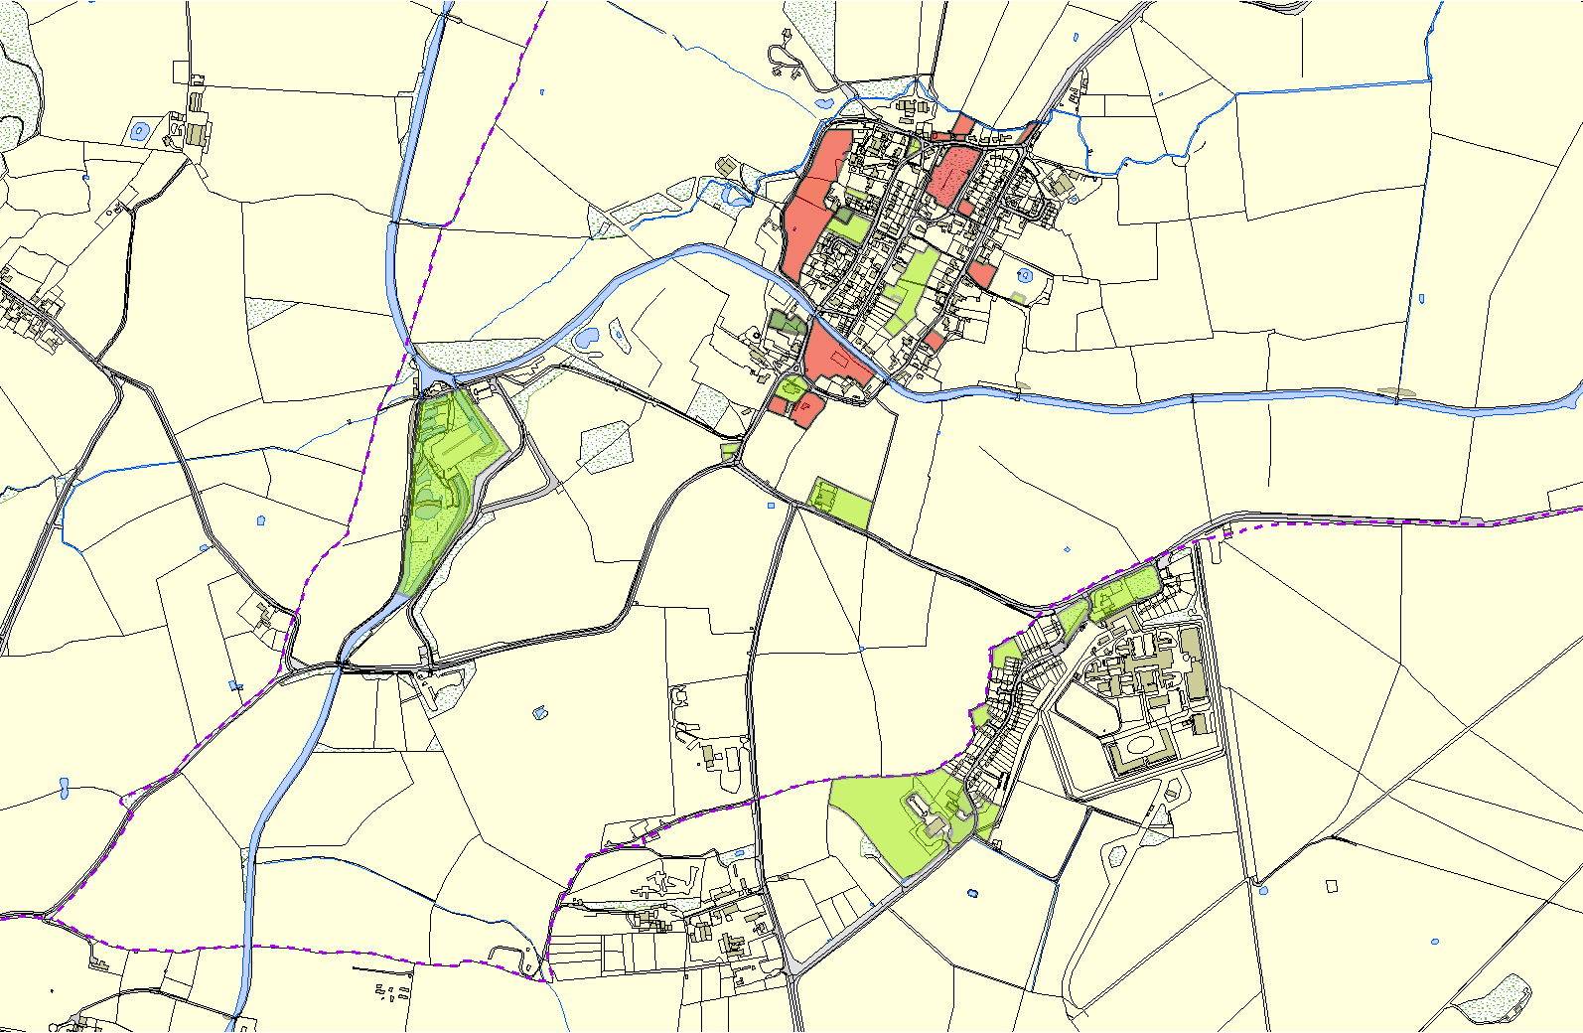
Foxton Cemetery
Foxton Locks

School in Foxton

Gartree Green Spaces - Lubenham

Gartree Green Spaces - Lubenham

Gartree Green Spaces - Lubenham

Gartree Green Spaces - LubenhamGartree Green Spaces - Lubenham

©Crown Copyright. All rights reserved. Harborough District Council 100023843 2014

