Foxton OSSR sites, LGS sites and Wildlife Sites Note the LGS sites are proposals only at Sept 2015

Legend

Not recommended for LGS Designation Recommended for LGS designation Wildlife Sites
Open Space, Sport and Recreation Sites
OS MM Boundary
DESCTERM
!!!!!!!!!!!!!!!!!!!! County

District Electoral Parish

LGS/FOX/12c - Paddock behind Nos 16 to 28 Main Street Foxton
LGSL/FGOSX/F/1O2Xb/1-2GaLaG-rdPSea/nFdoOdfoXNc/uk9mb- ebLteawrne2de8anMtNjauoinnsc1Sti6otrneaeontdf FM2oa8xitnMonSaitnreSettreanetdFSowxtinognbridge Street
Foxton Allotments

LGS/FOX/1 - Land bounded by Vicarage Drive, Middle Street and Main Street
LBGaSpt/FisOt CXe/1m1e-teTrhyre- eFoHxistotonric Paddocks Foxton

LGS/FOX/6 - Shoulder of Mutton garden Shoulder of Mutton Paddock - Foxton
LGS/FOX/7 - Land on corner of Vicarage Drive and Hog Lane

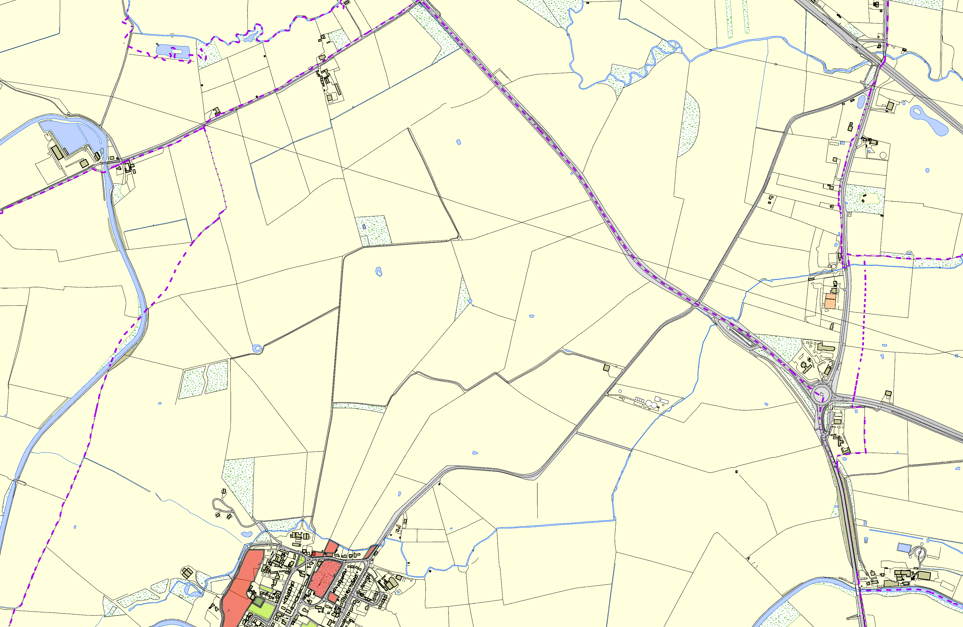
Robert Monk Recreation Ground - Foxton
©Crown Copyright. All rights reserved. Harborough District Council 100023843 2014

