Legend

Frolesworth OSSR sites, LGS sites and Wildlife Sites Note the LGS sites are proposals only at Sept 2015

Arkwright Farm, Burnside Road Balancing Lagoon

Not recommended for LGS Designation Recommended for LGS designation Wildlife Sites
Open Space, Sport and Recreation Sites
OS MM Boundary
DESCTERM
!!!!!!!!!!!!!!!!!!!! County

District Electoral Parish

Hallbrook School - Broughton Astley

Frolesworth Irrigation Lake 1

St Nicholas Churchyard - Frolesworth

Frolesworth Irrigation Lake 2

Frolesworth Irrigation Lake 3

Childrens Play Area - Leire Playing Fields - Leire

St Peters Churchyard - Leire

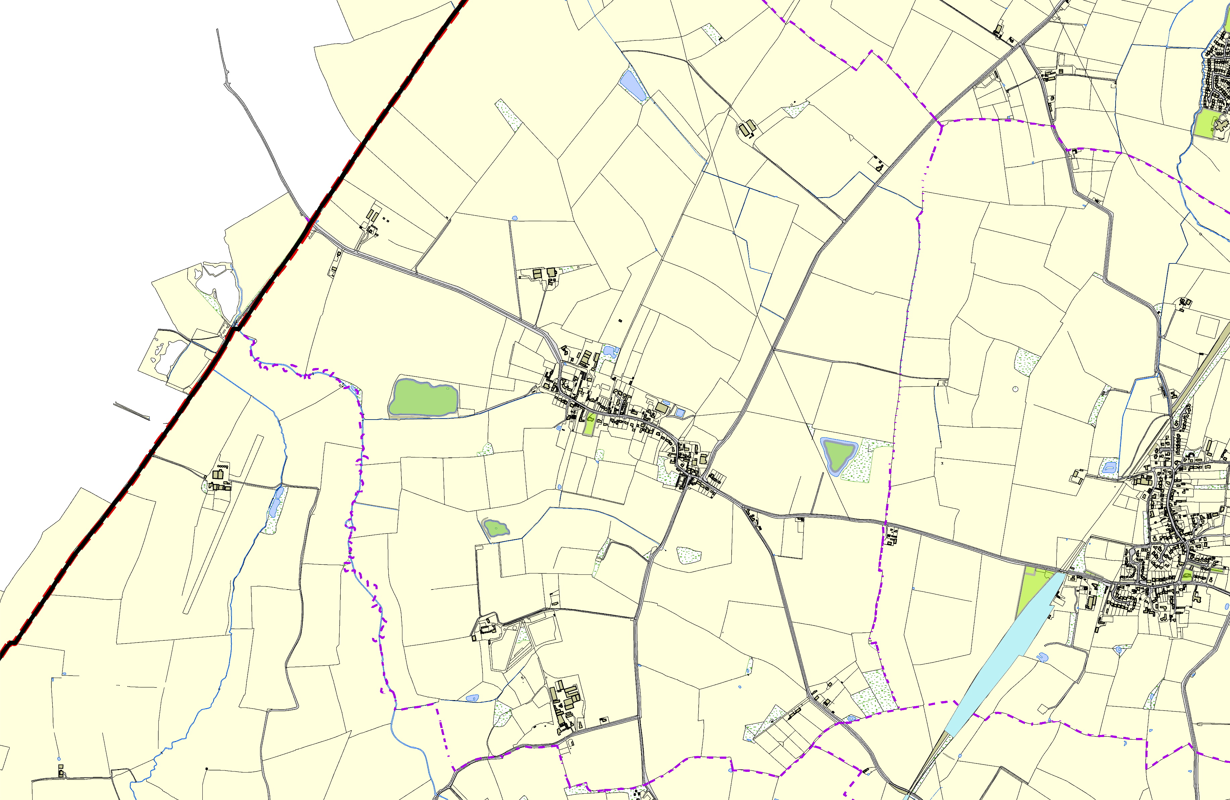

Jubilee Walk

Ullesthorpe Railway
©Crown Copyright. All rights reserved. Harborough District Council 100023843 2014

