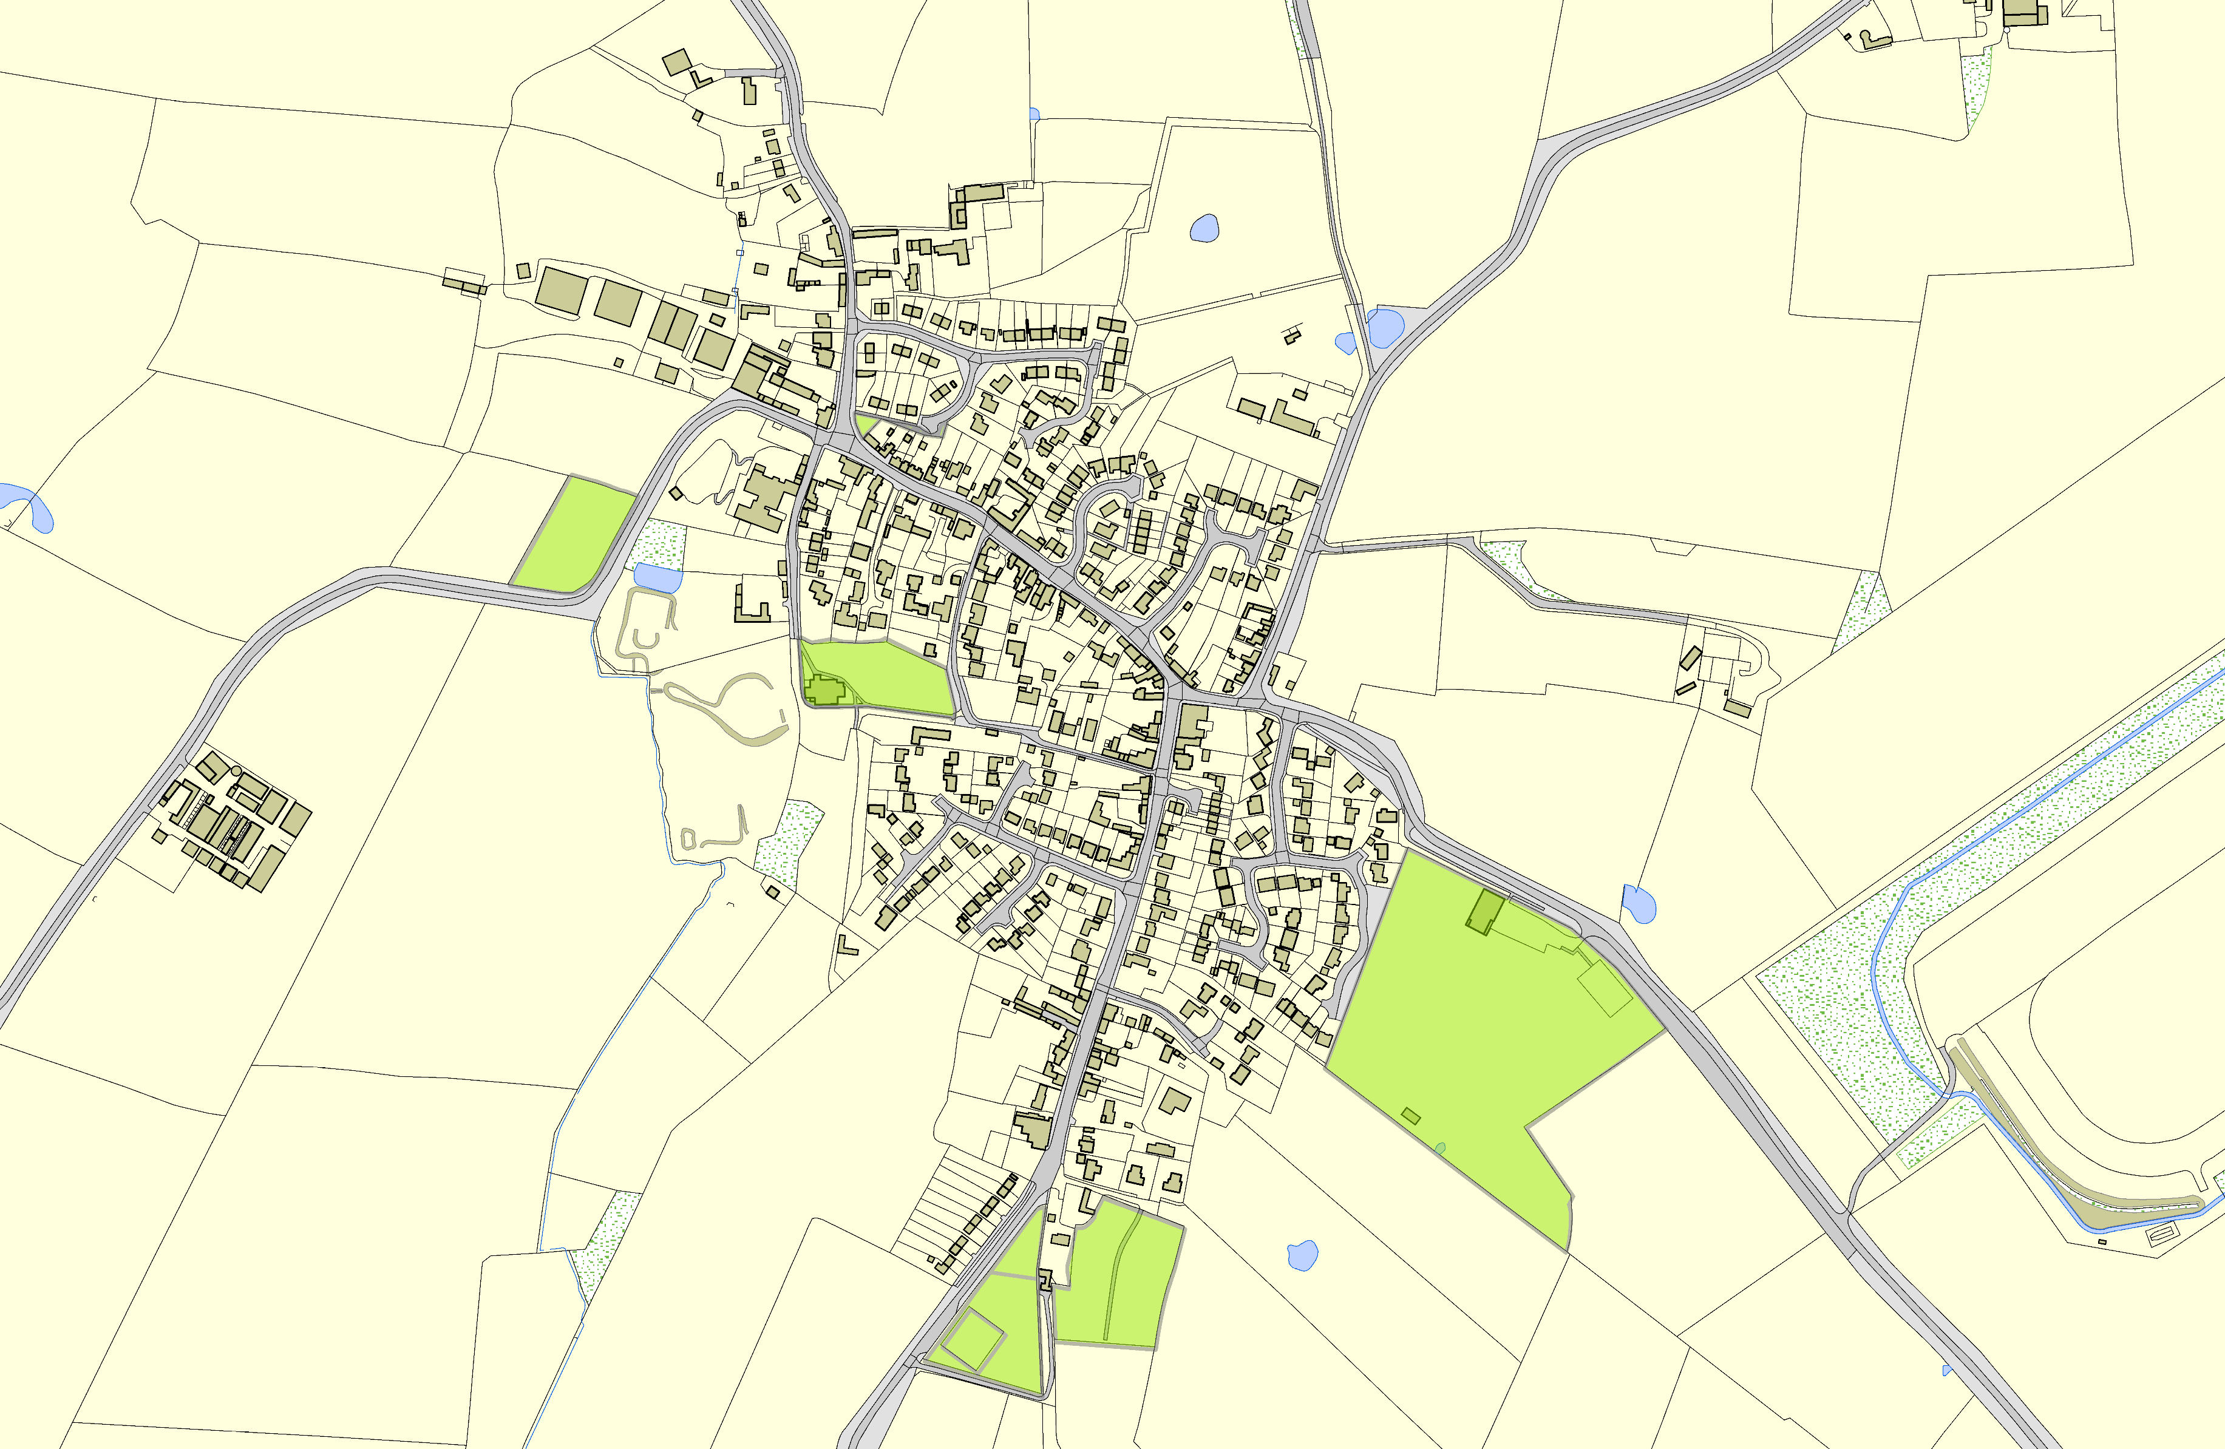
Gilmorton OSSR sites, LGS sites and Wildlife Sites Note the LGS sites are proposals only at Sept 2015

 | School Playing Fields - Gilmorton | Millenium Sign and Green - Gilmorton  Turville Road, Gilmorton  Church and Churchyard - Gilmorton  Play Area in Gilmorton  Gilmorton Allotments Recreation Ground - Gimorton  Tennis Courts - Gilmorton |  | Legend  Not recommended for LGS Designation Recommended for LGS designation Wildlife Sites  Open Space, Sport and Recreation Sites  OS MM Boundary  DESCTERM  !!!!!!!!!!!!!!!!!!!! County  District Electoral Parish  Lutterworth Pavillion and Road Playing Fields - Gi
 | ©Crown Copyright. All rights reserved. Harborough District Council 100023843 2014

