Gilmorton OSSR sites, LGS sites and Wildlife Sites Note the LGS sites are proposals only at Sept 2015

Buttercup Slope

Fishing Ponds - Peating Parva

Ashby Parva Meadows; Site A

Mill Farm Fishery - Gilmorton

Millenium Sign and Green - Gilmorton

School Playing Fields - Gilmorton

Church and Churchyard - Gilmorton

Lutterworth Pavillion and Road Playing Fields - Gi

Play Area in Gilmorton Gilmorton Allotments
Recreation Ground - Gimorton

Tennis Club - Bitteswell Lime Tree Coppice 1

Crack Willow 1

Legend

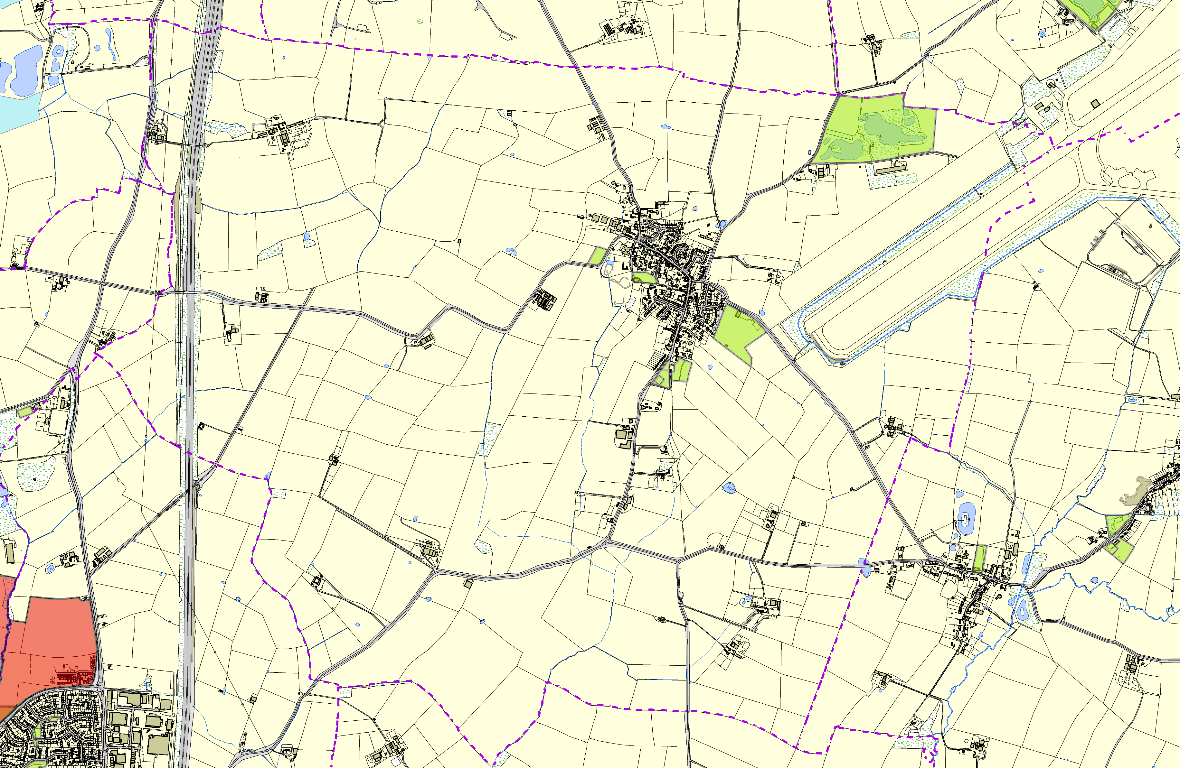

LGS/BIT/E - East of Ashby Lane Bitteswell

LGS/BIT/D - Land east of Bitteswell

Bill Crane Way, Lutterworth Burrough Way 1
Burrough Way 3 Burr
ough Way 2

y Way Recreation Ground
©Crown Copyright. All rights reserved. Harborough District Council 100023843 2014

Dunle

Not recommended for LGS Designati n
Gravel Hole at Walton
Recommended for LGS WdaeltosniVgilnlagaetHioallnPlayground
Playing Fields at Walton Village Hall
WAlil lSdalinitfseChSuricthe-sKimcote and Walton

Open Space, Sport and Recreation Sites
OS MM Boundary
DESCTERM
!!!!!!!!!!!!!!!!!!!! County

District Electoral Parish

