Glooston OSSR sites, LGS sites and Wildlife Sites Note the LGS sites are proposals only at Sept 2015

Glebe Farm Hallaton; Area C

Church in Glooston

Legend

Stonton Wyville Churchyard

St Michael & All Angels Churchy

Not recommended for LGS Designation Recommended for LGS designation Wildlife Sites

Open Space, Sport and Recreation Sites

ard, Cranoe

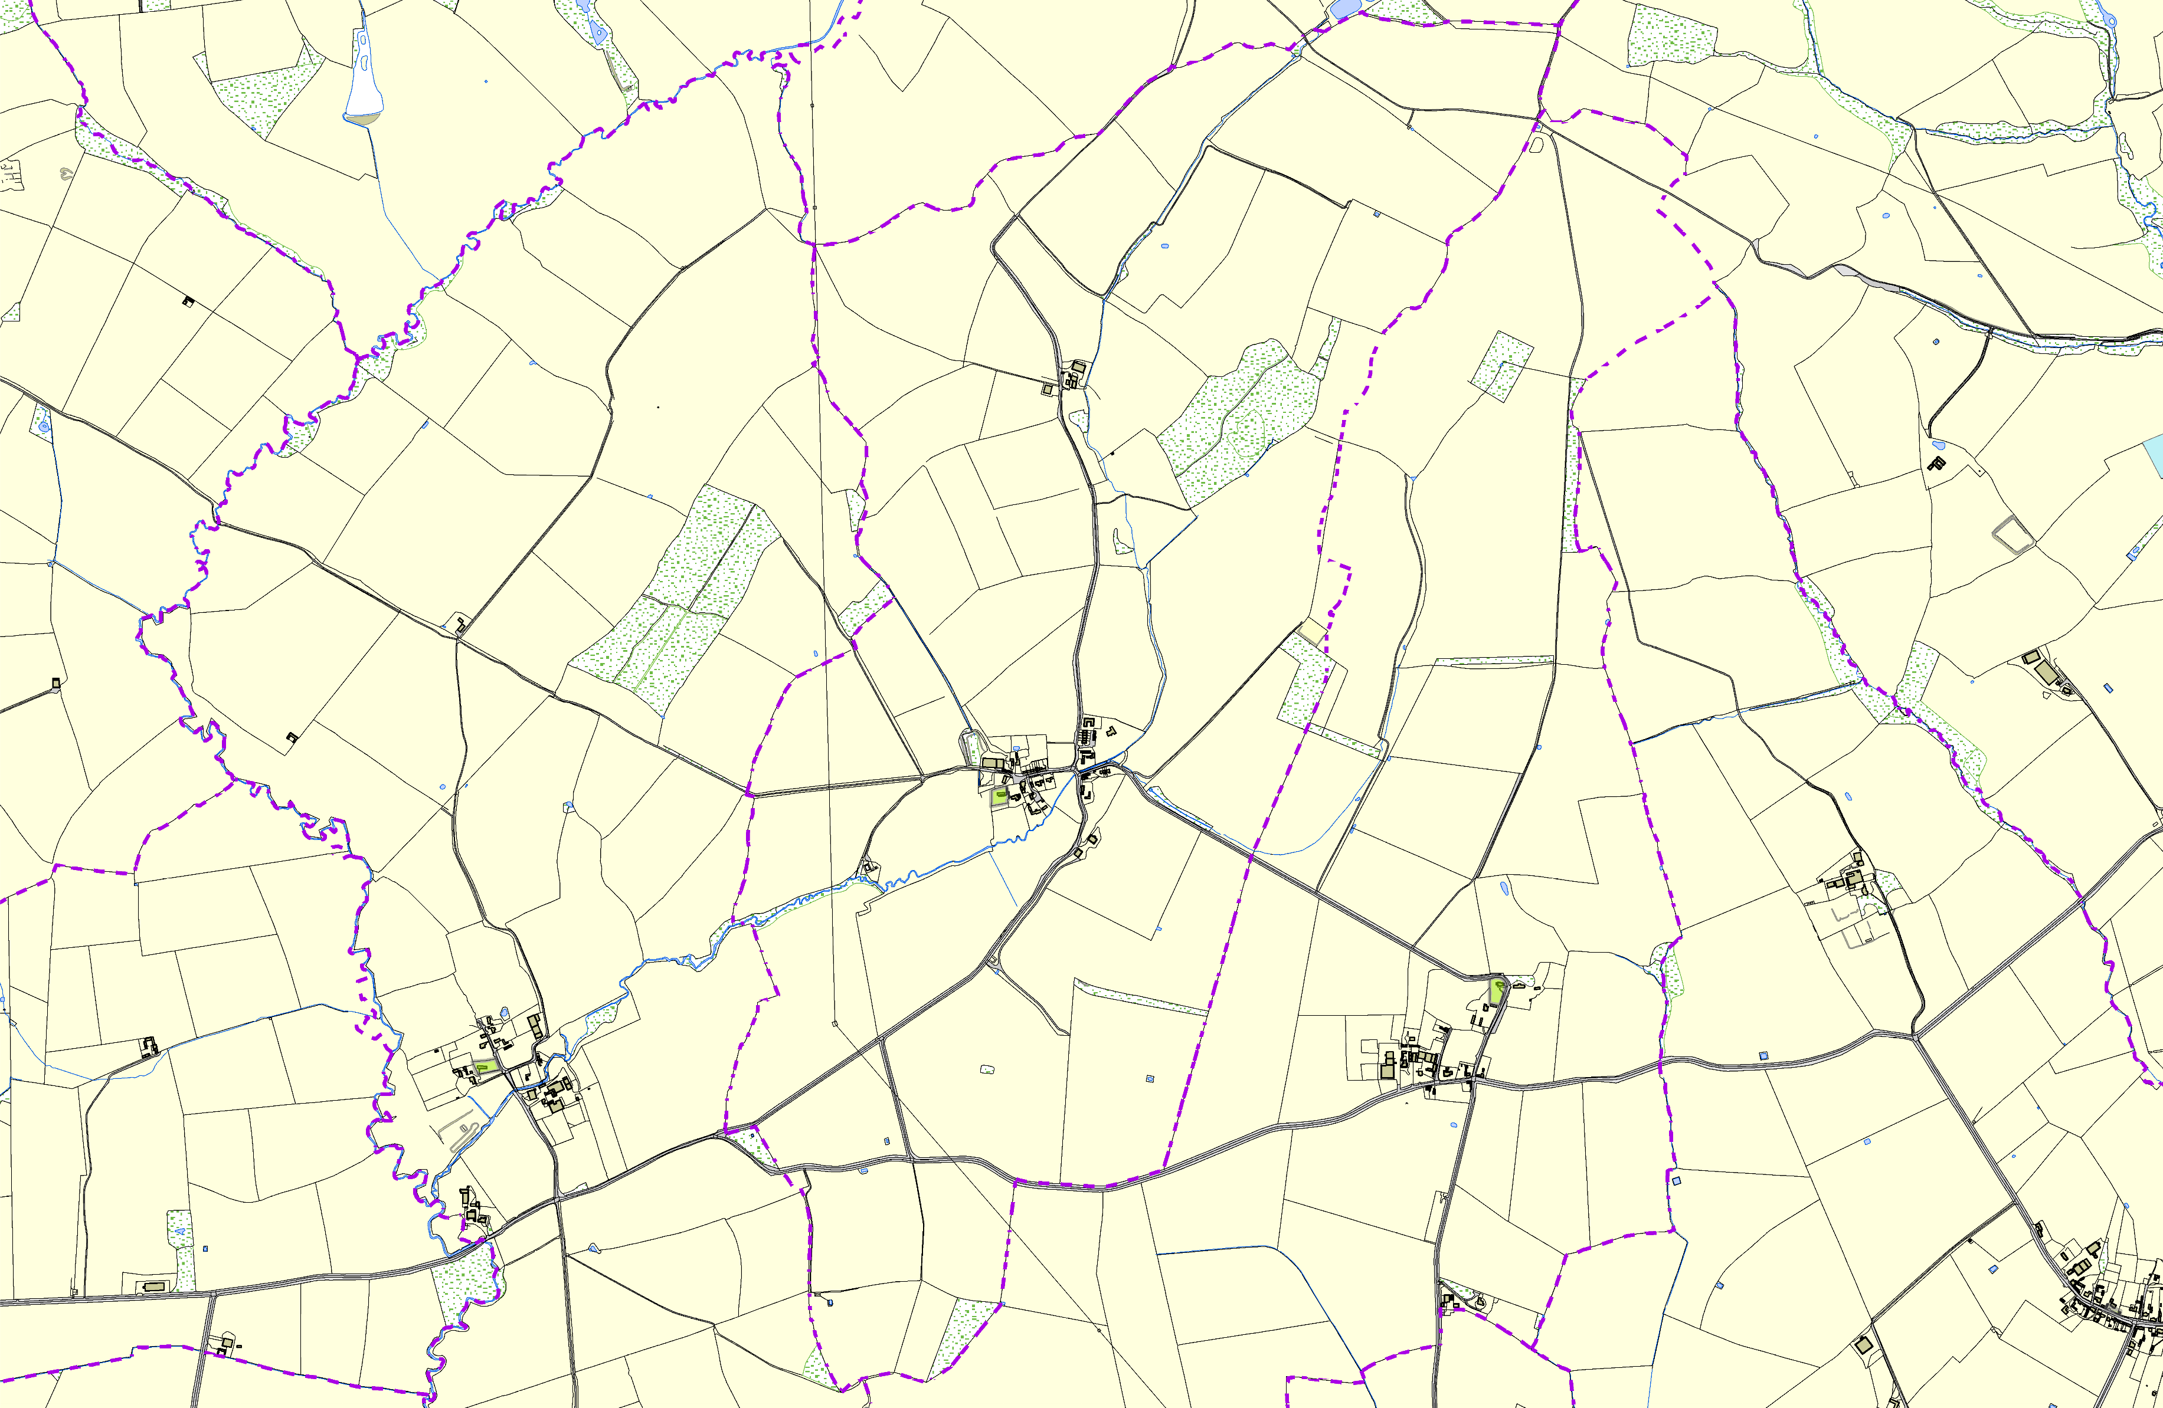
OS MM Boundary
DESCTERM
!!!!!!!!!!!!!!!!!!!! County

District Electoral Parish
©Crown Copyright. All rights reserved. Harborough District Council 100023843 2014

Main Street Village Green - Slawston

