Great Bowden OSSR sites, LGS sites and Wildlife Sites Note the LGS sites are proposals only at Sept 2015

Nether Green - Great Bowden
Nether Green - Great Bowden

Upper Green

Manor Road Open Space - Great Bowden
Great Bowden Village Green 4
Churchyard in Great Bowden

Great Bowden Village Green 3

Great Bowden Village Green 2
Village Green - Great Bowden
Village Green - Great Bowden
Sutton Road/Knights End Road Village Hall - Great Bowden

Primary School in Great Bowden
Village Green - Great Bowden
Great Bowden Cemetery

Community Wood - Great Bowden
Legend

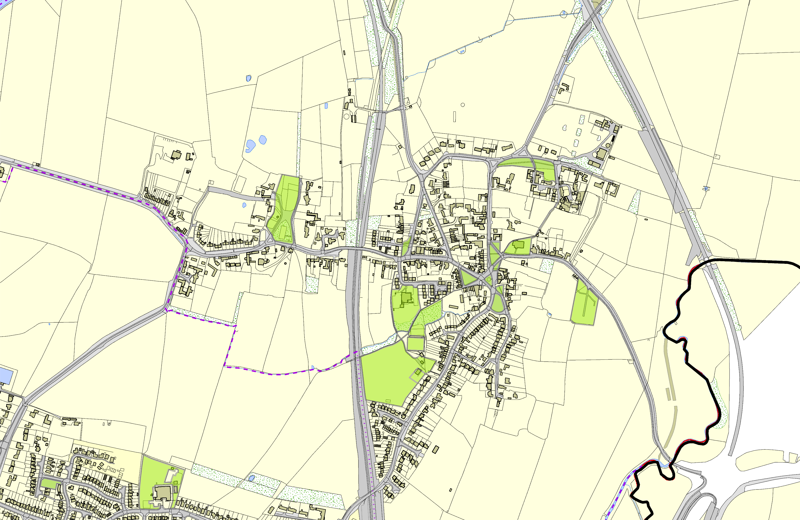

Scott Close, Market Harborough
©Crown Copyright. All rights reserved. Harborough District Council 100023843 2014

Ridgeway Primary, The Ridgeway, MH
Tennis Court - Private Club - Great Bowden

Recreation Ground - Great Bowden
Great Bowden Recreation Play Area

Not recommended for LGS Designation Recommended for LGS designation Wildlife Sites
Open Space, Sport and Recreation Sites
OS MM Boundary
DESCTERM
!!!!!!!!!!!!!!!!!!!! County

District Electoral Parish

