Great Easton OSSR sites, LGS sites and Wildlife Sites Note the LGS sites are proposals only at Sept 2015

Legend

Broadgate / High Street AGS, Great Easton

Not recommended for LGS Designation Recommended for LGS designation Wildlife Sites
Open Space, Sport and Recreation Sites
OS MM Boundary
DESCTERM
!!!!!!!!!!!!!!!!!!!!! County

District Electoral Parish

Great Easton Chuchyard Great Easton High Street AGS

Broadgate / Pitchers Lane Junction AGS Great Easton

Church Bank AGS Great Easton Church Bank AGS Great Easton

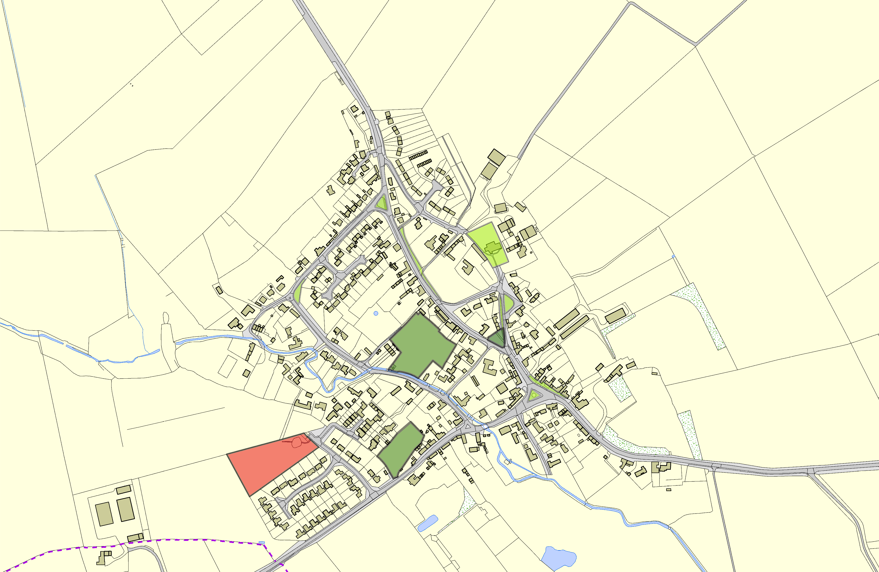
LGS/GRTE/4 - High St and Church Bank Gt Easton LGS/GRTE/2 - Brook Lane paddock Gt Easton

Kings Norton Village Greens 1 Kings Norton Village Greens 2

LGS/GRTE/3 - Barnsdale Paddock Gt Easton LGS/GRTE/1 - Clarkes Piece Gt Easton

©Crown Copyright. All rights reserved. Harborough District Council 100023843 2014

