Great Easton OSSR sites, LGS sites and Wildlife Sites Note the LGS sites are proposals only at Sept 2015

Great Merrible Wood Great Merrible Wood

Eyebrook Reservoir
Legend

Not recommended for LGS Designation Recommended for LGS designation Wildlife Sites
Open Space, Sport and Recreation Sites
OS MM Boundary
DESCTERM
!!!!!!!!!!!!!!!!!!!! County

District Electoral Parish

Nevil Holt Sports Field

Neville Holt Quarry, Neville Holt
Broadgate / High Street AGS, Great Easton
Great Easton Chuchyard Great Easton High Street AGS

LGS/GRTE/2 - Brook Lane paddock Gt Easton
Kings Norton Village Greens 1 LLGGSS//GGRRTTEE//13-- CBlaarrnksedsaPleiePcaedGdtoEckasGtot nEaston

Bringhurst School

Amenity Green Space St James Park, Drayton

Bringhurst Cemetery

St Nicholas Church - Bringhurst

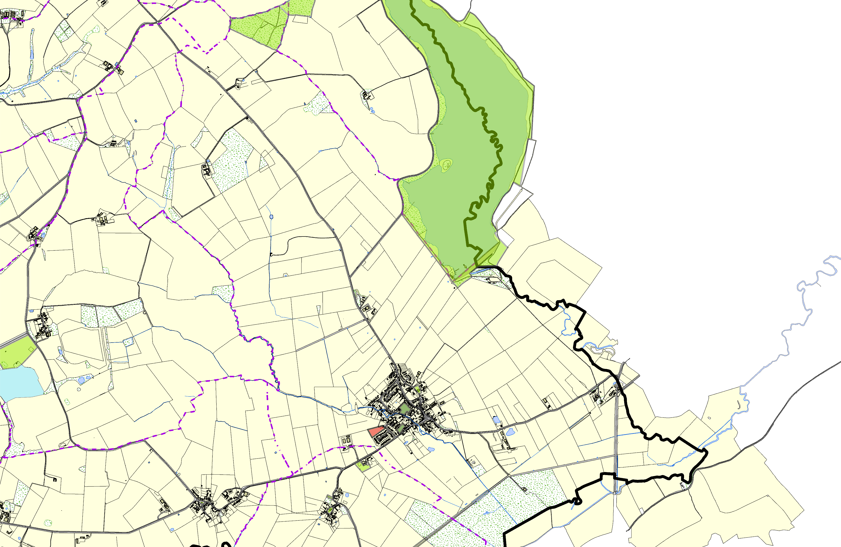

©Crown Copyright. All rights reserved. Harborough District Council 100023843 2014

