Great Glen OSSR sites, LGS sites and Wildlife Sites Note the LGS sites are proposals only at Sept 2015

Stream, Scrub and Woodland, Great Glen
Grassland with Scrub
Cracked Ash

LGS/GRTG/4 - Bund to Miller Homes Site (GG2)

Bridgewater Drive Amenity Green Space - Great Glen

Bridgewater Drive Amenity Green Space - Great Glen

St Cuthberts C of E School Playing Field

Great Glen Recreation Ground

Great Geln Play Area

LGS/GRTG/2 - Grassed Area outside Chemist GG

LGS/GRTG/1 - Post Office Green Great Glen

St Cuthberts Church - Great Glen

St Cuthberts Church - Great Glen

Cromwell Road Play Area - Great Glen
Legend

Not recommended for LGS Designation Recommended for LGS designation Wildlife Sites
Open Space, Sport and Recreation Sites

Memorial Green Stonehall Court Flats - Great Glen

OS MM Boundary
DESCTERM
!!!!!!!!!!!!!!!!!!!!! County

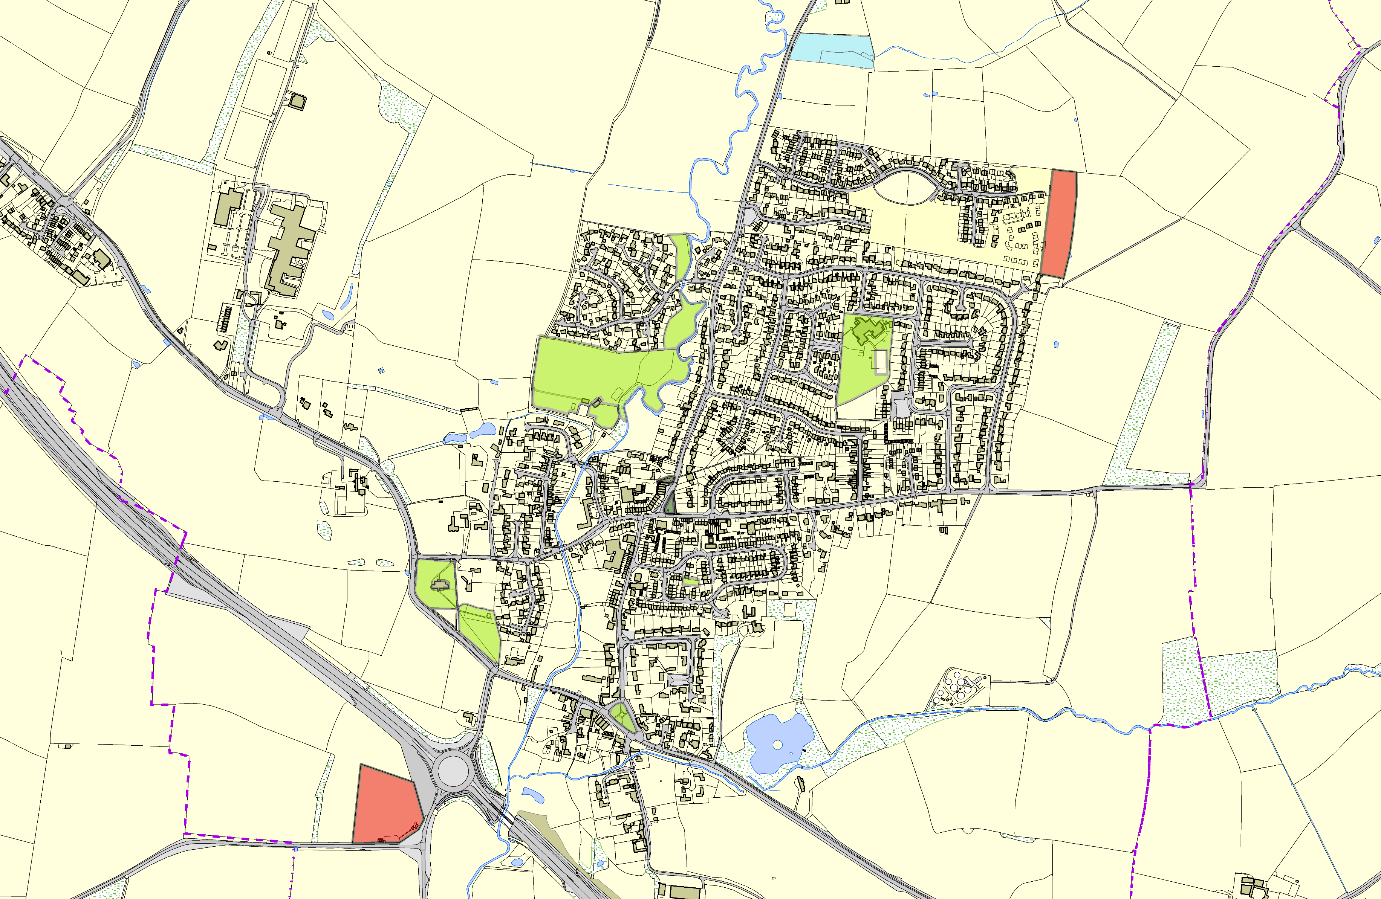
LGS/GRTG/3 - Archery Field Great Glen
©Crown Copyright. All rights reserved. Harborough District Council 100023843 2014

District Electoral Parish

