Great Glen OSSR sites, LGS sites and Wildlife Sites Note the LGS sites are proposals only at Sept 2015

Little Stretton Church/Cemetery

Village Hall and Small Play Area - Little Stretton

Chestnut Drive, Stretton Hall, Great Glen
Pheasant Woodland

Old Oak
Stackley House Grassland

Stream, Scrub and Woodland, Great Glen Grassland with Scrub

Erringtons Close, Great Glen

Bridgewater Drive Amenity Green Space - Great Glen

Bridgewater Drive Amenity Green Space - Great Glen
LGS/GRTG/4 - Bund to Miller Homes Site (GG2)

L
Legend LG

St Cuthberts C of E School Playing Field Great Glen Recreation Ground
LGS/BO/2 - Pasture land east of Scotland Lane

Not recommended for LGS Designation

Great Geln Play Area

LGS/GRTG/2 - Grassed Area outside Chemist GG LGS/GRTG/1 - Post Office Green Great Glen

St Cuthberts Church - Great Glen
Recommended for LGS dLeGsS/iBgOn/1a- tMiaoinnStreet Pasture Wildlife Sites LGS/BO/4 - Traf Open Space, Sport and Recreation Sites

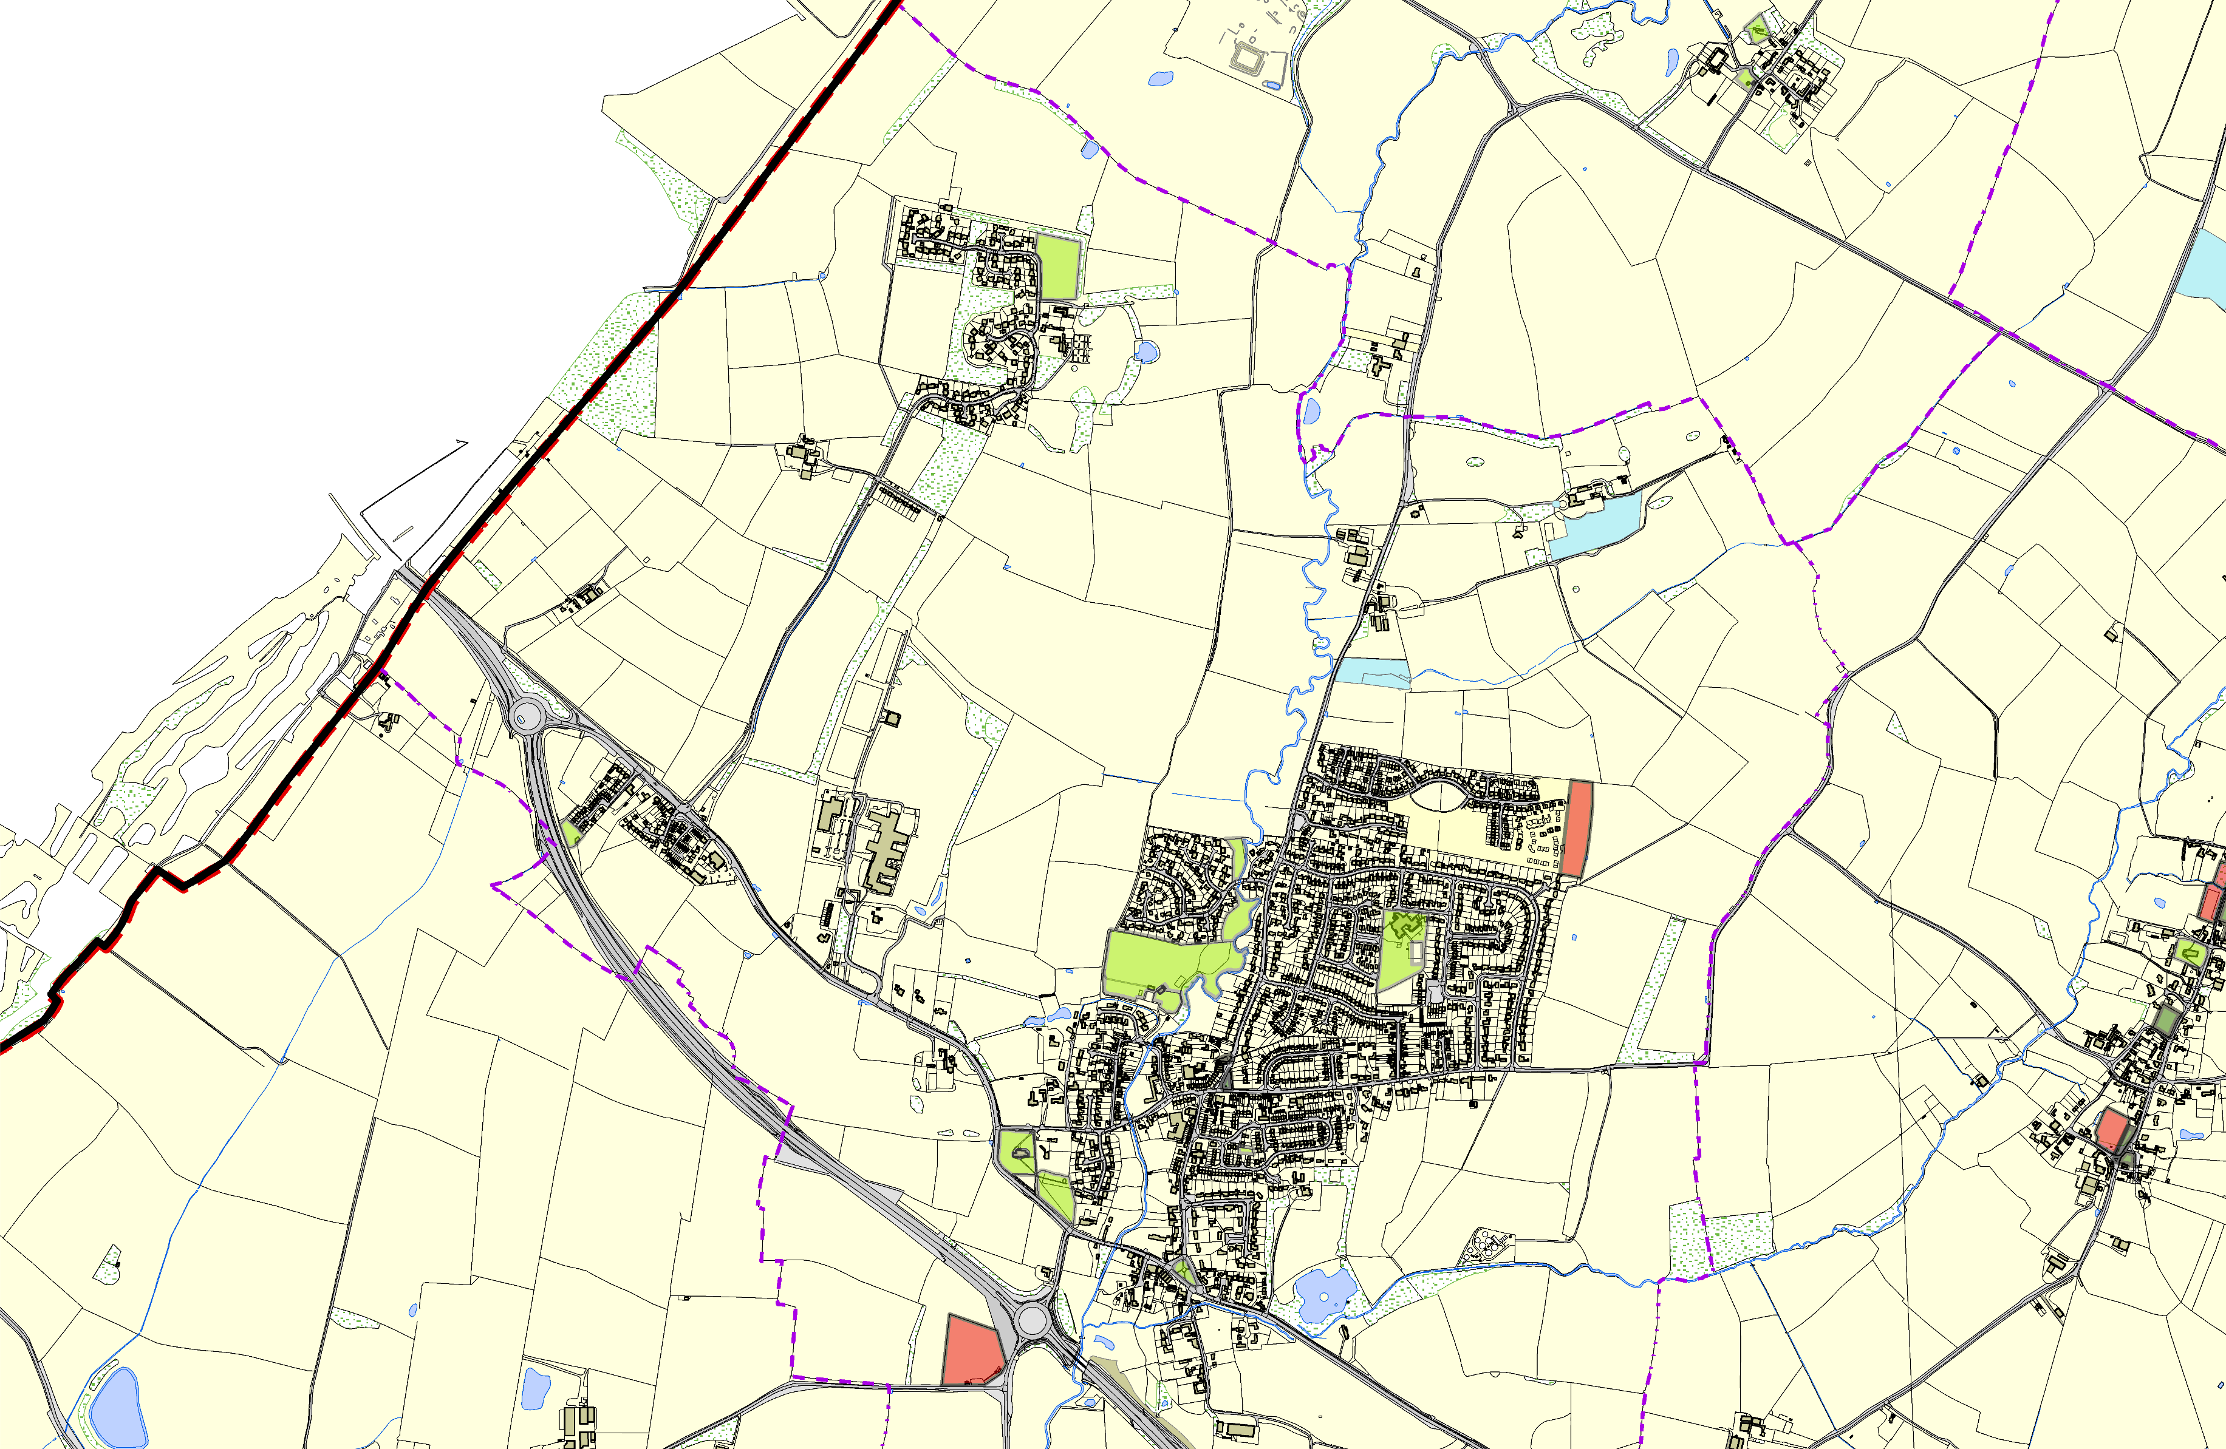
Cromwell Road Play Area - Great Glen
LGS/BO/7b - Old

St Cuthberts Church - Great Glen

Memorial Green Stonehall Court Flats - Great Glen

LGS/GRTG/3 - Archery Field Great Glen
©Crown Copyright. All rights reserved. Harborough District Council 100023843 2014

OS MM Boundary
DESCTERM
!!!!!!!!!!!!!!!!!!!! County

District Electoral Parish
LGS/BO3 - Main Street Spinney

