# Illston on the Hill OSSR sites, LGS sites and Wildlife Sites Note the LGS sites are proposals only at Sept 2015

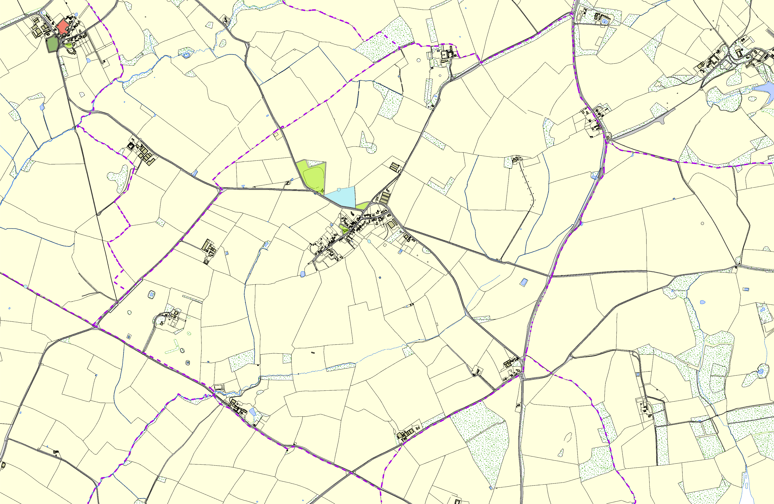

LGS/KIN/1- Land adjacent to Home Farm Kings Norton

Kings Norton Village Green 1

LGS/KIN/2 - Land Adjacent to Grange Farm Kings Norton Kings Norton Churchyard

Illston on the Hill - Cricket Field

Gaulby Road Grassland; Site B Gaulby Road Grassland; Site A

Illston on the Hill Park

Illston on the Hill Churchyard

Mature Ash Tree, Illston on the Hill

Ancient Ash

**Legend**

## Not recommended for LGS Designation Recommended for LGS designation Wildlife Sites

Open Space, Sport and Recreation Sites

**OS MM Boundary**

**DESCTERM**

!!!!!!!!!!!!!!!!!!!!! County

## District Electoral Parish

**©Crown Copyright. All rights reserved. Harborough District Council 100023843 2014**