Keyham OSSR sites, LGS sites and Wildlife Sites Note the LGS sites are proposals only at Sept 2015

Legend
Keyham Cemetery

Not recommended for LGS Designation Recommended for LGS designation Wildlife Sites
Open Space, Sport and Recreation Sites

OS MM Boundary
NaDturEal BSuriCal STiteE- SRcraMptoft
!!!!!!!!!!!!!!!!!!!! County
District Electoral Parish

Keyham Churchyard

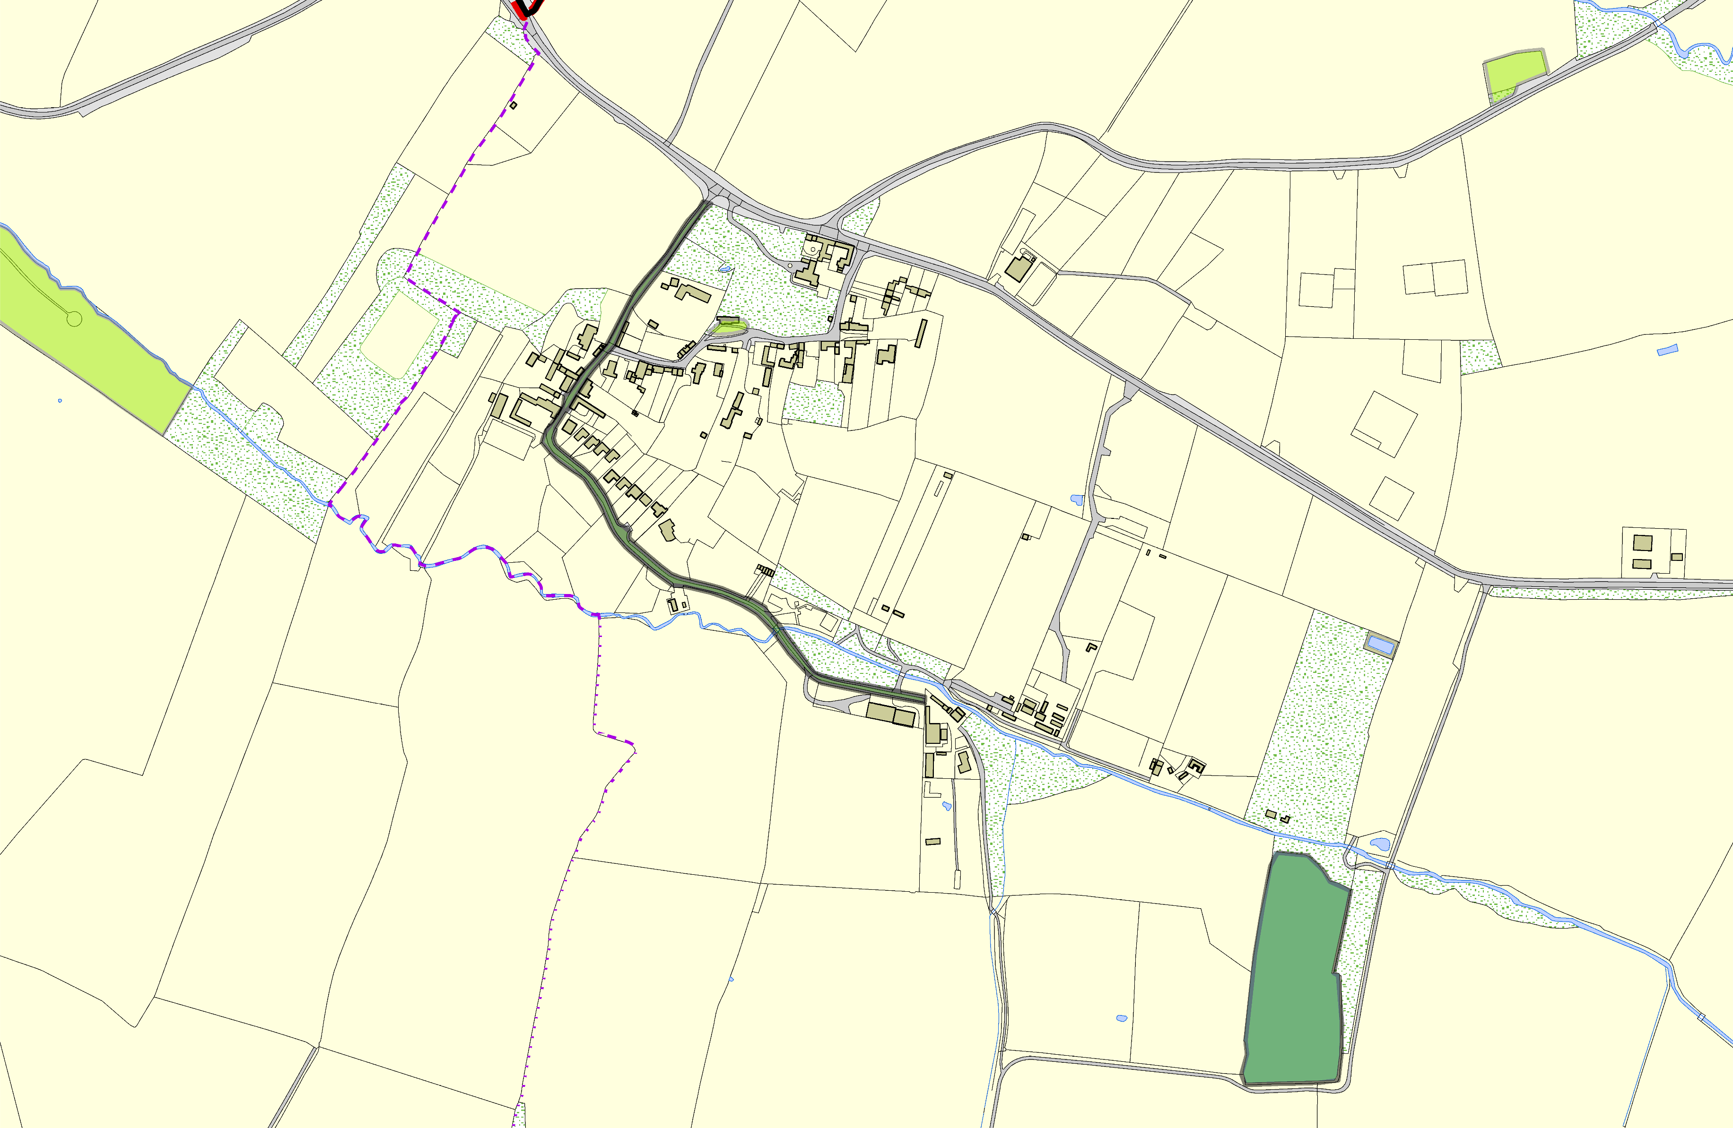

LGS/KEY/1a,1b,1c - Snows Lane - Sunken Lane Keyham

Keyham Meadow, Keyham LGS/KEY/2 - Miles Piece Keyham

©Crown Copyright. All rights reserved. Harborough District Council 100023843 2014

