Keyham OSSR sites, LGS sites and Wildlife Sites Note the LGS sites are proposals only at Sept 2015
Village Farm (Field 1-Rhombus Meadow) Private Lake

Legend

Village Farm (Pond 1)

Not recommended for LGS Designation Recommended for LGS designation Wildlife Sites
Open Space, Sport and Recreation Sites
OS MM Boundary
DESCTERM
!!!!!!!!!!!!!!!!!!!! County

Keyham Cemetery

Church and Churchyard in Hungarton Tennis Court at Millenium Green - Hungarton
Millenium Green

Quenby Fishing Lake Lake 2 - Hungarton

District Electoral
Parish
Natural Burial Site - Scraptoft

Keyham Churchyard

LGS/KEY/1a,1b,1c - Snows Lane - Sunken Lane Keyham

War Field Nature Reserve - Scraptoft

Quenby Park Brook, HungartonQuenby Wood
Keyham Meadow, Keyham Quenby Estate Woodland Strip

LGS/SCRAP/4 - Scratoft Rugby Club Field
Scraptoft RUFC
LGS/SCRAP/2 - Scraptoft Woodland Mitchell Grove, Scraptoft

Covert Lane, Scraptoft Covert Lane, Scraptoft
LGS/KEY/2 - Miles Piece Keyham
Double Meadow

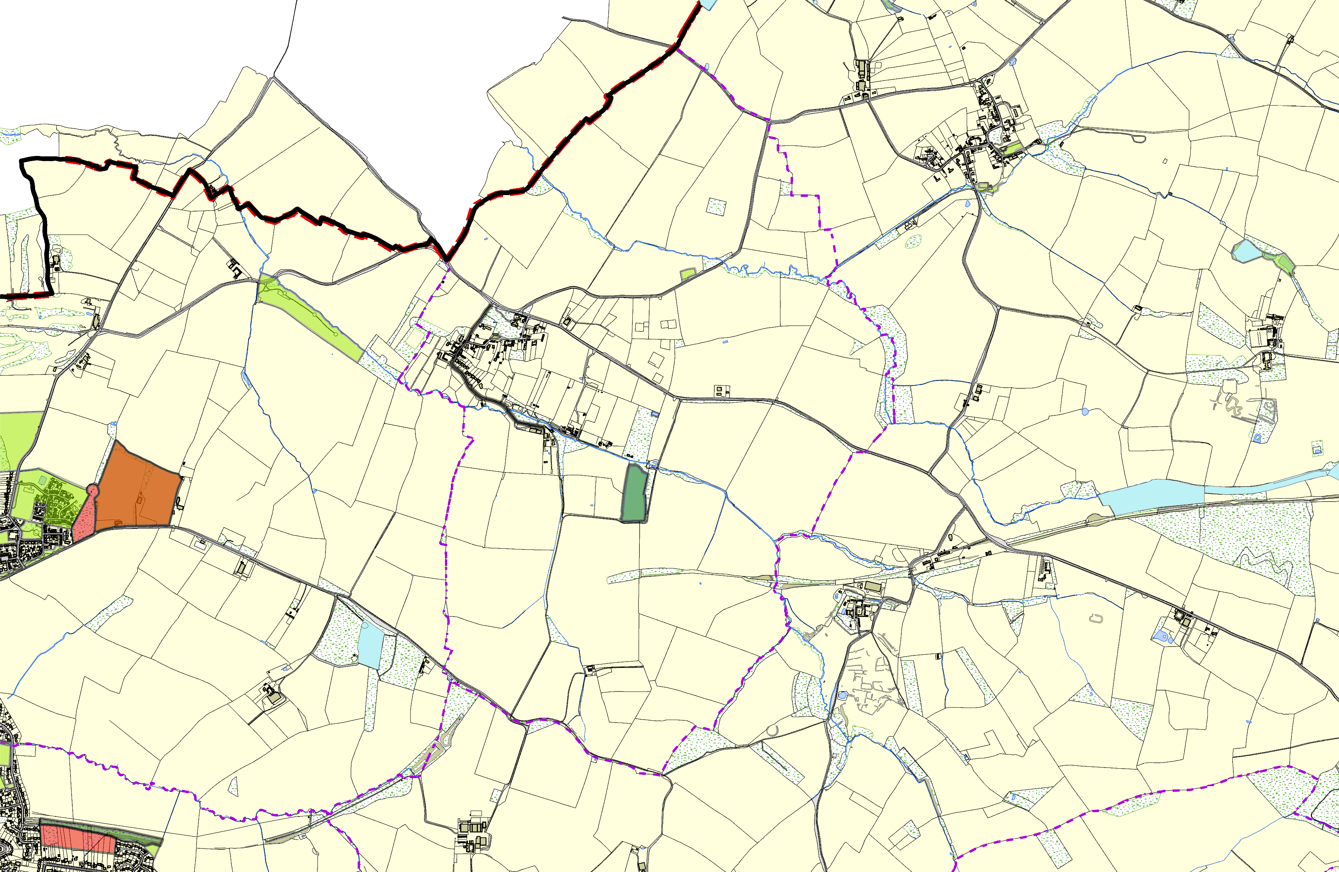

Pond at Four Acres, Scraptoft

Four Acres, Scraptoft

Pulford Drive, Scaptoft
Fernvale School - Thurnby and Bushby

Somerby Road Open Space - Thurnby and Bushby

LGS/THUR/8 - Dismtantled Railway Line Thurnby
LGS/THUR/8 - Dismantled Railway line - unsuitable area for LGS
Wadkins Badger Area, Thurnby
©Crown Copyright. All rights reserved. Harborough District Council 100023843 2014

